Design and layout of irrigation methods for field crops.

Open Education Resource
Different methods of irrigation:
There are different methods of irrigation and those methods should be layout accordingly
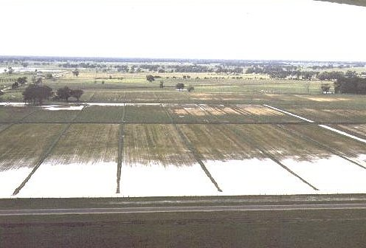
1) Free flooding methods:-
Allow water to flow freely in the field. This is easy and inexpensive method but cause water logging and uneven distribution of water.
2) Border strip flooding:-
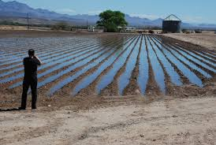
This is controlled method of irrigation. Divide the total area in strips with bunds on either side to check lateral movement of water.
Level the strips cross wise with gentle slope along the line of advance from front.
Keep one water channel at the head of the strips.
Irrigate each strip by opening the bund at the head of the strip.
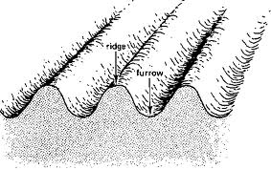
3) Furrow irrigation method:-
1) Level the land properly
2) Open the furrows with the plough, ridger or with spade.
3) Depth of furrow should be 10-15 cms.
4) Height of ridge 15-20cms and its width 40-60 cms.
5) Distance between two furrows varies according to crop and the length according to slope.

Ridges and furrow method
Crop Distance between ridges
1) Brinjal 75-90cm
2) Tomato 60-75cm
3) Chilli 45-60cm
4) Cabbage 60-75cm
5) Okra 45cm
6) Clusterbean 45cm
4) Improved corrugation method:-
Use gated pipes and shapes the furrow carefully.
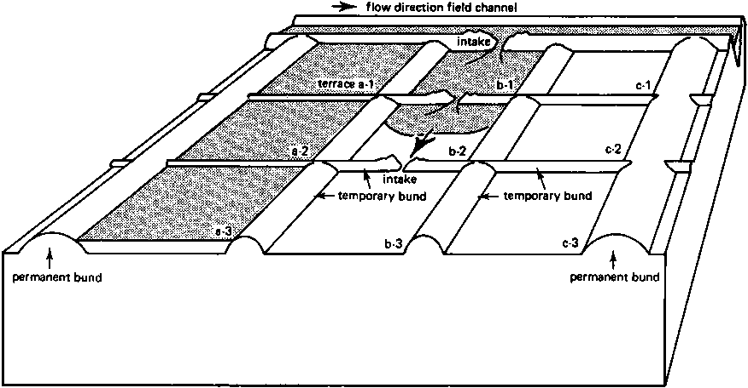
5) Basin system:-
Mark field as per the spacing of the given crop prepare a basin 20 to 30cms deep having a diameter of 0.75cm. This method is used for cucurbitaceous crops.
For fruit crops prepare larger basins according to canopy size of crop.

Methods of Irrigation:

Method | Crops irrigated | Topography | Size of bed (m) | Remarks
Free Flooding | Rice, Wheat, Fodder Millets | Sloppy and irregular up to 10 % | --- | In efficient method causes ponding, unequal distribution of water, save labour
Border strip | Wheat, rice sorghum, pulses. | No cross slope, slope along length, mostly leveled field | 15-30 m long  1.5-3 m wide | Sandy loam to loam, graded soil, low layout cost easy for interculture.
Furrow | Sugarcane, potato, cotton vegetables | Flat and gentle slope | 0.5-1.5m wide  10-50 m long | Economic water use facilitate interculture
Corrugated | Vegetables | Slope perpendicular to the furrow | 26 m | Interculture difficult
Broad ridge narrow furrow | Turmeric sweet potato watermelon | Flat |  | Almost fine gentle slope in both direction
Basin | Fruit crops cucurbits | Flat |  | Economic water use increases efficiently
Check basin | Orchard crop grain crop | Flat | 3-5 m | Low maintenance cost erosion control

Observations:

1) Name of the crop
2) Irrigation method followed
3) Water requirements of the crop
Results and conclusion: Proper selection and design of irrigation method is essential for saving water and for getting good crop growth

