NIOS OER Project

OER Frame work

Name of OER Developer: Aparna Bodas

Institution: Vigyan Ashram

Course: Rural Technology

Subject: Agriculture

Prescribed syllabus: Topic: Field crop

Unit: Field crops

Concept based syllabus - Content Analysis:

  - Concepts
    - Facts, definitions, terms,
    - Occurrence in nature and society
    - Context and meaning
    - Processes and Procedures
    - Experiments
    - Theories
    - Applications
    - Relationships
    - Creative activities

  - Activities
    - Learning activities
    - Situated assignments
    - Projects

  - Evaluation
    - Rubrics
    - Question bank
      - Knowledge
      - Skills
      - Applications
      - Tech Tools
      - Portfolio- artifacts

Selection of a concept for OER development: One to ensure content mastery
Three OERs – Level 1. For Learner Objective: Self learning
2. For Mentor Objective: Facilitation of learning
3. For Evaluator Objective: Assessment / Evaluation / Testing

Concept and Concept map: ***

Medium- Multimedia / Video / Audio / Film / Printed Text / any other (specify)
Content:

PART: B

OBJECTIVE: After going through this OER, the learner will be able to:
- Select proper crop type suitable for his/her soil and climate
- Cultivate selected field crop by performing various cultivation practices

SITUATION:

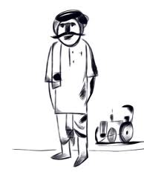
Vitthal! You know that we own a big land. But only small part of it is under cultivation. That is because I don’t have much help.
Yes. I know that father.

Now that, you are big enough, why don’t you grow one crop all by yourself? You can try that on a small piece of uncultivated land.
Sure! That sounds interesting.

OK, then! Let’s do it in the coming season.
Vitthal’s father tells his son that their soil is fertile, rich in organic matter. Surrounding climate of the land is warm and humid. While enjoying Diwali vacation, Vitthal studies these things and finalizes Maize as the crop for cultivation.

Activity 1:
Check Vitthal’s crop selection is correct or not. Please refer Table No. 1 (Maize Details) at the end of this document for this activity.

Vitthal’s friend visits him. Vitthal tells him about his ‘cultivation project’.
Vitthal, is Maize a cash crop?

No. Sugarcane, cotton etc. are cash crops.

How do you classify these crops?

To answer this question, Vitthal then explains to his friend basic classification criteria for field crops. Here is the summary of it:

Supportive doc --classification of field crops.docx

Vitthal starts working in the field from the following week. First, he measures the piece of land which is given to him. It is 10m X 10m in dimensions. These land measurements will be very useful for deciding the methods of sowing, seed rate calculation, manure/fertilizer dose and even for irrigation.

Then, he follows all the ‘preparatory tillage’ practices. That means he prepares his land according to the type of crop he wants to cultivate and to the type of irrigation he is going to use. Vitthal has decided to cultivate Maize. So he ploughs the land and repeats the process 2 to 3 times for better results. He is going to use ‘ridges and furrows’ as his irrigation technique.

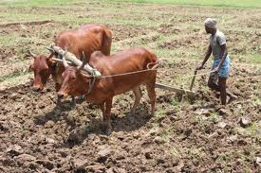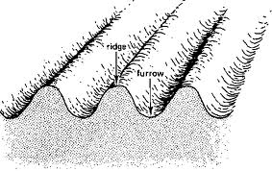
Fig. 1 Land Ploughing Fig. 2 Ridges and furrows

Here, one should understand that, land preparation is different for different crops and different irrigation types.

Now, Vitthal does examination of soil (Please refer OER on ‘Study of soil/Soil Testing’) and decides the dose of manures/fertilizers according to the table given at the end of this document (Table No. 1 – Maize details)
Since Vitthal has a small piece of land to cultivate, he decides to cultivate Maize as Fodder and not as grain. At this stage, he goes to the market and checks the varieties of Maize (fodder) available. This is very important to check the varieties available to you as new variety with different benefits keeps coming in the market.

Couple of days later Vitthal asks his father:

Father, I have selected the crop variety I want, tested the soil and also checked the dose of manures/fertilizers I need to give. But how many seeds should I buy for sowing?

Look, there is a formula to calculate the seed rate. But I will show it in a simple way. See the following diagram and explanation about it.
Suppose this is your land (10m X 10m). Then, there should be 30cm distance between two rows and 15cm distance between two plants. It will look somewhat like the following figure:
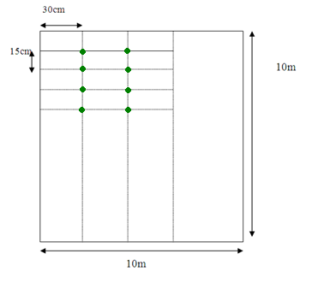
You need to keep sowing the seed on each intersection.

Activity 2:
- Calculate how many seeds you are going to need for the entire area of Vitthal’s land.
- You cannot buy seeds by unit. It is always by weight. So, weigh 100gm of seeds and count how many seeds come in 100gm. Now, calculate the weight of the seeds Vitthal will need for his land.

Method of sowing mainly depends on the area of your land and the type of your crop. In Vitthal’s case, since his plot is small, he goes for ‘Dibbing’.

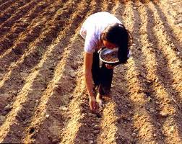
Fig. 3 – Sowing seeds (Dibbing technique)

Vitthal’s calculation for ‘seed rate’ and his sowing were successful. One day his father visits his crop and says…
Vitthal, you did a good job till now. But you cannot just forget about the crop until harvest. You have to pay attention to the after care.
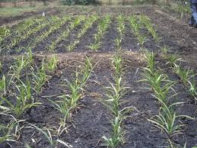
Fig. 4 – Growing crop – Initial stage
What exactly I have to do now, father?
See, you have to keep your plot clean by hoeing and weeding. Check for any disease or pest regularly. Give the remaining dose of manures/fertilizers. Always follow your irrigation schedule properly.
OK! Father, how long it will take to grow the crop fully?

It might take approximately 90 to 120 days to mature the crop. And the most important thing you should do is maintain the crop record. It will help you in many ways like for your future crop planning, cost estimation etc.
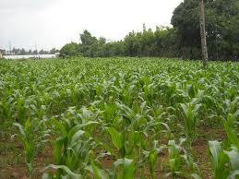
Fig. 5 – Growing crop – later stage

Activity 3:
Find out different varieties of maize and other grains available in the market near your area.

As per father’s advice, Vitthal starts maintaining the crop record. He also takes good ‘after care’ of his crop. Now, his
crop is growing and looks healthy too. But he is not sure exactly when his crop will be ready to harvest. What is the indication of crop maturity? His father then tells him…
Knowing when to pick your crop is very important. In your case, you are growing maize as Fodder. So, the crop should be tender. Here are some simple tips:
- Check when the threadlike strands of maize turn brown.
- Feel the maize by placing your hands around it. It should feel dense.
- Also, know the standard maturity time for the specific variety you planted and compare your time with it.

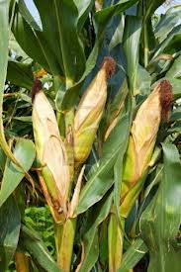
Fig. 6 – Maize is ready to harvest

Activity 4:
      - Make a table to keep your ‘crop record’. It should include all the major dates like date for plantation, first fertilizer dose etc. It should also include your irrigation schedule.
      - Maturity parameters given here are for ‘fodder maize’. Find out the same for ‘maize grain’. Are there any differences? If yes, find out the reason behind it.

Going by his father’s expert advice, Vitthal did harvest his crop at right time. And look what he has got –

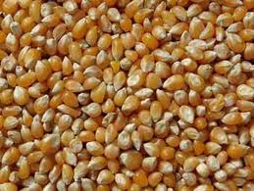
He got a good yield at his very own, first attempt. He calculated the yield. It was a win-win situation. Good job, Vitthal! His hard work and determination brought him success.

Congratulations!

Following table will give most of the details you need to know to cultivate ‘Maize’; from its botanical name to approximate yield etc.

Table No. 1 – Maize Details

Common name | Maize (Makka, Makai, Corn)
Botanical name | Zea mays
Origin | America
Climate | Warm and humid
Soil | Deep, fertile , rich in organic matter, well drained, alluvial soils
Varieties available in India as on now (year 2012) | Hybrid – Ganga hybrid 1,3,5,101  Ganga safed-2, Deccan double hybrid.  Composite varieties-Hi-starch, Amber, Jawahar, African tall, Hunis.
Preparatory tillage | Ploughing, 2 to 3 harrowings, ridges nad furrows
Water management | 4 to 5 irrigations
Seed and sowing -i) Time of sowing | Kharif -June-July  Rabbi –oct-nov  Summer – Jan-feb
Seed and sowing -ii) Method of sowing | Drilling, Dibbing  Spacing  Medium & full season – 75X25cm²  Early and very early 60X22cm²  Fodder 30 cm  Seed rate  Grain-15 to 20kg/ha  Fodder-75 kg/ha (ha – hector)
Manures and fertilizers | 12 to 15 tons/fym  N P K Kg/ha  Rain fed 90 40 40  Irrigated 120 60 40  Fodder 120 30 20
After care | Gap filling, Thinning, hoeing & weeding
Harvesting | Sheaths of cobs turn brownish and seeds become hard and dry
Yield | Rain fed 6.5 to 7.5q/ha (approx.)  Irrigated 17 to 18q/ha (approx.)  Hybrid 50 to 70 g/ha (approx.)  Green fodder irrigated 35 to 50 tons/ha (approx.)  Rain fed 15 to 20 ton/ha (approx.)

