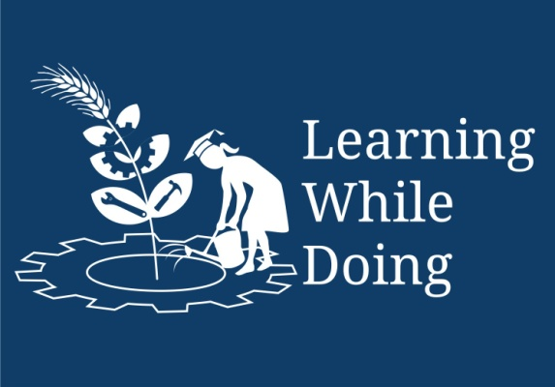
Need for Soil Testing
Soil Sample Collection
Open Education Resource
There are about 20 elements essential for plant growth out of which primary and secondary elements like N, P, K, Ca, Mg, and S are involved in major metabolic functions of plants and their deficiency in soil affects crop yields. Soil PH is also one of the crop growth limiting factors which indicates acidic or alkaline soil condition under which growth of plants is restricted. Salt concentration is also one of the plant growth limiting factors.
Soil testing therefore involves analysis of available nutrients like N, P, K , Ca , Mg and S, micro nutrients and based on acidic and alkaline PH conditions lime and gypsum requirement of soil.
For efficient soil testing and better results, the soil testing programme can be divided into different phases viz.
- Collection and preparation of soil sample
- Extraction of available nutrients and their determination
- Calibration and interpretation of results
- Recommendation of fertilizers based on soil testing results.

Representative of Soil Sample
The soil sample constitutes the largest single source of error in a soil testing programme. A poor sample is not only a waste of time and money but also leads to enormous conclusions and recommendations which will prove costly to the cultivator.
Soil sampling is the most important step in good soil testing programme.

For Soil Sampling Methodology go through..\PPTs\Soil sampling and testing.ppt

Also here are some guidelines about soil sampling Guidelines to collect sample before sending to laboratory.docx
Now, as we have collected different soil samples let’s see, which kind of soil is best suited for our agriculture and which are the physical and chemical properties of soil -
Characteristics of an ideal soil with respect to plant growth:
- The soil should be well aerated: Plants take oxygen and hydrogen from the soil which is necessary for plant growth. Also, if oxygen is present in the soil, micro-organisms will grow there which eventually are helpful for crop growth.
- pH of the soil should be between 6 to 8: pH of the soil should be between 6 to 8 for proper crop growth This is because, in this pH, nutrient movement will be good.
- It should have good water holding capacity.
- It should also have well drainage capability for excess water.
- Soil should have good amount of organic matter and available nutrients.
- It should be free from soil borne diseases and pests.
- Soil should be deep, friable and well textured.

