

Module III: Energy & Environmental Services
Lesson 6: Electrical Services – IC Engines, Pumps, motors

------------------------------
Topic : Diesel Engine

12.1 Introduction :
Many farmers are using a diesel engines for pumping a water from well, canals directly to their farms. Diesel engines are used to run pumpset, floor mills, agricultural equipments, generators etc. They are very useful in the areas, where electricity is not reliable. Diesel engine is device which converts chemical energy in the fuel into mechanical energy.

12.2 Objectives :
After completing this unit the student will be able to
- Identify the basic parts of diesel engine and explain how they work together.
- Explain the operation of 4 stroke diesel engine.
- Understand the problems come in the diesel engine.

12.3 Diesel Engine :
Basic Parts of diesel Engine :-

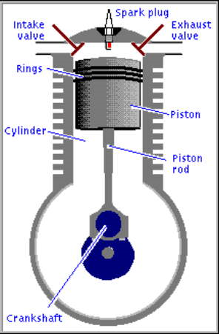
The most essential parts of 4 stroke diesel engine are listed below :-
- Cylinder :
The engine block is fitted with a cylindrical shaft. This is the cylinder which is hollow and stationary.
- Piston :
The Piston is free to slide up and down within the cylinder.

Combustion Chamber
The fuel mixture is brought into the cylinder then the piston moves up and compresses the fuel into a small space called the combustion chamber. When the fuel is ignited and burns, tremendous pressure builds up. This pressure forces the piston back down the cylinder. The basic motion within the engine is that of the piston sliding up and down the cylinder a reciprocating motion.
- Crankshaft :-
It converts reciprocating motion into more useful rotary motion.

- Valves :-
These are the doors for admitting fuel mixture and releasing exhaust.
There are two valves, one to let the exhaust out (Exhaust valve) and one to allow the fuel mixture to come in (intake valve).
- Crankcase :-
It is a body of Engine.
It contains most of moving parts of engine.
- Piston Rings :-
Piston rings provide a tight seal between the piston and cylinder wall.
The piston rings reduce friction and control the lubrication of cylinder wall.
Three or four piston rings are mounted on a piston.
- Compression Rings :-
First two are compression rings. They can move slightly up and down and expand slightly in and out.
It act as a power seal ensuring that a maximum amount of the combustion pressure is used in forcing the piston down the cylinder.
- Flywheel :-
The flywheel is mounted on the tapered end of crankshaft.
It help to smooth out the operation of engine.

Fig. 3.1 Basic parts of four cycle engine.

  - IN TEXT QUESTIONS :-
Fill in the Blanks :
- Types of piston rings are …………………and …………………
- Most essential parts of the engine are …………,………..,………….
- Crankshaft is used to …………………………………………..
- The piston and crankshaft is connected by ……

12.5 OPERATION OF FOUR STROKE DIESEL ENGINE :-
Four stroke cycle means that it take four stroke of the piston to complete the operating cycle of the diesel engine.

Strokes | Movement of Piston | Intake Valve | Exhaust Valve | Action in combustion chamber/ cylinder
1. Intake stoke | Piston moves down | Open | Closed | Fuel and air enters in combustion chamber.
2. Compression stroke | Piston moves up | Closed | Closed | A fuel mix is compressed into a small space at the top of cylinder
3.Power Stroke | Piston Pushed down | Closed | Closed | Fuel mixture is ignited. It produces a rotary motion in flywheel.
4. Exhaust stroke | Piston moves up | Closed | Open | Piston pushes exhaust gases out of cylinder.

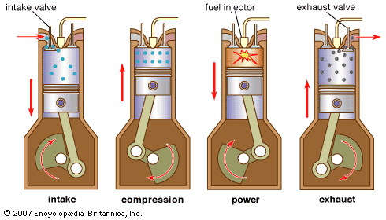
Fig. : Operation of four stroke diesel engine.

In most of the diesel engine, crank is rotated manually till engines fires. During intake stroke, fuel enters into cylinder. It gets compressed while piston moves upwards in return stroke. This is called as compression stroke. Exhaust and inlet valves remains closed while piston return. The temperature of fuel insider the chamber increases with pressure and it bursts, giving thrust to the piston. This is called as power stroke. While piston returns to its initial position, exhaust valves opens and burned gases are passed out.
Operation of opening and closing of valves is done using Cam fitted on the shaft.
These four strokes complete the engines cycle, means four strokes needs two revolutions of the crankshaft. As soon as one cycle complete, the another begins. If an engine is operating at a speed of 3600 RPM. These are 1800 cycles per minute.
Stroke means a regular up & down movement of piston in cylinder.

  - IN TEXT QUESTIONS :-
Fill in the blanks :

- The fuel mixture is ignited in ………………stroke.
- In exhaust stoke ………….. valve is closed .
- Stroke means a regular up and down movement of ……………in a cylinder.
- Names of the four strokes are 1…………….2………………3……………4………………

12.6 Trouble shouting of diesel Engine.

* Engine starts with difficulty *

Cause / Fault | Remedy / To Remove it.
1. No fuel in tank | Fill tank with fresh fuel.
2. Water in fuel | Drain the tank.  Clean carburetor and fuel liens.  Dry spark plug points.  Fill tank with fresh and clean fuel.
3. Improper Carburetor | Adjust Carburetor.

 | Cause / Fault | Remedy / To Remove it.
1 | Carbon in combust on chamber | Remove the cylinder.  Clean carbon from head and piston
2. | Loose flywheel | Check fly key  Tighten flywheel
3. | Loose connecting Rod | Replace connecting rod.
Engine Overheats
 | Cause / Fault | Remedy / To Remove it.
1. | Engineer improperly times | Time the Engine
2. | Carburetor improperly adjusted | Adjusted Carburetor
3. | Excessive load on engine | Check operation of associated equipment  Reduce excessive load.
4. | Lack of Lubrication | Full crankcase with proper oil.
Engine Vibrater excessively.
 | Cause / Fault | Remedy / To Remove it.
1. | Engine not securely mounted | Tighten loose mounting bolts.
2. | Bent crankshaft | Replace crankshaft
3. | Associated equipment out of balance | Check associated equipments

12.3 IN TEXT QUESTIONS :
Write the sentences are true or false
- Stop the engine by using decompressor lever.
- Engine overheats due to lack of lubrication.
- If engine vibrates excessively then we should replace the crankshaft.
- Engine knocks due to loose flywheel.

12.7 What have you learnt ?
In this lesson you have learn ,
- Four stoke of Engine
- Intake stoke
- Compression stroke
- Power stroke
- Exhaust stroke
- Stroke means a regular up down movement of piston in a cylinder.

12.8 Terminal questions :-
- How many revolutions are required for the complete cycle ?
- Explain the power stoke.
- What is a combustion chamber ?
- What purpose do piston rings serve ?
- Explain the starting procedure for the engine ?

ANSWERS TO INTEXT QUESTIONS 12.1 :
a) Types of piston rings (1) Compression ring
(2) Oil control ring.
    - Essential parts of diesel engine :-
Cylinder, Piston, Flywheel, Crankshaft, Camshaft piston rings, valves, connecting rod etc.
c) Crankshaft is used to convert the reciprocating motion into more useful rotary motion.
- The piston and crankshaft is connected by connecting rod.

ANSWERS TO IN TEXT QUESTIONS 12.2 :-
- Power stroke
- Intake valve
- Piston.
- Four strokes are intake stroke, compression, power and exhaust stroke.

12.3 ANSWERS TO IN TEXT QUESTIONS :-
True or False
- False.
- True
- True
- True

