

Module III: Energy & Environmental Services
Lesson 6: Electrical Services – IC Engines, Pumps, motors

------------------------------

Topic :Pumps

11.1 Introduction :
In this chapter we will study about borewells , open wells. We will also study different pumps to take out this water from the ground.

11.2 Objective:
After completion of this lesson you will be able to
- know the open wells, bored wells, water yield
- understand about the operation of hand pump
- learn the types of pumps for different application
- Skillfully compute the head of the pump & safety precautions.

11.3 Open well or Dug well :
In the past open wells or dug wells are common. The wells are lined with stones, bricks, tile, or other material to prevent collapse. They are excavated by hand shovel to below the water table until water get stuck.. The reason was, water table was very near, depth at which the under ground water available was near. Currently no body goes for the digging the well , because the water table has gone too deep.
11.4 Bored well or Drilled wells.
They are basically hole drilled into a ground below water table. A casing is fitted to seal the well from material falling inside. These wells are relatively economical to construct. They are of varied sizes from 4” to 12” in diameter depending on the water yield in the bore and requirement of the user.
We can get ground water through bore well or open well. But wherever possible take it from bore well. If bore well and open well are on the same place and have the same depth then capacity of both of them to give water is same. This means same amount of water can be taken out from the well in 24 hours without changing their water level. Only difference in the storage capacity. Open well can store more water. In borewell we can take out only the amount of water that is getting percolating insider the well.

Well yield :
Once bore well is dugged , first question people asked is ‘How much is the yield of the bore well ?’. Selection of proper pumpset depends upon the water yield of the borewell. A pumping test is done to estimate the yield of the borewell.
The sustainable yield of a well is the amount of water that can be pumped from the well continuously over time without causing damage to the well (too much drawdown) or causing the well to go dry.
A trial pump set is put inside the borewell, capacity of the pump to discharge water is known. Head to be delivered by the pump is known. The water discharge is adjusted to run the pump set without getting dry. Amount of water given by the pump set in liter/second or m³ per second is calculated.
There are other methods as well to test yield of the borewell. Longer duration of trials gives accurate estimates. However, it is usually possible to get a reliable estimate of well in a test span of 2 to 8 hours.

Activity :
Discuss why more water is not coming in big open well than bore well ?
Discuss with bore well vendor, the details about pump test he is carrying out to determine yield of the borewell.

Pumps :
Pump is used to take water out from the well. In the past, water was taken out manually using pulley, rope and bucket. This method is still used at many places. In case of borewell, It is not possible to take out the water manually using bucket as depth is more and diameter of the bore is small.

11.5 Hand Pump :
Hand pumps are designed to take out the water from borewell manually.
For a borewell, India Mark II pump is specially developed. Design of this pump is made so that clear water comes out continuously.

There are four parts of hand pump.
- Foundation of Pump
- Upper part of Pump : Pedestal, tank and handle
- Pipe and rod
- Cylinder , Piston etc

- Foundation :
Foundation of pump is very important. It is constructed for preventing used/sanitary water from entering inside the bore well. Please take following precautions :
- Used/sanitary water must be sent 3 meters away from the well. This ensures used/sanitary water does not goes into the bore well directly.
- Take care that foundation & platform is strong and without any cracks. If foundation is strong then pump do not vibrate and inside pipe does not get loosened.
- Always keep pump platform clean.

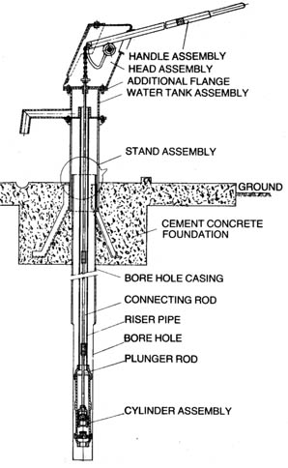
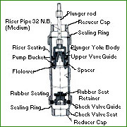

2. Upper part of Pump
- Upper part of pump is made of a strong ferrous material. It has paint and galvanized to prevent rust.
- Nut and bolt and head should be kept tight.
- Handle is made heavy so that we can pump easily and need not have to lift the weight of 80 feet rod. To make the action smooth, two bearings are used.
- Instead of pumping the handle speedily, slowly move it completely up and down. With this water will come out properly and pump can give service over years.

3. Pipe and rods
From water tank to the deep in the bore well, pipe (1.25” B class, blue strap) is used. While pumping rod moves up and down and water comes out through the pipe. Pipes are connected to each other hence their joints need to fix properly. Otherwise pipe may get slipped into the bore. Class B pipe is used at such places. Rods are also connected with socket by making threads on it. Rod is of 12-mm thickness and socket is welded to one rod. Check nut is fixed on another rod. With this arrangement rod does not get loosened.

4. Cylinder
Cylinder is fitted at the bottom of pipe. Cylinder is made up of iron and brass sleeves are fitted inside. Brass sleeves does not catches rust and it surface remains smooth.
There are two types of valves in cylinder. One valve is fitted at the bottom of cylinder and another is fitted to a rod. Piston is also fitted to the same rod. These valves allow water to flow in one direction. They closed down by pressure if water starts flowing in opposite direction.

When piston gets lifted along with rod at that time valve in the piston remains closed. But valve at the bottom opens and water from the bore get sucked in. After this, when rod and piston starts coming down, valve at the bottom closes with the pressure coming from above and valve at the top open to allow water to enter into pipe. To prevent leakage during piston movement, rubber washer (Cup) is used. This washer becomes soft and expands in water. Therefore water cannot come out of it.

Now Mark III types of hand pumps are available. In this hand pump, for repair there is no need to remove riser pipe for maintenance in cylinder assembly. The cylinder assembly can be removed with the help of riser pipes.

Advantages of hand Pump:
- No need of diesel or electricity. They can be fitted anywhere. Therefore useful for drinking water.
- They can lift the water from deep well. Upto 12-45 mtr depth.
- Once pump is installed, bore well is completely closed. Waste material does not fall inside. Sanitary water also does not go inside.
- Handle is made heavy for balancing. Therefore it becomes easy to move the handle and pump the water.
- Height of platform is made in such a way that there will be less stress on the back. Even with small effort, water comes out easily. There is no need to press the handle heavily.

Intext questions 11.1
True / False
- open wells are dug at lower depths
- Hand pump is the popular pump used for the borewells.
- Pump is used to give water from tank to well.
- Hand pump works on electricity.

11.6 Types of pumps :

- Positive displacement pumps
- Centrifugal pumps
- Multistage pumps
- Submersible pumps
- Jet pump

Positive displacement Pumps.
In the last section we discussed about hand pumps. These are positive displacement type of pumps. In which water is physically displaced and pressure is build up by piston. Movement of piston pushes water upwards. Oil pumps are examples of positive displacement pumps. 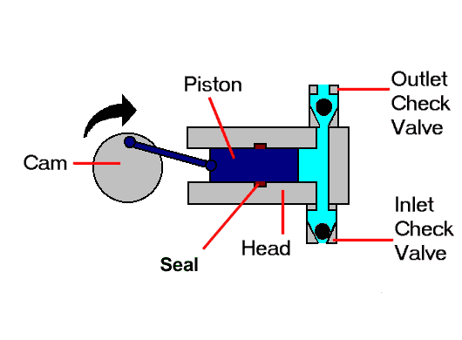

Centrifugal Pumps

Other types of pumps are centrifugal pump. In which rotating impellers imparts kinetic energy to the fluid around it. This kinetic energy is then converted into pressure energy due to typical shape of the casing.

A centrifugal pump has two main components:
I. A rotating component - Impeller and a shaft
II A stationary component comprised of a casing, casing cover, seal and bearings.
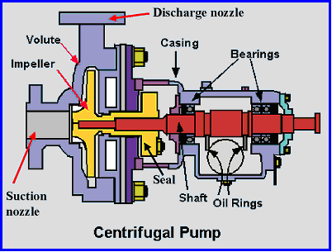
General components of Centrifugal Pump
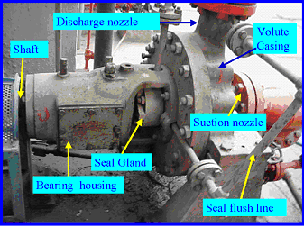
General components of a Centrifugal Pump

Impeller : Impeller is fitted on shaft and it is rotated by electric motor or diesel engine. This impeller imparts kinetic energy to liquid around it. Velocity of the liquid increases. Common types of impeller are shown in the figure
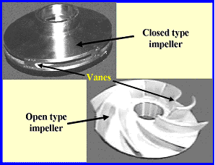
2) Casing : The casing is of volute shape. The shape is like a curved funnel wrapped around a impeller. Speed of water decrease when it goes through the casing to outlet. As speed decreases, the kinetic energy gets converted into pressure energy. Liquid gets lifted due to this pressure called head.
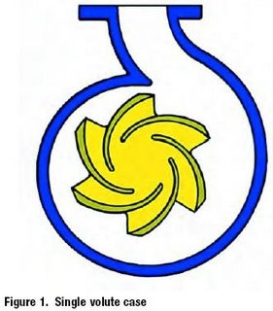
Multistage pump :
When head required is high then series of impellers are used on single shaft is water is passed through these different impellers. Pressure of liquid is increased in stages. This is called multistage pump.
Instead of volute casing , Diffuser is used to reducing speed imparted by the impeller and converting into pressure. Diffuser has small vanes of ventury shape.
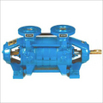

Submersible Pumps :
Ordinary motors are not water proof. If water goes inside, it damages the motor. A submersible pump is a pump in which motor and pump both are submerged in the water.
Submersible pump is essentially a multistage pump of smaller diameter which can be lowered in the borewell. Precaution has to be taken that pump will never run dry in submersible pump.
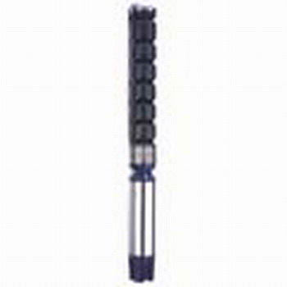

Jet Pump :

Unlike other pumps, a jet pump has no moving parts. A sim-ple jet pump, illustrated in figure , consists of a jet supply line, a jet or nozzle, a suction line, a suction chamber, a diffuser, and a discharge line.
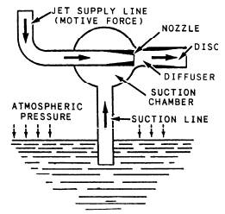
Simple jet pump.
In a jet pump, pumping action is created as a fluid (water, steam, or air) passes at a high pressure and velocity through a nozzle and into a chamber that has an inlet and outlet opening.
The operating principle of a jet pump is as follows: Upon starting up, the rapidly moving jet fluid pushes on and gives sufficient motion to the air (or whatever substance may be in the suction chamber) to carry it out through the discharge line. Displacement of the air from the suction chamber creates a partial vacuum within the suction chamber, causing fluid to flow through the suction line. The fluid entering the chamber from the suction line is picked up by the high-velocity fluid, thus providing continuous pumping action. Jet pumps are designed to pump large volumes of water. Figure illustrates a portable jetpumps used for emergency dewatering of a flooded compartment. In modern ships, fixed jet pumps have replaced fire and bilge pumps as a primary means for pumping bilges, deballasting, and dewatering compartments. Jet pumps allow centrifugal fire pumps to serve indirectly as drainage pumps without the risk of becoming fouled with debris from the bilges. The centrifugal pumps pressurize the firemain, and water from the fire-main actuates the jet pump. The jetpumps in modern combat ships have a much larger pumping capacity than fire and bilge pumps. They are installed as part of the piping in the drainage system and are flanged to permit easy removal and disassembly when repairs are necessary.
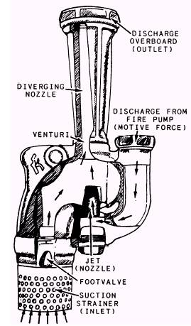
Portable jet pump
Because of their simplicity, jet pumps generally require very little maintenance. Since there are no moving parts, only the nozzles will show wear. The erosion action will cause the nozzles to become enlarged; in this case they are generally renewed. Occasionally the nozzles are removed; the strainers, if fitted, are cleaned; and a special reamer is inserted in the nozzles to clean out any rust or scale that may have accumulated.

Precaution while using Pump :

- Do not run pump dry
- Priming of the pump :
Most of the pump requires priming before start of the pump. Priming means the pump casing has to be filled with water before starting the pump. Otherwise pump will not function.
- Select pump with proper capacity. Pump capacity is determined by flow of water and head (Pressue) it can deliver. Flow of water is measured in m^3/hr or liters per second. Head is measured in meters.
- Selection of proper pumpset for proper application is very important otherwise it will give maintenance problem.
- Use proper gland for the pump so that water will not leak out.
- Run pump on proper head and flow, else it will take excess current.
l
Intext questions 11.2
Fill in the blanks
- Hand pump is ………….displacement pump.
- …………………………. are the general parts of the centrifugal pumps
- ……………….. is a multi stage pump of smaller diameter.

11.7 Calculating head required for the pump :
Selection of head (pressure) required to be developed by pump is very important. Head or height is measured in meters. 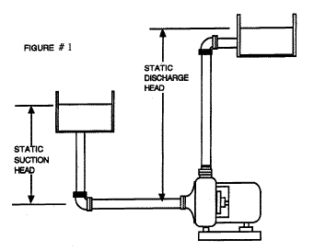
If you will refer to above Fig , to calculate the head of the pump.
Total head of the water to be lifted by pump = Static discharge head – Static suction head + friction loss

As shown in below fig 2 , If the water storage is below the pump center line then
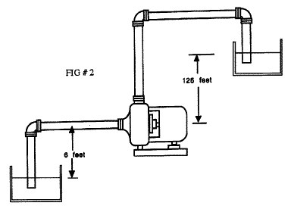
Total head to be lifted by pump = Static discharge head + static suction head + friction loss
Friction loss :
There is always loss of pressue due to resistance offered by pipes , fittings and bends when water passes through a pipe line. Friction loss is approximately taken as 0.01% of the total pipe length. Means for every 100mtrs of pipeline, 1 mtr is added as a friction loss to calculate head of the pump.
Intext questions 11.3
- Calculate head required for the pump ( above mentioned figs)…. ……….

- Mention the different types of pumps.(……………………………….)

- For every 100m of pipe line ,……………..mtr is added as a frictional loss.

11.8 WHAT HAVE YOU LEARNT:

Open wells, bore wells, hand pump, types of pumps, calculation of head , frictional loss etc.

11.9 TERMINAL QUESTIONS:

- Write differences between open wells & bore wells
- Explain the operation of the handpump.
- What is a pump ? mention the types of pumps.
- Mention the precautions while using the pump.

Answers to the Intext questions:11.1

- True
- True
- False
- False

Answers to the Intext questions 11.2

- positive displacement
- Impeller , casing ,….
- Submersible

Answers to the Intext questions 11.3

- 132ft
- positive displacement, centrifugal, multistage, jet
- 1m

11.10 Suggested activity

Practical : To dismantle pump and observe its part.
Test the pump for its flow – head curve. { Details can be obtained from pump dealer)

