Product Details – 1
Name |  | Prakash Torch
Technical Data
 | Dimensions | 85 x 41 x 20mm (L x W x H)
 | Weight | 60 g
 | Wattage | 0.8 Watt
 | Battery | 9V (use and throw)
 | LED | 10mm White LED
 | Light Dispersion | 30 deg
 | Light Intensity | 200 Lux
Features |  | - High ease of use for people of all ages
 |  | - 50 hours back up
 |  | - White focus provides steady, bright light
 |  | - Water proof
 |  | - Very easy to change the battery
 |  | - No loose contact
Operating Conditions |  | - 9V DC
 |  | - 0°C to 50°C

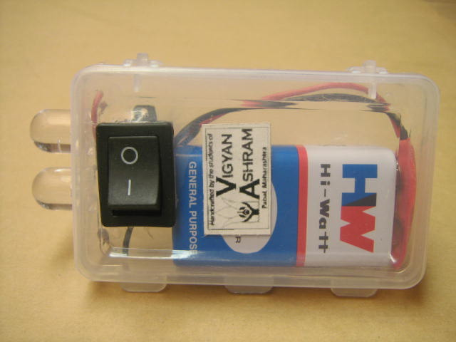
Prakash Torch

Product Details – 2
Name |  | Prakash Torch
Technical Data
 | Dimensions | 85 x 41 x 20cm (L x W x H)
 | Weight | 55 g
 | Wattage | 0.8 Watt
 | Battery | 9V (use and throw)
 | LED | Super Flux LED
 | Light Dispersion | 130 deg
 | Light Intensity | 132 Lux
Technological  Features |  | - High ease of use for people of all ages
 |  | - 50 hours back up
 |  | - Wide angle of LED, reduces strain on eyes.
 |  | - Water proof
 |  | - Very easy to change the battery
 |  | - No loose contact
Operating Conditions |  | - 9V DC
 |  | - 0°C to 50°C

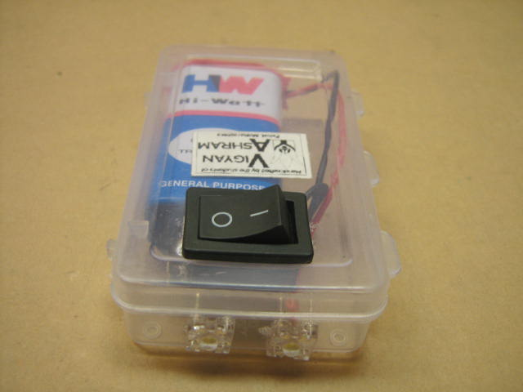
Prakash Torch (Super Flux LED)

Product Details – 3
Name |  | Emergency Lamp
Technical Data
 | Dimensions | 287 x 110 x 79mm (L x W x H)
 | Weight | 1.2 kg
 | Wattage | 1.25 watt
 | Battery | 6V Rechargeable
 | LED | 18 Super Flux LEDs
 | Light Dispersion | 130 deg
 | Light Intensity | 160 Lux
Technological  Features |  | - High ease of use for people of all ages
 |  | - Handle bar on top for easy mobility
 |  | - White focus provides steady, bright light
 |  | - Easy access slide button on top for low light situations
 |  | - 30 hrs back up provides long life and infrequent need for charging
 |  | - Durable acrylic casing available in different colors (Blue, Red, yellow, White, Pink)
 |  | - Charging indicator lets user know the battery is receiving charge
 |  | - Battery warranty of 6 months
Operating Conditions |  | - 6V DC. Dry battery, Maintenance Free.
 |  | - 0°C to 50°C
 |  | - Charges on 230V AC

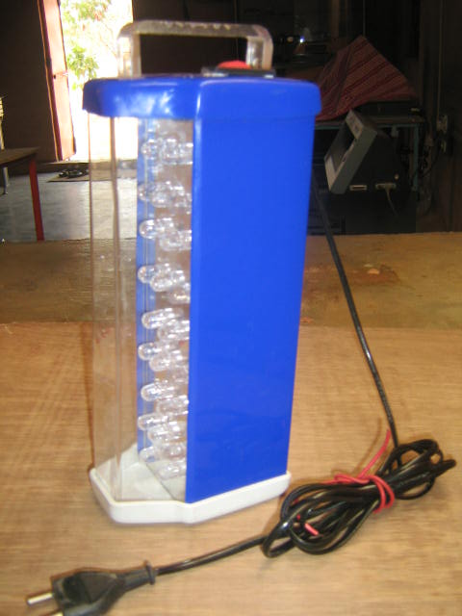 | 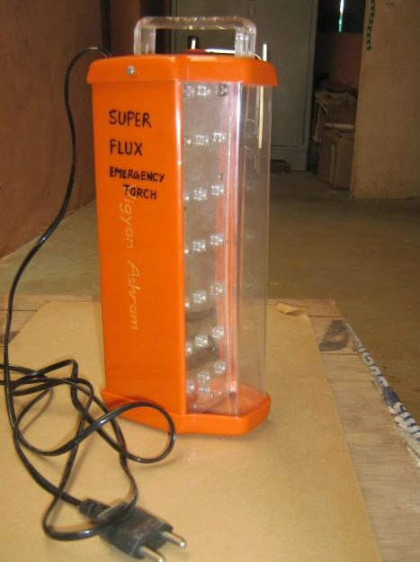
Emergency Lamps

Product Details – 4
Name |  | Kisan Torch
Technical Data
 | Dimensions | 192 x 120 x 140mm (L x W x H)
 | Weight | 1.0 kg
 | Wattage | 0.5 watt (10 mm LED); 0.1 watt (Super Flux LED)
 | Battery | 6V Rechargeable
 | LED | 8 10 mm LEDs; 2 Super Flux LEDs
 | Light Dispersion | 60 deg
 | Light Intensity | 420 – Lux (Front) & 420 – Lux (Side)
Technological  Features |  | - High ease of use for people of all ages
 |  | - Handle bar on top for easy mobility
 |  | - White focus provides steady, bright light
 |  | - Two types of light for optimal usage in low light situations
 |  | - 34 hours back-up provides long life and infrequent need for charging
 |  | - Durable casing available in different colors (yellow, white, red)
 |  | - Charging indicator lets user know the battery is receiving charge
 |  | - Battery warranty of 6 months
Operating Conditions |  | - 6V DC. Dry battery, Maintenance Free.
 |  | - 0°C to 50°C
 |  | - Charges on 230V AC

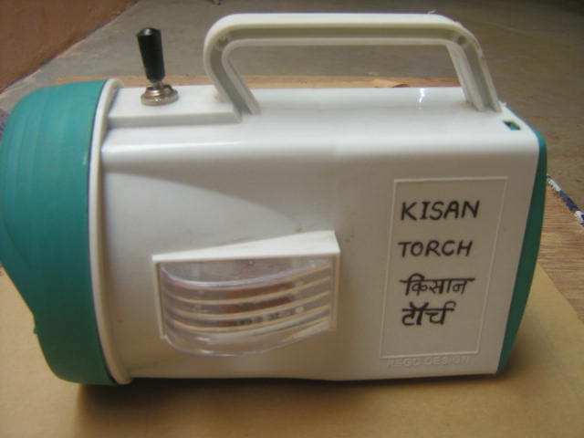 | 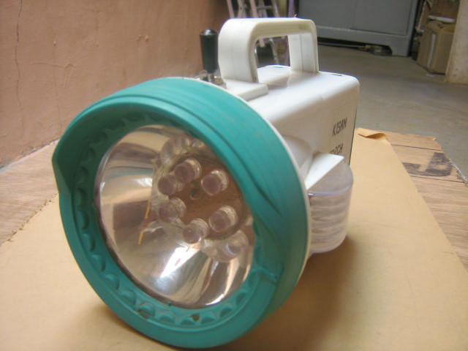
Kisan torch

Product Details – 5
Name |  | LED Strip
Technical Data
 | Dimensions | 192 x 120 x 140mm (L x W x H)
 | Weight | 400 g
 | Wattage | 1.3 watt
 | Battery | 12V Rechargeable
 | LED | 21 Super Flux LEDs
 | Light Dispersion | 160 deg
 | Light Intensity | 340 Lux
Technological  Features |  | - High ease of use for people of all ages
 |  | - White focus provides steady, bright light
 |  | - Easy to fix on ceilings, walls, or table-tops
 |  | - Durable casing made of sturdy plastic
 |  | - Can be used inside of houses or on vehicles
Operating Conditions |  | - 12V DC
 |  | - 0°C to 50°C

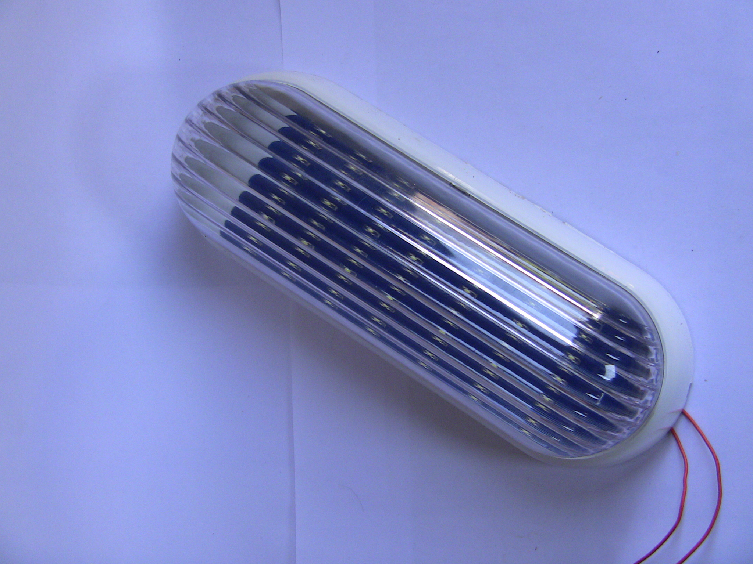 | 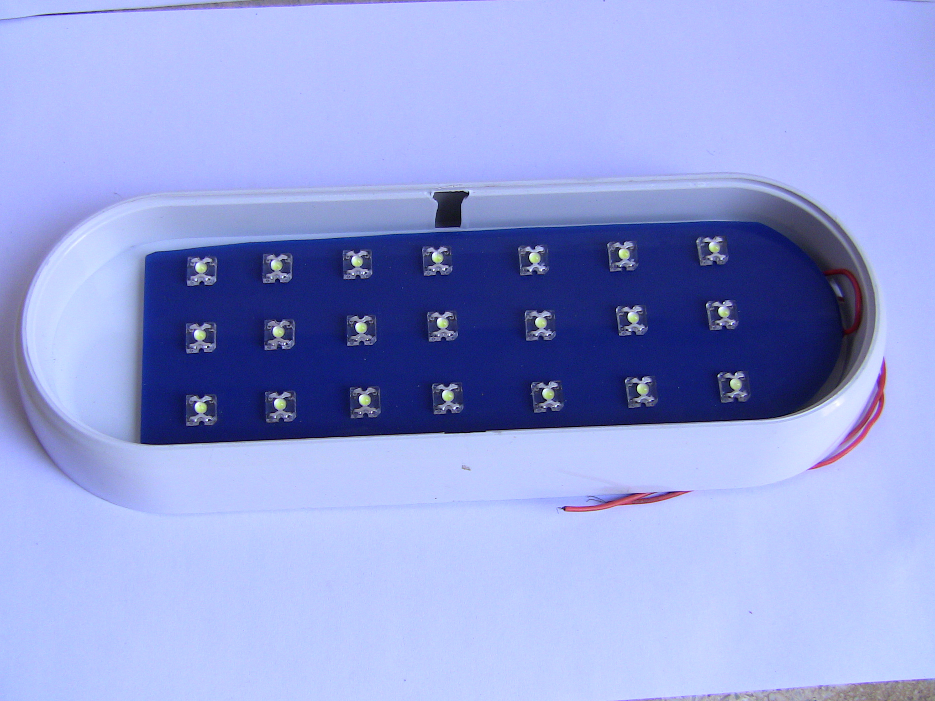
LED Strip

Product Details – 6
Name |  | 12V DC Bulb
Technical Data
 | Dimensions | 35 x 35 x 50mm (L x W x H)
 | Weight | 100 g
 | Wattage | 2 watt
 | LED | 6 Super Flux LEDs
 | Light Dispersion | 140 deg
 | Light Intensity | 286 Lux
Technological  Features |  | - Low power consumption
 |  | - White focus provides steady, bright light
 |  | - Easy to fix in DC Holder
 |  | - Durable and compact casing
 |  | - Works on 12V DC
Operating Conditions |  | - 12V DC (170mA minimum)
 |  | - 0°C to 50°C
 |  | - 2 Watts/hour

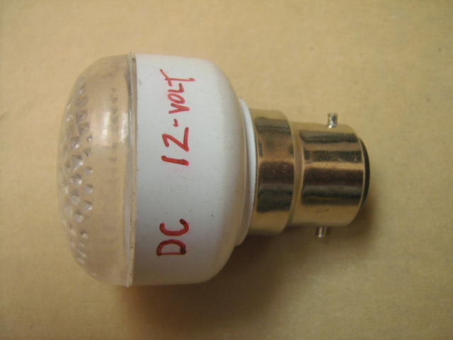 | 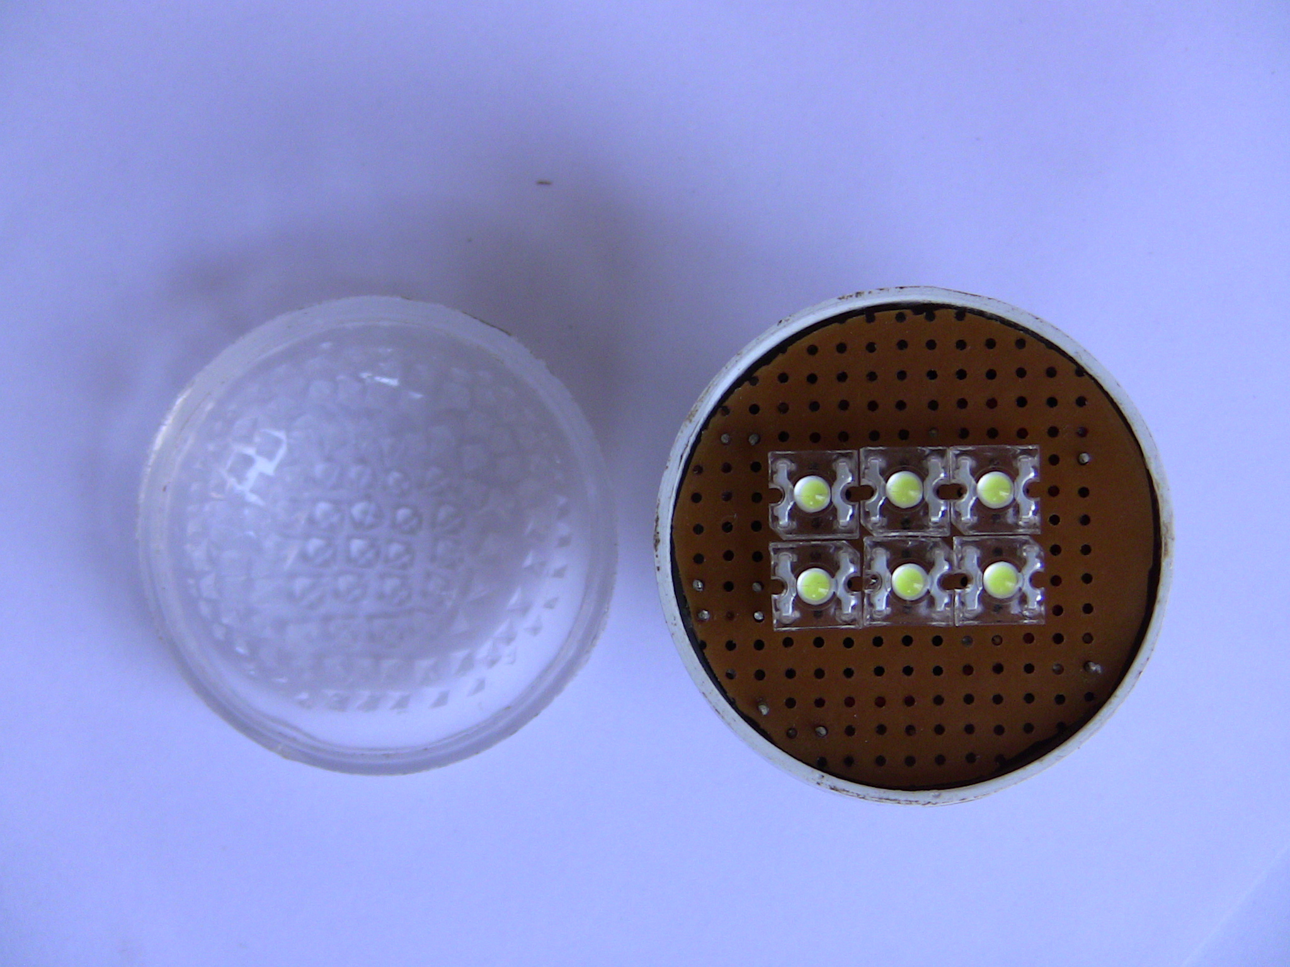
12V DC Bulb

Product Details – 7
Name |  | 6V DC Bulb
Technical Data
 | Dimensions | 35 x 35 x 50mm (L x W x H)
 | Weight | 100 g
 | Wattage | 0.5 watt
 | LED | 6 Super Flux LEDs
 | Light Dispersion | 140 deg
 | Light Intensity | 200 Lux
Technological  Features |  | - Low power consumption
 |  | - White focus provides steady, bright light
 |  | - Easy to fix in DC Holder
 |  | - Durable and compact casing
 |  | - Works on 12V DC
Operating Conditions |  | - 6V DC (83mA minimum)
 |  | - 0°C to 50°C
 |  | - 0.5 Watts/hour

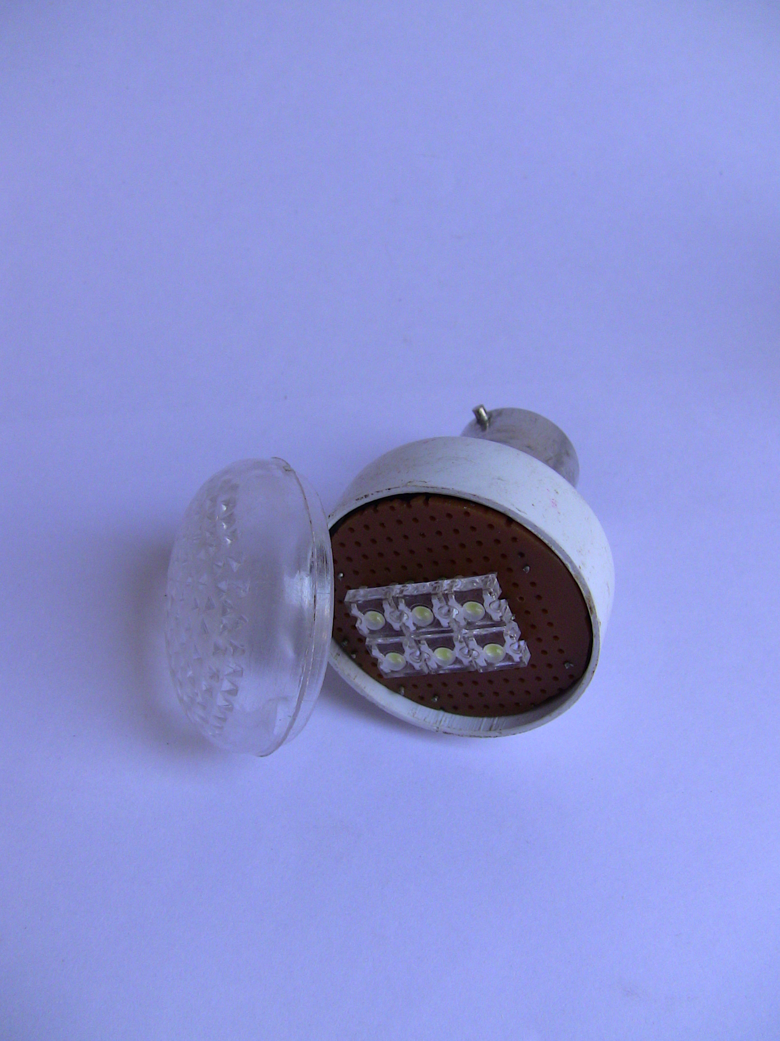 | 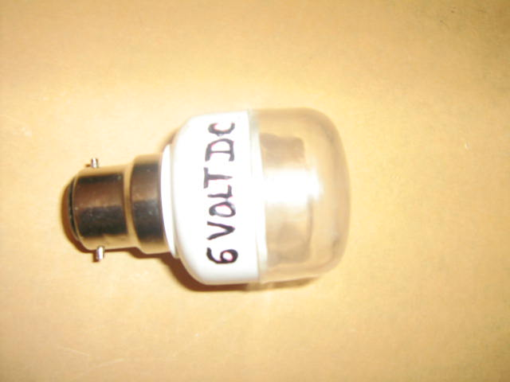
6V DC Bulb

Product Details – 8
Name |  | LED AC Bulb
Technical Data
 | Dimensions | 35 x 35 x 50mm (L x W x H)
 | Weight | 100 g
 | Wattage | 1 watt
 | LED | 6 Super Flux LEDs
 | Light Dispersion | 140 deg
 | Light Intensity | 200 Lux
Technological  Features |  | - Low power consumption
 |  | - LED-usage provides long life without compromising on brightness
 |  | - Useful in areas of low or non-existent light sources,
 |  | - Small white compact casing provides for high durability
 |  | - Can be placed in existing grid without the need for extra batteries
 |  | - Weather and shock resistant for use in harsh environments
Operating Conditions |  | - 230V AC
 |  | - 0°C to 50°C
 |  | - 1 Watt/hour

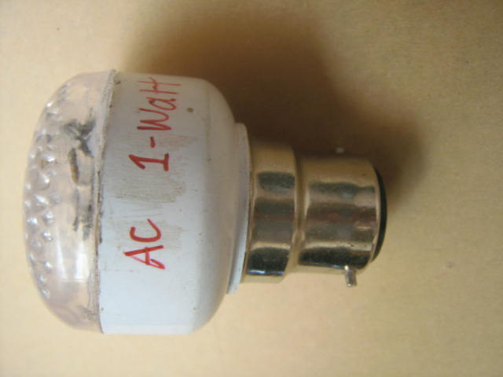
LED AC Bulb

