Lesson 3:Biogas

3.1 Introduction:-
Biogas is generated by the bacteria in cow dung. Cow cut the grass with its teeth. Broken grass is digested in cow’s stomach by bacteria. They broke it into chemicals and gases. The bacteria which come out with the dung continue with the same process, provided they are with condition similar to the cow’s stomach like Light and air have to be excluded and the dung has to be kept at a warm temperature, somewhere between 20ºC and 40ºC. This gives us biogas from the dung.
This kind of bacteria can digest other kind of bio wastes such as kitchen, any material with starch content as well. If solid waste is not disposed properly then it creates problems like increase in infectious diseases, contamination of ground water etc. Eco friendly ways of disposing the waste such as vermin- composting will help for small quantity of waste. Biogas Technology offers dual advantageous; it will generate biogas as source of energy and also provide slurry which is good quality manure. In this lesson we are going to study details of biogas plant.

3.2 Objective:
After completing this unit student will be able to
- Explain the operation of Biogas plants.
- Understand different types of biogas plant
- Maintenance of biogas.

3.3 Biogas Plant :
A typical biogas plant is shown in the figure.

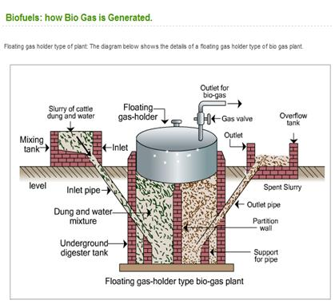

It has following components:

1.Feed Inlet: From where feed is fed into the system
2.Digester tank: Where the feed and water will stay for some and bacterial operation will get completed.
3.Gas holder: It stores biogas generated.
4.Outlet gas: Gas generated is supplied through outlet valve
5.Outlet slurry: slurry is discharged from outlet pipe.

3.4 Based on various designs of digester, biogas are classified as
- Floating Dome type (KVIC Model)

2. Fixed Dome type (Janata Model)

    - Floating Dome type (KVIC) type:

In this model the gas stored in a tank. The tank is floating in slurry.Tank goes up as the gas gets generated and it lowers when the gas is consumed. The size of tank depends on the size of the feed. Normally it is 50 times the amount of feed available per day. For Eg. if 20lits of dung water mixture is put into a plant every day. We need tank of 20 * 50 = 1000 Ltr capacity.
Generally tank is made out of iron sheets. Therefore cost of the biogas goes up. Recently many organizations started using PVC tanks.

Photo of Pabal biogas plant

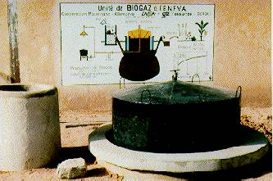

Floating dome

3.4.2) Fixed dome type (Janata Model)
It is built either of cement-concrete or brick-walled. The gas is stored in the upper dome. With increase in gas, pressure in dome rises up. It pushes of the digested material out of the tank. The costs of a fixed-dome biogas plant are relatively low. It is simple as no moving parts exist. There are also no rusting steel parts and hence a long life of the plant (20 years or more) can be expected. Fixed-dome plants are not easy to build. They should only be built where construction can be supervised by experienced biogas technicians. Due to the porosity & cracks gas generated may leak.
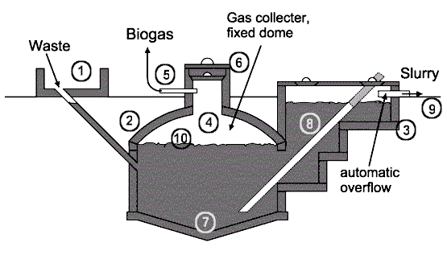
Intext questions 3.1

- Biogas is generated by ----------- present in the cow dung.
- ---------- & ------- are two type biogas digesters available.
- Biogas may leak due to the ----------- & ----------- in the tank.

3.5 Feed:

Following feed is generally used in most of the biogas plant.
- Cow dung
- Human excreta
- Non edible oil cake(like Mahuva )
- Food waste
5. Any material which has starch content

3.6 Biogas generation statistics:

Amount of gas generated changes with the quality and quantity of the feed. For e.g To generate 1cubic mtr. of biogas we need approx 25kg of cow dung. Whereas 3 kg of oil cake also produces 1cubic mtr of biogas.

After installation of biogas plant, the gas productions may take from a few days in summer and 3 to 4 weeks in winter. Initially outlet valve is kept closed to prevent the produced gas from escaping. After few days, formation of bubbles will be noticed in the outlet tank. The gas is allowed to accumulate till it almost pushes the slurry to the level of outlet opening.
The initial gas has more carbon dioxide (CO₂) and less of methane (CH₄).It has oxygen as well as some other gases. This mixture of gases is allowed to escape by opening the outlet.
The gas is again accumulated for 3 days, now the biogas will burn with a blue flame and ready for use. This gas will not have any odor while burning. Proportion of fresh dung and water for feeding is 1:1 i.e. (50% fresh dung(kg) and 50% water (ltr).
Daily feeding of fresh cow dung per capacity of biogas is as below: -

Capacity of Biogas | Required Dung | Water (LTR)
1 M³ | 25 Kg | 25
2 M³ | 50 Kg | 50
3 M³ | 75 Kg | 75
4 M³ | 100 Kg | 100
6 M³ | 150 Kg. | 150

3.7 Biogas constituents –
Biogas is the mixture of gases, consists mainly of methane (CH₄: 60%) and cabon dioxide (CO₂:40%) plus traces of hydrogen sulphide (H₂S) and several other gases.

Biogas may be used in the following three ways:
- Direct combustion for cooking,
- Generation of electricity and
- Purification and export as compressed gas or in liquid form. Just like CNG gas cylinders

3.8 Biogas Stove :
Biogas gets generated at atmospheric pressure hence normal LPG gas stove will not work directly on biogas. You need to remove the pressure reducing pin from the LPG stove to operate the stove on biogas.

3.9Biogas Generator :

Normally 15KW above genset are available in the market which can be directly run on biogas. We can use dual fuel (Diesel + biogas) attachment on any diesel generator, can produce the required power.
Alternatively, if all other gases (Co2 + H2S + moisture etc) are removed from the biogas, then only methane remained. This methane can be compressed and used like Compressed natural gas (CNG) to run automobiles, generator.

Intext questions 3.2
Fill in the blank :

- Biogas is a mixture of …………...and ……………… gases.
- Proportion of fresh dung and water for feeding in biogas is …………
- Daily the fresh dung slurry is added back in biogas plant to maintain the ………………
- 2 M³ biogas requires ……………Kg dung.& …………….Ltrs of water.
- Initially biogas has a bad odor ,due to the presence of …………………gas.
- To produce electrical power,…………. Attachment is used on any ……. Generator.
3.10 Advantages of Biogas-
1. The technology is cheaper and much simpler.
2. Slurry is very good manure and can be used as fertilizer and also in preparation of vermicompost.
3. Waste material is used to generate electricity as well as good fertilizer.

4. The digested material coming out of the plant will not have any odor and there will not be any mosquito/insects breeding on the same.

3.11 Factor affecting production of gas
Temperature – Lower the temperature lesser is the gas yield. If the temperature goes down especially in winter it is advisable to use hot water to make slurry.

3.12 Maintenance tips for biogas plant :
1. We must feed the biogas continuously. If biogas plant shuts down , it will take again 40 days to generate the biogas.
2. Check biogas plant for leakages using soap solution
3. In floating dome type, paint the dome regularly to avoid rusting.
4. Check for any blockages in pipe line etc., frequent observation is must on the regular basis.

3.13 What have you learnt:

In this lesson you have learn
1. What is biogas?
2. Different types of biogas plant.
3. Feed to be used and procedure to use biogas
4. Uses and precautions while maintaining the plant.

3.14 Terminal Questions :-
- Write flow chart of operation of biogas plant.
- Write the major differences between the floating dome & fixed dome
- What are the other feeds used to generate the biogas
- Why biogas can’t work over the LPG stove ? How we can make it to run?
- Why in winter the gas production diminishes?

ANSWERS TO THE INTEXT QUESTIONS 3.1

- bacteria
- floating dome & fixed dome
- porosity & cracks

Answers to In Text Questions 3.2
1)Methane and Carbon dioxide
2)1:1
3)The microbial population
4)50 Kg & 50Ltr
5)Hydrogen Sulfide.
6)Duel fuel , diesel

Suggested Activities 3.15: Visit the near by biogas plant & study the details discussed in the lesson.

