Pressurized Petrol Stove
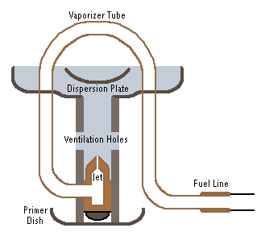 | A pressurize petrol burning stove must be constantly fed fuel and may be fed fuel by gravity (tank mounted higher than stove jet), via a pressurized fuel tank (hand pump or self pressurized via thermal feedback), or by a capillary jet or electric pump.  The first step for most backpacking petrol stoves is to pump up your tank to pressurize your fuel.
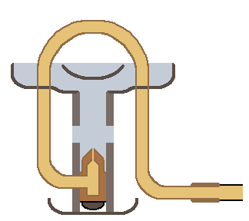 | Open the flow valve a bit to allow fuel to flow out of the tank and into the jet.
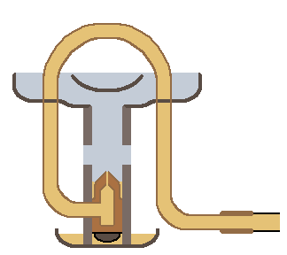 | Allow a little fuel to spill onto the primer dish or wick, then shut off your valve.  If you are using kerosene, diesel or another oily fuel, you may want to use alcohol or primer paste to preheat your stove to decrease the amount of soot.
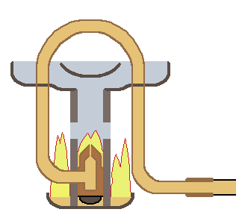 | Light your stove and wait for it to heat up the fuel line.
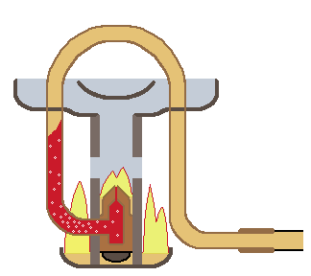 | As the fuel line heats up, the liquid fuel will likewise heat up and begin to boil and vaporize.
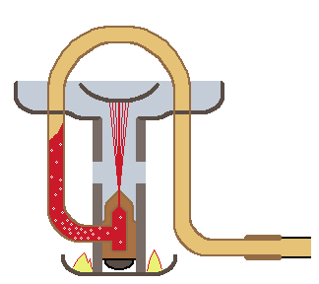 | When the preheat fuel is just about out, turn on your fuel valve. Vaporized fuel will be forced out of the jet and into the flame dispersion plate.
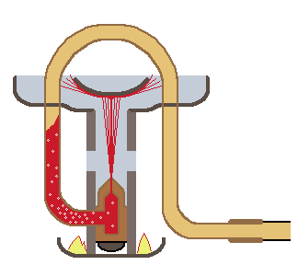 | There are various designs for the dispersion plate, each with the purpose of spreading out the jet and stopping it from just going straight up in the air.
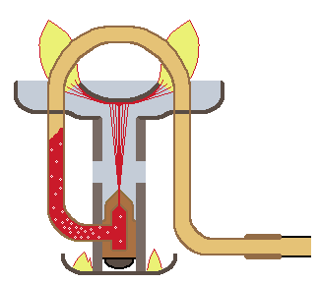 | The atomized fuel vapor is ignited by the primer flame, or with a match.
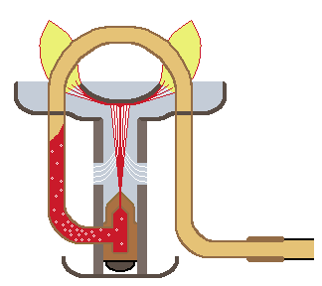 | The fuel jet and burning fuel creates an updraft that pulls in air from the ventilation holes just above the jet.
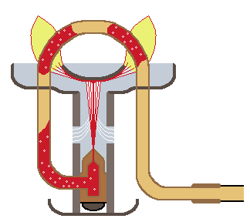 | The oxygen rich fuel heats up the fuel line running over the flame, vaporizing more fuel. The fuel line that passes over the flame is often referred to as a generator tube, primer tube, or a vaporizer tube.
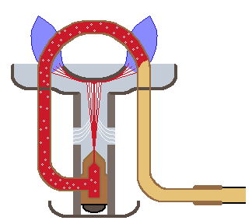 | Once the stove gets going, it continues to feed itself hot vaporized fuel mixed with cool oxygen from the vent tubes. If the fuel doesn't completely vaporize, you will end up with incomplete combustion, yellow flames and possibly a clogged jet.
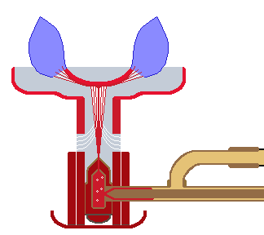 | Note - Some petrol stoves don't have a vaporizer/generator tube and rely on the stove to heat up enough to keep the incoming fuel vaporizing near the jets. This is the case with most petrol stoves that have a second valve near the jet, designed for better fuel control and simmering.

