

Module III: Energy & Environmental Services
Lesson 8: Survey Techniques

Topic : Leveling

2.1 Introduction:
It is very common, in our daily life to measure the difference between heights of two or more sights, points or spots. Sometimes we have to mark on the ground same points of same height. For example, If we want to built house on sloping side of hill, then we have to mark point of equal-altitude.
Similarly when we build cannel in farm, we need to check proper slope so that water will flow easily by gravity. We also check slope, while transporting water from one spot to other. Water conservation works are carried on the on barren sloppy land. Trenches and bunds are constructed on the slopping land. They constructed on the point of same height. “The imaginary line joining all points of the same point on the ground is called as contour line”. Also we will learn about leveling, different types of instruments used for leveling and drawing of contour lines.
2.2 Objectives: After the completion of this lesson you will be able to:
* Understand the use of instruments like spirit level, leveling tube, Dumpy Level.
* Apply the method to mark Contours for a small watershed and check dams.

2.3 Leveling:
“Leveling may be defined as the art of determining the relative heights or elevations of points or objects on the earth’s surface”.
Following are the instruments used for leveling:
a) Spirit-level –
A bottle contain spirit as a liquid with an air bubble. When air bubble is at the centre of two lines, the bottle is on perfect level. If the bubble is not in the center then tripod screws are adjusted to bring the bubble exactly at the center.
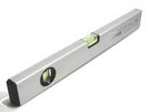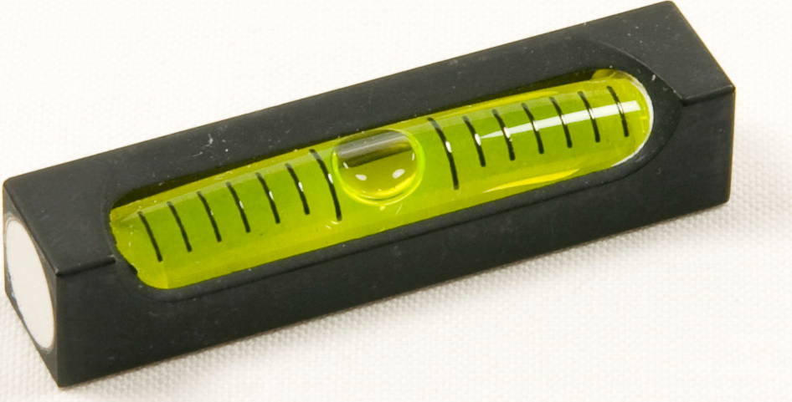

b) Level-tube:

(Image of the level tube)

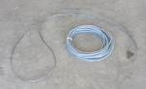

Water has a property, which always remains at the same level. This principle is used in level tube. A transparent water-filled plastic long tube is taken. When we hold two ends of tube at any distance water level at both ends , shows equal height.
During construction, level tube is used, to equal all sides of the wall at same height. The level tube along with scale can also be used to find out height difference between two spot.

C) Dumpy Level: : 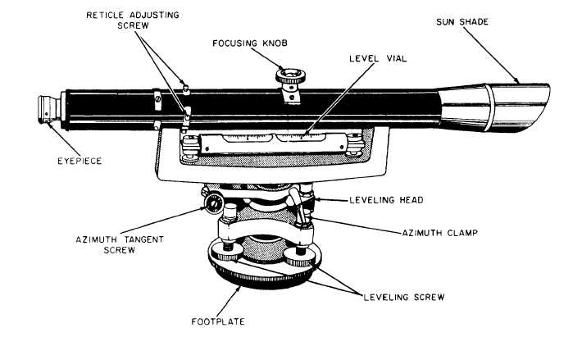
Fig. of Dumpy Level

Dumpy level has an eyepiece , spirit level and three leveling Screws as well as a focus for the telescope lens – quite often the base has a 360 degree compass. This instrument is used while surveying. Using spirit-level-bottle telescope is adjusted to plane level. In this condition all spots look at equal height.

The dumpy levels have perpendicular cross hairs. There are the two short cross hairs above and below the main cross hair.

Upper Reading

Middle Reading

Lower Reading

The difference between upper reading & Lower reading is multiplied by 100 to give you the distance from where you are to where the staff is
Example:
Upper Reading : 2.218
Lower Reading: 2.163

Distance between Staff & Dumpy level

= (Upper Reading - Lower Reading ) x 100

= (2.218 – 2.163) x 100

= 0.055 x 100= 5.5m

Distance between staff & Dumpy Level = 5.5 metres

Dumpy-level will have compass to show direction. With dumpy-level and staff, height, direction and distance can be measured at a time and we can draw map and contour.

2.4 Dumpy Levels can be used for:
- Determining the height of a particular point.
- Determining differences in height between points.
- Drawing contours on a land.
- Providing data to calculate volumes for earthworks.
- Setting out level surfaces for construction.
- Setting out inclined surfaces for construction.

Intext questions 2.1:
  - To check the level of the surface ………….. instrument is used.
  - To determine the height between the two points …….. is used.
  - Water always remains in ------- level.
  - A meson always use a ……………… for brick construction.

2.5 Measuring height using Dumpy Level :
- The place of which height is to be measured is called Station.
- Height is always measured with reference to sea level.
- Survey of India established benchmarks (B.M) at several places.
- Ideally the distances should be taken from the benchmark.
- If it is not available then we can select point on the map whose distance from sea level is known as the reference.
- We can fix any suitable point as Temporary bench mark and all heights can be measured from that point. We can fix any temporary bench mark , but if its MSL( at temporary BM) is not sure , then before starting the surveying permanent BM reading should be clear.
- Now we will learn how to take actual readings. Please observe below figure carefully .
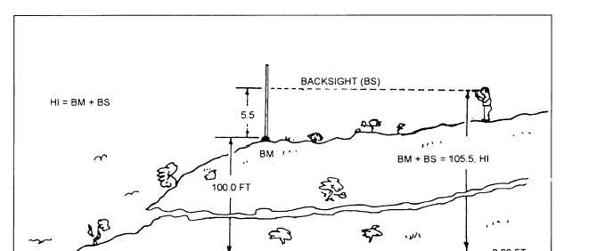

HI= BM+BS BACKSIGHT(BS)

- In the picture Bench mark is setup at a height of 100 ft.
- As a first step we need to know the height of the place from where instrument is placed. In the picture, a boy is standing on a place from where survey will begin.
- To know the height of the instrument place a staff or level rod at bench mark location. And from the instrument take the reading on the staff. In this case reading on the staff is 5.5ft . This reading is called as backsight reading (BS).

Height of the instrument = BM + BS
= 100 + 5.5 = 105.5 ft.

Now surveyor can go ahead and determine heights of other places. Look at the following figure to take further reading. These readings are called as foresight reading (FS):

HI+FS=ELEVATION FORESIGHT(FS)

Now staff or level rods are put on the point (D) height of which is to be measured. The reading on the staff is recorded through telescope of dumpy level.
In present case the reading shows 2.3ft. This reading is called Forward site ( FS)
Therefore height of point D is calculated as follows
Height of point D = Height of Instrument (HI) – FS
= 105.5 – 2.3
= 103.2 ft

Distance between the instrument and the station D can be measured using meter tape or from the difference between upper & lower readings on the telescope.

IN TEXT QUESTIONS 2.2

Fill in the blanks.

1) …………. is the lowest level of the earth.

3) Dumpy level survey measurements starts from a …………….

4) HI= BM+BS ( True / False)

5) Elevation=HI +FS( True / False)
2.6 Change Point
If the area is hilly then you may not able to cover all points from one place. In such cases instrument is shifted to the convenient place. Height of this new station is measured from the existing location before shifting the dumpy level.
New readings are for fore and back sights are taken.

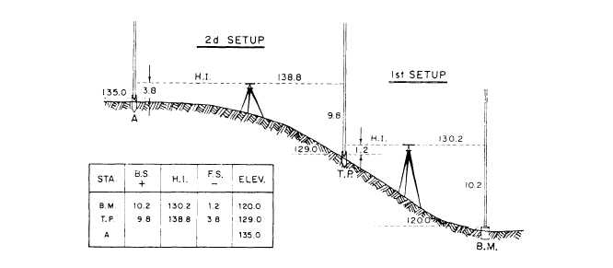

Station +BS HI FS Elevation
BM  120ft | 10.2 ft | 130.2ft | 1.2ft | 129ft=TP
TP=X  129ft | 9.8ft | 138.8ft | 3.8ft | 135ft=A

BM-Bench Mark, TP-Temporary Point

2.7 Drawing contour lines
All points of same heights are join together to draw a contour. For Eg. a survey of plot of 120m. X 100 m. is done and heights are measured at different points as shown in the following chart.

2.8Uses of the contour lines:
- To estimate the water storage capacity, back water limit and max . water storage level of the dam.
- Volume of the proposed excavation wok,
- To decide whether certain location is visible from another location,
- To decide exact line of railway or road way haing safe slope,
- To determine the ground water level from contours of ground water.

2.12 WHAT YOU HAVE LEARNT

In this lesson, you have learnt about need of leveling. Different instruments used for leveling and determining height of a place. We also learn how to determine height of a place and draw contour.

2.13 TERMINAL QUESTIONS:
Give brief answers to following.
  - What are the uses of a dumpy level?
  - How to draw a contour?
  - How to fill a level tube with water & how to use a level tube?

ANSWERS TO INTEXT QUESTIONS 2.1
      - Level tube / spirit level
      - Dumpy Level
      - Same
      - Level tube
ANSWERES TO INTEXT QUESTIONS 2.2
1.Sea Level
2.Partcular point
3.BM ( Bench Mark)
4.Level Tube.

2.14 Suggested Activity.

A dumpy level survey is done and following contours are drawn. Give answers to following questions ( fig from IBT Xth std Page 34) Q3

- What the contour indicates ? Is it a peak or a valley ?
- What is the height of point A
- What is the difference in height of point B and D ?
- Which is the highest peak ? What is its height ?
- Which is the point on the lowest height ?

