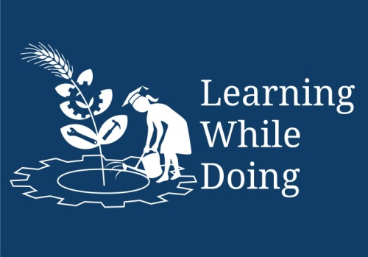

Module III: Energy & Environmental Services
Lesson 8: Survey Techniques

Topic : MAPS

Introduction :

Map is a picture of Earth’s surface. Mountains, valleys, rivers and sea etc are shown in it along with Houses, roads, temples, railway routes etc are also shown in it.
. The information, which cannot be given in words, can be expressed in brief through maps. Even those, who are illiterate, can read & understand maps. Language of drawing and reading maps is common all over the world. Oldest maps available are from middle Asia.
They are over 5000 years old. Around 2000-2500 years back Greek people had tried to draw world map. At the end of first century, a scientist Tolemi wrote a book “Geographia”. He introduced the terms latitude and longitude. He also discussed the method of showing rounded surface of the earth on plane paper.
Why people in ancient period needed maps? Since beginning man is a vagabond. He realized importance of the notes of the information where he had traveled, what he saw in those places. He found this information is useful to him and other people in future. Use of maps was started from these needs. Government needs these maps to decide the ownership of a place and to levy taxes.

Importance of maps
- To understand roads and subways at new places.
- To calculate distance between two places.
- To know whether there are two or more paths to the same place and which is shortest.
- We can get the information about mountains, river, valley or any other thing, which may come on the way, and we can prepare for that.
- We can get the information like height of the place or the up and downs on the road.
- Boundaries of the land to define ownership.
- Places like houses, farmhouses, mines can be shown on the map.
- We can also mark crops, weather reports, direction of wind, the ratio of rain on the maps.
- Government needs the map to keep the record of the owners.

Who makes the maps?
In our country the responsibility of making maps is given to an organization ‘Survey of India’. This organization made the maps of whole India by making survey for over more than 100 years.
In the past big maps (village or taluka places) were with the scale 1” =1 mile or 1”=1/4 mile. At present , we get the maps to scale 1:25,000 or city map with scale 1:10,000. The small scale maps(Means map giving the information of large places) are made with scale 1:10,00,000 or 1:25,00,000. The 1:6,000 maps are used to show ownership of the land and its boundaries.

Technical terms related to Map
Following are the technical terms used in the map.

1. Scale:
Maps are always to the scale. This means there is a fixed relationship between actual distance or shape and distance or shape on the map. The actual distance is in multiple of the distance taken on the map; this is called as scale of map.

The scale is described in terms of 1:25000. This means 1cm distance on the map is equivalent to the actual distance of 25000cm (250 meter). If we know the scale of the map then we can calculate distance between two places.

2. Direction
North direction is marked in the map. Generally it is on the upward side. Other directions are known from this. Following symbol is used to show north direction.

mention the other directions.
N
3. Symbols
Following symbols are used on the map
Water( symbol) is required.
Road
Train
River
Bridge

4. Longitude and Latitude

Types of maps
Following are types of maps depending on their uses
- Political map
- Geographical map
- Descriptive map
- Statistical map

In Text Questions

1) Study map of India and your state. From the map calculate distance of your town from Delhi.
2) What are the longitude and latitude of your town. Find out from the map.
3) Please observe contours of hill ranges (Viz Sahyadri, Himalaya etc) on the map.

Use of contour :
In real life, often we need to measure difference between two heights. For e,g
  - To level land for construction or for agriculture.
  - To design pipeline for taking water from one level to other etc.
  - To construct road etc.
  - To decide on site for dam or water storage.

Summary :
In this chapter we have learn about map, different symbols used in the map, contours on the map. We also studies different uses of maps and contours.

