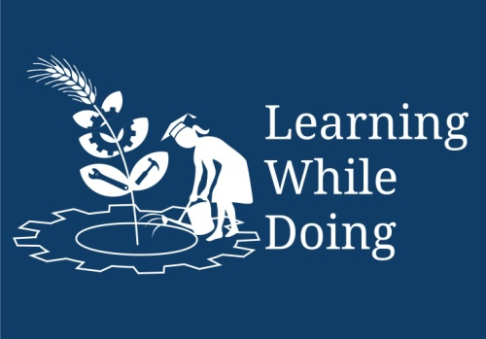

Module III: Energy & Environmental Services
Lesson 8: Survey Techniques

Topic : Plane Table Survey & Maps

  - Introduction :
Map is a picture of Earth’s surface. Mountains, valleys, rivers and sea , along with houses, roads, temples, railway routes etc are also shown in it. In this chapter we are going to learn about the Importance about the maps, technical terms of, symbols, types. Also we are going to learn how to draw the maps? Along with that we are going to make the real dimensions and computing the area with the help of plane table instrument.
.

1.2 Objectives:- After the completion of this lesson you will be able to ,

- understand what is map, its importance.
- Know the types , symbols used etc.
- the understand the application of different instruments used in plane table survey.
- understand, how to draw a map with real dimensions.

1.3Maps:
The information, which cannot be given in words, can be expressed in brief through maps. Even those, who are illiterate, can read & understand maps. Language of drawing and reading maps is common all over the world. Oldest maps available are from middle Asia.
They are over 5000 years old. Around 2000-2500 years back Greek people had tried to draw world map. At the end of first century, a scientist Tolemi wrote a book “Geographia”. He introduced the terms latitude and longitude. He also discussed the method of showing rounded surface of the earth on plane paper.

Why people in ancient period needed maps? Since beginning man is a vagabond. He realized importance of the notes of the information where he had traveled, what he saw in those places. He found this information is useful to him and other people in future. Use of maps was started from these needs. Government needs these maps to decide the ownership of a place and to levy taxes.

1.4 Importance of maps :
- To understand roads and subways at new places.
- To calculate distance between two places.
- To know whether there are two or more paths to the same place and which is shortest.
- We can get the information about mountains, river, valley or any other thing, which may come on the way, and we can prepare for that.
- We can get the information like height of the place or the up and downs on the road.
- Boundaries of the land to define ownership.
- Places like houses, farmhouses, mines can be shown on the map.
- We can also mark crops, weather reports, direction of wind, the ratio of rain on the maps.
- Government needs the map to keep the record of the owners.

Who makes the maps?
In our country the responsibility of making maps is given to an organization ‘Survey of India’. This organization made the maps of whole India by making survey for over more than 100 years.
In the past big maps (village or taluka places) were with the scale 1” =1 mile or 1”=1/4 mile. At present , we get the maps to scale 1:25,000 or city map with scale 1:10,000. The small scale maps(Means map giving the information of large places) are made with scale 1:10,00,000 or 1:25,00,000. The 1:6,000 maps are used to show ownership of the land and its boundaries.

1.5 Technical terms related to Map

1. Scale:
Maps are always to the scale. This means there is a fixed relationship between actual distance or shape and distance or shape on the map. The actual distance is in multiple of the distance taken on the map; this is called as scale of map.

The scale is described in terms of 1:25000. This means 1cm distance on the map is equivalent to the actual distance of 25000cm (250 meter). If we know the scale of the map then we can calculate distance between two places.

2. Direction
North direction is marked in the map. Generally it is on the upward side. Other directions are known from this. Following symbol is used to show north direction.

N

W E

3. Symbols
Following symbols are used on the map
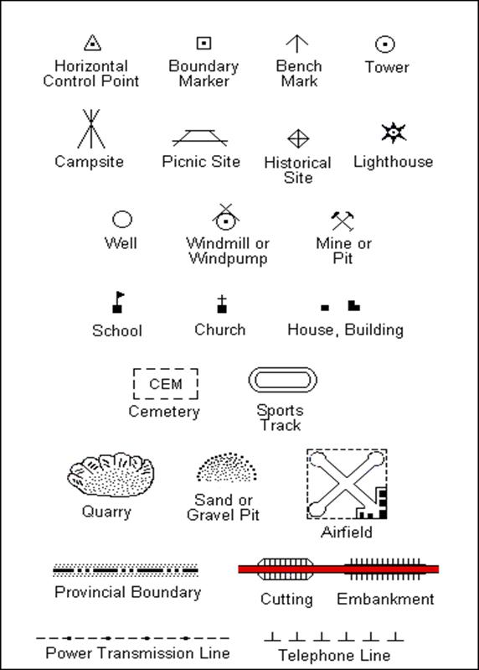

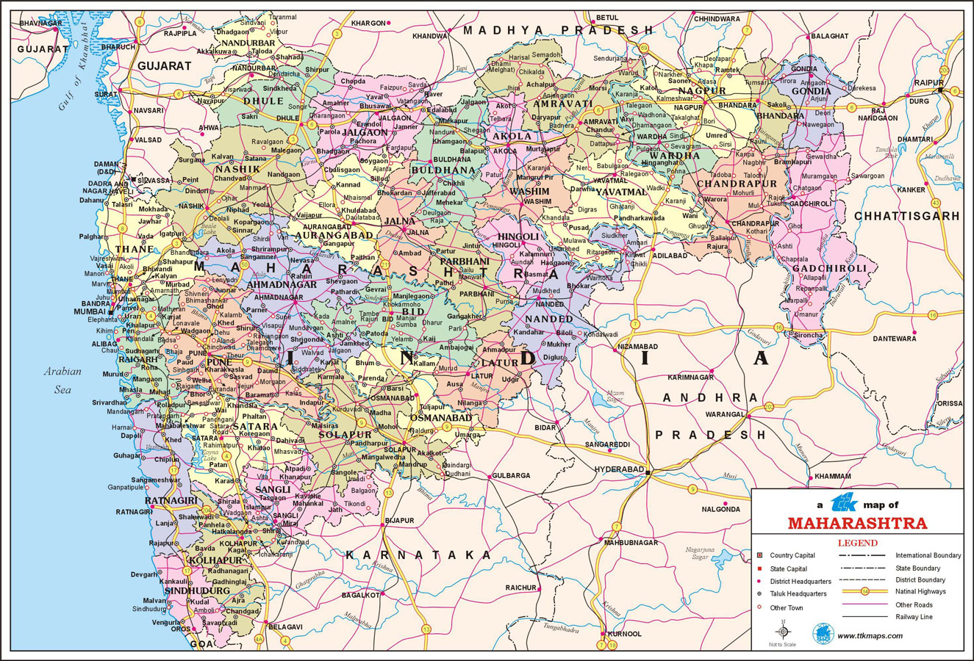

4. Longitude and Latitude

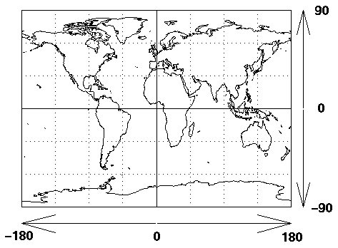

Latitude is measured from the equator, with positive values going north and negative values going south. Longitude is measured from the Prime Meridian (which is the longitude that runs through Greenwich, England), with positive values going east and negative values going west. So, for example, 65 degrees west longitude, 45 degrees north latitude is -65 degrees longitude, +45 degrees latitude.

1.5 Types of maps
Following are types of maps depending on their uses
- Political map
- Geographical map
- Descriptive map
- Statistical map

Intext Questions 1.1

1) Study map of India and your state. From the map calculate distance of your town from Delhi.
2) What are the longitude and latitude of your town. Find out from the map.
3) Find the shortest distance between Mumbai & Delhi

1.6 Surveying:
“Surveying is an art of making measurements on the surface of the earth. Plane Table is a graphical method of surveying in which the field works and plotting is done simultaneously”.

1.7 instruments are used for plain table survey:
- The Drawing Board: The board is made of well-seasoned wood such as teak or pine and varies in size from 16’’ X 12” to 18” X 24” rectangular. It is mounted on a tripod in such a manner that it can be leveled, and revolved about a vertical axis and clamped in any position.

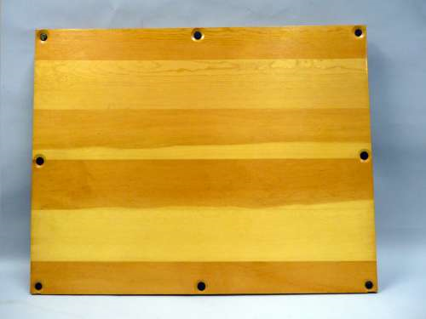

2) The Alidade:
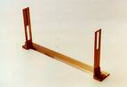
The alidade consists of a metal ruler about 18” long. It has rectangular holes with a fine wire held vertically in the opening. While using the alidade, the user sights an object and lines it up with the wires in each vane.

3)A trough compass is for marking on paper the direction of the magnetic meridian.

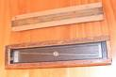

( fig of the trough compass)

4)A plumbing fork with a plumb bob for centering the table.
( fig of the plumbing bob )



5)Tripod : A tripod is a three-legged stand for a drawing board , used to stabilize the drawing board. 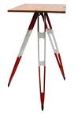
6)Other items: Paper, Pins, Pencil , Rubber , Scale etc.

Assembled image of plane table & instruments
1.2In text questions:
Match the pairs

1 .A tripod A).centers the plane table.

2. An Alidade B).To measure distance between the plane table and razing rod.

3. A plumb bob C). To stabilize the drawing board

4. A meter tape D). A sighting apparatus

1.8 How to use the plane table:
We are now going to draw a map of school ground.

The following operations should be performed while setting up the table at a station.
Initially select a point from where all points will be seen.
- The legs of the tripod should be spread well apart, and firmly fixed into the ground.

- Centering of the table is done by using plumb bob. If no plumb bob is available, centering of the table may be done by dropping a stone from a point on the underside of the board which is directly under the point on the paper.

- The table is then leveled by means of the leveling screws with reference to the level tube or spirit level, placed on the table first parallel to the two screws and then over the third screw.

1.9 Precautions while drawing the map:
Following precautions need to be taken.
- The board is not being horizontal.
- The table not being accurately centered.
- The table not being correctly oriented.
- The objects not being sighted accurately.
- The alidade not being correctly centered on the station point.
- Inaccuracy in plotting.
- The expansion and contraction of the paper.

1.10 Advantages of Plane Table survey:
- It is most suitable for preparing small scale maps.
- It is most rapid.
- It is less costly than a theodlite survey.
- No great skill is required to prepare a satisfactory map.

1.11 Disadvantages of Plane Table survey:
- It is heavy to carry.
- It is not intended for accurate work.

