Manual of Wearable Rakhi

Raksha Bandhan
Raksha Bandhan is a Hindu festival, celebrated in many parts of the Indian subcontinent, notably India and Nepal. Raksha Bandhan means "bond of protection". It is observed on the full moon day of the which typically falls in Gregorian calendar month of August.
Objective
- 2d designing and laser Cutting
- Basic Knowledge of Electronic
- Introduction of Electronic Components.
Step by Step Process.
Step 1: Material required
- Electronic Material –
Sr.no | Component Name | Function | Photo
1 | LED | emits light when current flows through it. | 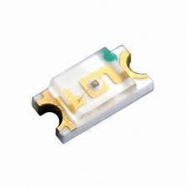
2 | Resistor | resistors are used to reduce current flow, adjust signal levels, to divide voltages, bias active elements, and terminate transmission lines, among other uses. | 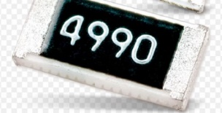
3 | Button cell | Button cells are used to power small portable electronics devices | 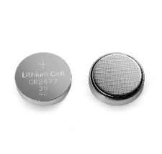

- Decoration Material
- Velvet/Fancy Cloth for decoration
- Designing Thread

- Tools Required
- Glue gun
- Scissor
Step 2: - Start to make design
In Rakhi festival we can made different types of rakhi from paper, designer cloths, etc. Here I am using laser cutting machine so refer Acrylic Material. Before cutting I started to make a design using Corel draw software
I Started to make models. So, to make this download Smiley face design (Vector graphics image) from internet which needs to be suitable for your rakhi. Now import that downloaded image into either Inkscape or Corel draw software to make this laser cut file and for additional improvements. Here I used Corel draw.
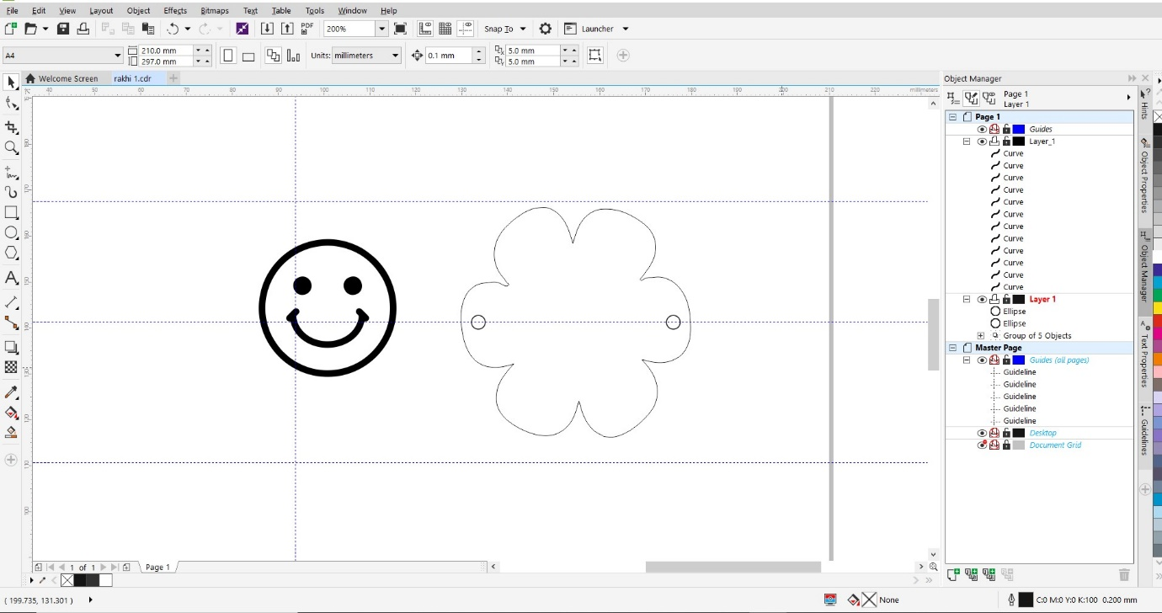
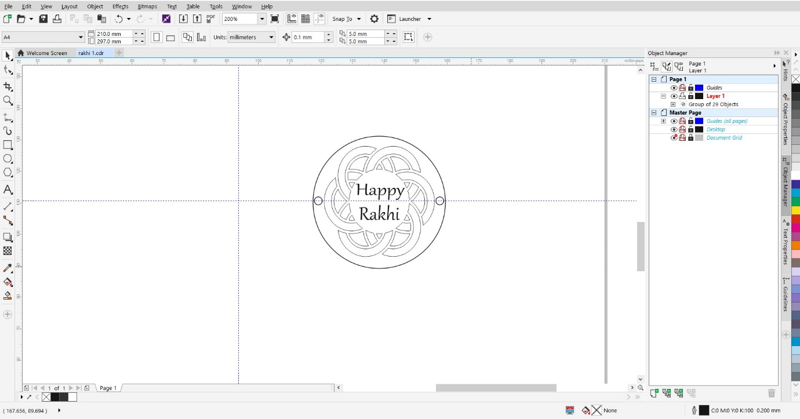
Step 2: - Cut designs on Laser
Import exported DXF file in laser machine software. Here I’m used SIL laser cutter with RD works software. Now arrange it properly and give it to laser cutter to cut on 2.5mm Acrylic sheet. Make your parts ready for assembling.
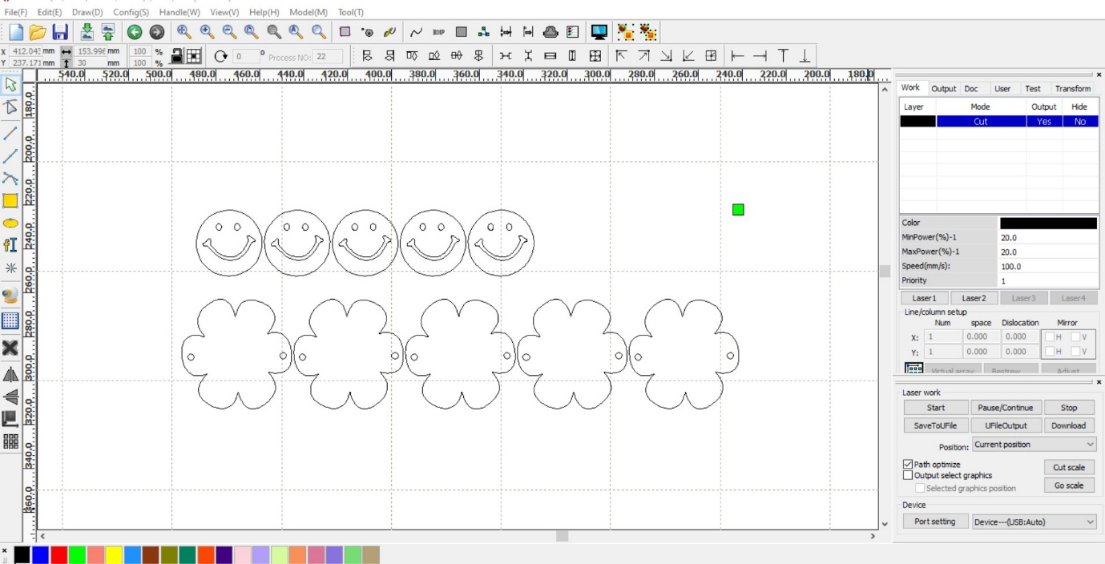
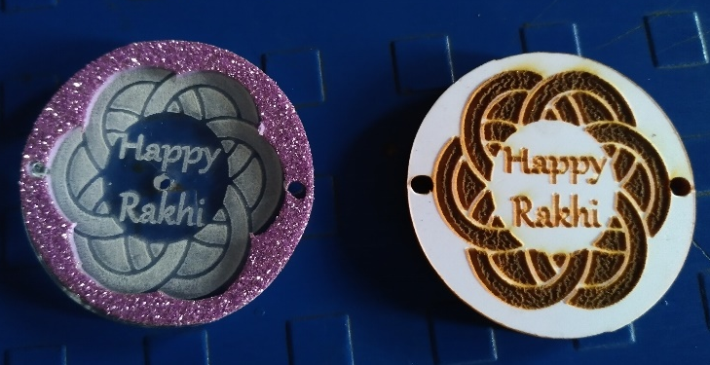
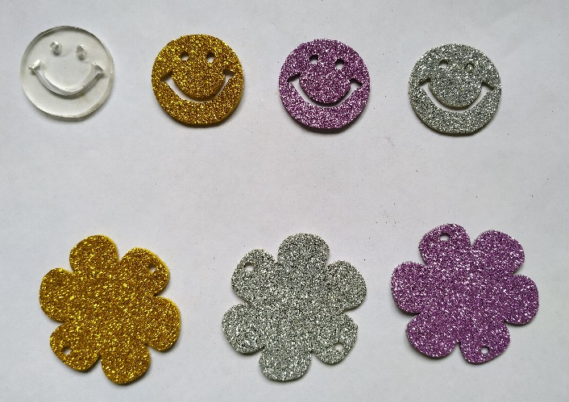Step 3: - Electronic Parts: -
In Electronics I used 2smd LED,4990ohm resistor and Button Cell for Supply. Here I draw circuit diagram for Connection.
Circuit Diagram: -
GND

VCC
GND
LED 2
LED 1

GND
4990 Resistor
Button Cell

- Connection: -
- Connect LED 1 Positive to LED 2 Positive.
- Connect LED 2 Negative to LED 2 Negative.
- Connect Resistor one side to LED Positive.
- Connect Resistor another side to Button Cell (Positive).
- Connect LED Negative to Button Cell Negative.
Let’s start assembling laser cut parts and electronics part together.

Step 4: - Decorate Your Rakhi
For decoration you can use any type of decorative material. here I used decoration lase and Shiny Crafting Paper to decorate Rakhi. hangers and for border decoration.
