Lesson 3
MACHINES

Introduction
Machines became part of our daily lives. They help us to do work easily. Scissors, brakes, pulley, hears, screw jack etc. all are examples of machines. Machines help us to reduce efforts required to do the work. They have few or no moving parts. These machine uses energy to do work. A simple machine is a mechanical device that changes the direction or magnitude of a force. In this chapter, we are going to study six simple machines. All big complicated machines are based on the combination of these simple machines. To increase the efficiency of our work, we need to reduce friction. We will also learn about friction and lubrication in this lesson.

Objective
In this chapter, you will able to know about principles of simple machines, different types of simple machines such as lever, slope, wheel, pulley, screw. We will also learn about friction and lubrication.

Principle of Simple machines
Consider following examples -
1) We can put force or pressure with hands at a single spot at a time. But with the help of machine we can put pressure or force at different spots at the same time.
Example No- 1 – Bicycle.
When we apply pressure on brakes on handle, with the help of machine, the brake works on the both sides of rims of the wheels.
Example No- 2—Churning Butter-milk.
At the time of churning cream or butter-milk, we apply pressure on the rope with two hands but the pressure is spread on every part from bottom of the churn.
Thus the power is transferred from one spot to another easily with the help of machine.

2) By changing, place of application of the force, we can increase or decrease the force required. Remember we cannot reduce energy required to do the job but we can reduce the force required. If more force is applied, we can do the work in smaller time. If force is less then we will need more time to do same amount of work.

Power = force X speed

Work = force x distance.

work force x distance
Power = ------------- = ----------------------- = force x speed.
Time time

We can increase and decrease Force, distance, time and speed by changing other parameters using simple machines.

Example :
1) Two tank of 50 lits is to filled with water. One tank was filled by father and another by his younger son. Father used water bucket of 10lits and son uses water bucket of 5 lits capacity.
Father makes 5 trips to fill up the water and son makes 10 trips to filled the tank. Energy required by both is the same. But since son could apply smaller force, he chooses 5 lits of bucket. Hence distance traveled by him increased.

2) While churning the milk, we increase the speed. The churn moves faster than the shaft where we wind the rope. It is because churn is bigger in diameter. We need to churn milk with more speed , therefore we reduce the force and increases the speed of churn.

Intext question 3.1
i) ………… required to do the work remains the same.
ii) Work = force * ……….
iii) Unit of work = ……….
iv) There are ……… types of simple machines.

Simple Machines
Main types of simple machines are 1) Lever 2) Slope 3) Wheel 4) Pulley 5) Wedge 6) Screw. We will study them in details.

1) Lever : A famous scientist Archimedes once said, ‘Give me big rod and a point to rest it in the space, I will able to move earth alone’. A big rod and point to rest the rod is nothing but lever. A bar is called lever and turning point is called the fulcrum. An object that a lever moves is called the load. The closer the object is to the fulcrum, the easier it is to move.
There are three types of levers.
- Class 1 : the fulcrum is located between the applied force and the load.
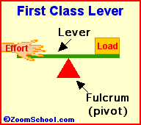

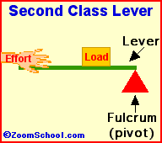
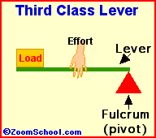
Fig. _______

- Class 2 : the load is situated between the fulcrum and the force

- Class 3 : the force is applied between the fulcrum and the load.

Following are examples of lever in daily life.

a) A lever is used to move rock or heavy object.
To move load from one place to other. Closer the object from fulcrum, less effort is required. (fig. 2)
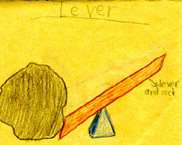
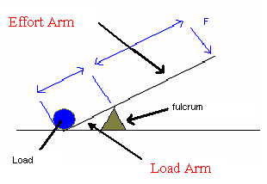
Fig.2
b) See Saw - Sea saw is another example of use of lever. In see-saw, fulcrum is at the center. Therefore it require efforts equal to load. Therefore we can enjoy playing it.
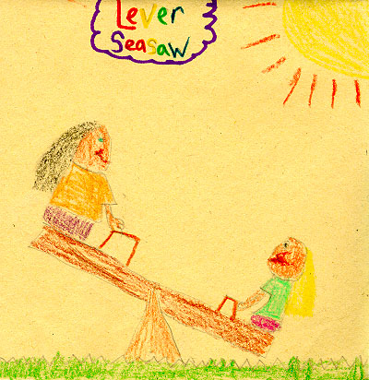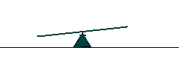
Fig.3

2) Inclined plant or Slope – This is another simple machine. You can use this machine to move an object to a lower or higher place. You will need less force to move objects with an inclined plane. Observe the fig 4(a) and (b). In fig.4(a), more effort is required to lift the load. In fig 4(b) when slope is used, we need less effort to move the load but distance traveled will be more.

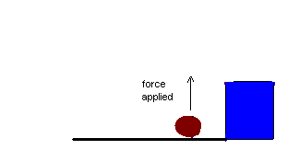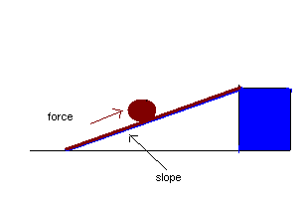

Fig.4 (a) Fig.4 (b)

Intext questions 3.2
i) Ramp near big warehouses are made using ________ type simple machine to reduce force required to move object.
ii) In stapler , _________ is in between _______ and fulcrum.
iii) In Barbers scissors , _______ is in between load and _______.

3) Wheel and Axle

The wheel and axle is another simple machine. The axle is a rod that goes through the wheel. This makes it easier to move things from one place to other.
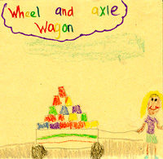
Fig.6

4) Pulley
A pulley is another simple machine. It is made of a wheel with a groove between two flanges around its circumference. A rope, cable or belt usually runs inside the groove.
Most common example of pulley is to fetch water from the well. Pulleys are also used in cranes to lift load. Pulleys are also used to change the direction of force to transmit rotational motion from one wheel to other.
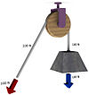
Fig.7

5) Wedge - Have you seen how wood cutter cuts big wood apart ? He uses tool called as wedge. A Wedge is a simple machine used to push two objects apart. A wedge is made up of two inclined planes. These planes meet and form a sharp edge. This edge can split things apart.

Knife, axe, nail etc are example of wedge. Fork spoon used to cut food item is also example of wedge.

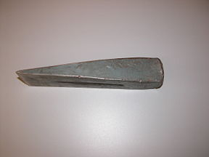
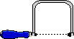
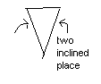
fig. 8

Screw

A screw is nothing but an inclined plane wrapped around a rod.
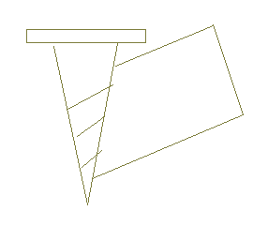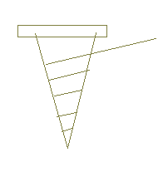
Fig. 9
Take a paper or thread as shown in the figure __ and wrapped it around a bar, then it becomes screw. Screws are used to hold the job together. They are used to lower or raise the job. Following are some examples of uses of screw:
- Jar Lids ii) Clamps iii) Jacks iv)Wrenches
Screw Jack :
Have you seen one person raising a car or truck with the help of jack to repair tyre. He uses jack to raise the truck. Jack mainly uses principle of screw.
We have seen work done = Force * Distance
We will need lot of force to lift the vehicle directly. It is impossible for a man to lift truck vertically up against gravity. When we uses jack, it has a screw. The load has to travel through length of thread. This means we are increasing distance to be traveled. This reduced the force required and a normal person can lift the vehicle using jack.
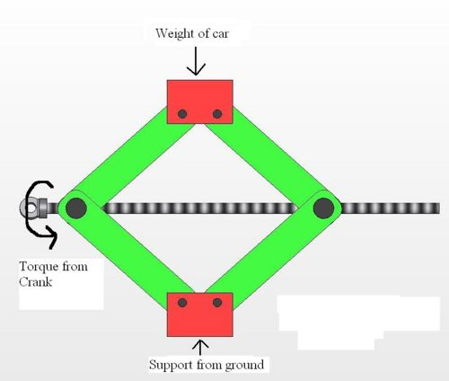
Fig.10

Gears
A gear has teeth cut on the circumference of wheel. It is used to transmit the motion, increase or reduce the speed. We can apply more force by reducing speed by selecting gear with bigger diameter. Bevel type gears are used to change direction of motion.
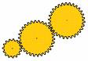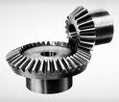

Fig. 11

Mechanical Advantage

Mechanical advantage is the ratio of output force to input force.
Output force
------------------------------------------- = Mechanical advantage
Input force

Efficiency
When moving parts move on each other, some energy gets lots in overcoming friction. Therefore power output by the machine is always less than the power input. Lesser is the energy wasted, more is the efficiency.

Power output of machine useful power
Efficiency = ------------------------- -------- = --------------------------------
The power we put in power put in

Intext questions 3.3
i) Match the following
A B
Scissors Inclined plane
Lifting pump from borewell Screw
Wood cutting axe Lever
Hilly road Pulley
Jack Wedge

ii) Fill in the blanks
i) In hand drill, _____ types of gears are used.

ii) Efficiency = --------------------
Power Input

iii) In slope, force required is reduced because _____.

FRICTION AND LUBRICATION
Some times there is screeching sound while using a pulley or hand pump.
Friction is a force. Whatever work we do, friction works opposite to our
Force. When we apply a force to move some thing, the friction opposes our
force and there is no motion. When our force is greater than the friction
force, the object starts moving. The parts where there is friction, wear out
fast.
A smooth surface shows lots of uneven and rough surface under a microscope.
When these rough parts rub on each other, it results in friction.
Oiling and greasing reduces friction and wear & tear of parts. When there is dust or foreign particles in the area of contact, friction and wear are high and rapid To prevent this, we must first clean the friction area and put oil or grease there.

Advantages of friction
Friction is not always bad. Sometimes we require friction. For example
1) While walking friction helps us. If we put oil on the floor, we will fall down due to slippery floor. We need friction to be able to walk.
2) It is commonly seen that in muddy area the wheel of a truck slips round and round because there is no friction between the tyre and ground.
3) Flour mill works because of friction between belt and wheel.
4) Bicycle can be stopped by putting on a brake, which works because there is friction.
5) When we tie a knot in a rope, it is the friction which holds the knot.

Thus friction is useful to extent but it will reduce the efficiency of work.

Factors affecting friction
The intensity of friction depends on following.
I) The area involved in friction
ii) The pressure applied on the surfaces.
Force == Pressure * Area
Frictional force will increase if the area of contact will increase or if pressure applied on the surface increased.

Methods to reduce friction
- Polish the contact surface.
- Put oil or grease so that it fills in the small gaps of the flat parts.
- Use ball bearings to reduce area of contact between rotating parts.

Lubrication
Oil is either thin or viscous. It depends upon SAE No of oil. (SAE means Society of Automotive Engineers). If we use very viscous oil, it does not reach all the parts. Very thin oil will flows away easily and gets wasted. Grease is used in such cases. It is generally used around ball- bearing.
Normal grease or oil is never used where there is high pressure, high temperature and high speed. Special lubricants are used in such cases.
In cold season the oil becomes thick and in hot season it becomes thin. Therefore selection of lubrication also depends on the season. It is always advisable to refer operating manual of the equipment before selecting the lubricant.

What have you learnt
In this chapter, you have learnt different types of simple machines. You also studied its application. Any big machine is combination of six simple machines. You also know about efficiency and mechanical advantage. In the end, you learnt about friction and lubrication. You also learned about advantages of friction.

Terminal question
i) Draw a diagram of brake system of bicycle. Mark different fulcrum points, load arm and effort arm. Discuss how force is transferred to apply brakes.
ii) On the slope, driver changes gear. Can you give reason behind it ?
iii) Draw different types of forks used in kitchen ? Why they are of different shape ? Which type of simple machine is used in it ?
iv) Observe sugar cane juice machine. Write down important parts and simple machine principles used in it.
v) Why boric power is used on carom board ?
vi) Give three examples when friction is desirable and undesirable.
vii) Why bush is used around a rotating shaft ?
Answer to intext question
3.1 i) Energy ii) distance iii) N-m iv) Six
3.2 i) slope ii) efforts , load iii) fulcrum , efforts
3.3
i) Match the following
A B
Scissors lever
Lifting pump from borewell pulley
Wood cutting axe Wedge
Hilly road Inclined plane
Jack Screw
ii) bevel, Power output / power input , distance traveled by load increases

Suggested Activity
Observe following scissors carefully i) Barber scissor ii) Gardner scissor iii) Tailors scissor iv) Doctors scissor. What is difference between them ? Find out reason by actually working with.

