
Module II: Rural Industries
Lesson 5 Engineering drawing

Topic : Engineering Drawing

Introduction
Drawing is universal language. It has several advantages over textual information. It is easily understood - even by illiterates. Engineering drawing is the language of the technicians. Like any other language, Engineering drawing has it rules and grammar. We must learn to use principles of engineering drawing to convey our ideas. Engineering drawing makes it possible to convey ideas from one person to others. It makes it possible to replicate the jobs in large numbers without any deviations. In this lesson, we are going to study basic rules of drawing.
Objective
After reading this lesson, you will know different forms of drawing and their use. You will learn to select scale. You will also learn to draw basic shapes. You will also able to calculate area of regular and irregular shape.
Basic Forms of graphical representation of knowledge –
Any information can be represented by any one of the following four basic forms -
(1) Engineering drawing, (2) Geographical Maps & Contours, (3) Electrical Diagrams, (4) Flow charts & Graphs.

Basic symbols used in Engineering Drawing :
Engineering drawings are usually created in accordance with standardized conventions for layout, nomenclature, interpretation, appearance , line styles, size, etc. The purpose of drawing is to accurately and unambiguously capture all the geometric features of a product or a component. The end goal of an engineering drawing is to convey all the required information that will allow a manufacturer to produce that component. All engineering drawing uses standard symbols while drawing. The list of symbols is shown in the Table. 1.
Different line styles are used to convey information such as hidden line, center line, dimension line etc. Similarly while drawing maps and flow charts standard symbols must be used.

Table 1 – Symbols & Line Types
Symbols |  |  |  | Line Types
Engg. Drg. | Geographical Maps & Contours | Electrical Diagrams | Flow charts and Graphs | Line Types
First Angle Method  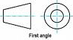  Third Angle Method  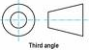  Dimensioning  Linear Dimensions  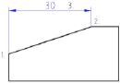  Radial Dimensions  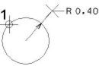  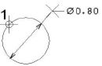 | North  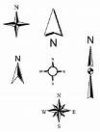  River / Stream  Lake  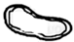  Road  Rail  Helipad  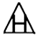  Trees | Switches  Single Pole  Double Pole  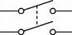  Fuse  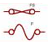  Earth / Ground  Socket  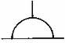  Fluorescent Tube  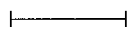  Lamp  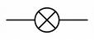 | Symbols used in Basic Flow Chart -  Process  Alternate Process  Decision Box  Data  Terminator  Connector | Border Line  Hidden Line  Center line  Cutting Plane Line  Dimension Line  Short Break Line  Long Break Line

Selecting Scale for drawing
a) Engineering drawing
To drawn engineering drawing or map on a small piece of paper, we need scale. By selecting appropriate scale we can accommodated all details of the object on a small piece of paper. It helps is studying a large area.
Scale is selected by the maximum length available for drawing on the paper divided by maximum actual length to be plotted.
For e.g if drawing paper size 25cm available for drawing. And we want to draw engineering drawing of sketch given in the fig.2. Maximum dimension to be plot is 300 meter on the drawing paper. Therefore you can select scale as --
Scale = length available on the paper / Maximum length of the object to be draw
= 25 cm / 300 m = 1 cm / 12 m
Therefore scale will be 1 cm = 12 m
Please remember all dimensions on the plot has to be reduced to this scale. For the sake of simplicity try to select the scale in integers. i.e 1, 2, 3 … As far as possible do not select a scale in fractions 1.2, 1.4 , 4.5 etc.
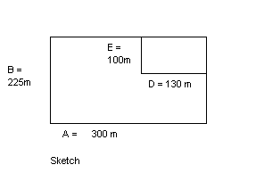
Fig. 2
Actual dimension in meter | Dimension reduced to scale for drawing on paper ( 12 m = 1 cm)
A = 300 m | 300/12 = 25 cm
B = 225 m | 225 / 12 = 18.75 cm
D = 130 m | 130 / 12 = 10.8 cm
E = 100 m | 100 / 12 = 8.3 cm

b) for Geographical maps & contours – Distances plotted on the maps are very high. They can be hundreds of Kms. Consider maximum actual distance in the area to be mapped (A in KM) and maximum possible length available on the paper (B in cms), then,
Scale = B in cm / A in KM
e.g. if maximum distance in the area to be mapped is 70 KM (A) and maximum possible length available on a wide A3 size (11.693" X 16.535") is say, 35 cm (B); then,
Scale = 35 cm / 70 KM = 1 : 2 KM
This means each 1 cmon the paper represents 2 KM. Suppose, distance between two places on the map is 6 cm, then the actual distance between those two places would be 12 KM.
- for Electrical Diagrams –
To communicate electric connections, position of switches and load, polarities etc electric circuit diagram is very necessary. We have seen various symbols used in electric circuits.
Scale for electric diagram is selected as in engineering drawing. For e.g Maximum actual distance in the wiring diagram is A = 100 m and the maximum possible length available on the paper to be B = 35 cm . Then the scale would be -
B / A = 35 / 100 = 1 / 2.85
For simplicity of calculation, we can make it 1cm : 2 m That means, every 1 cm of the figure on the paper represents 2 meter of actual wiring

- Graphs generally have grid of 1cm * 1cm. Therefore considering number to be plotted on graphs , we can calculate the scale as shown above.

- Flow charts - Actually, Flow Charts represent only flow of any procedure, so they don't need any scale.

Intext question 1.1
Select appropriate scale for plotting on the maximum drawing sheet of size 40 cm.
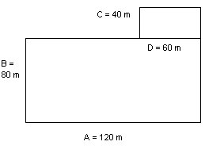

Write down size of all dimension for drawing on the paper.
Scale = __________
Actual scale | Drawing dimension
A = 120 m
B = 80 m
C = 40 m
C = 60 m

Drawing basic shapes
Using compass, scale, sets square ( 30 – 60, 45-45), protractor are used to draw basic geometrical shapes.
- Triangle
We can use compass and scale to draw triangle. Various steps to draw triangles are shown in the figure. Sum of all three angles of triangle is 180⁰.
Area of Triangle = base * height / 2

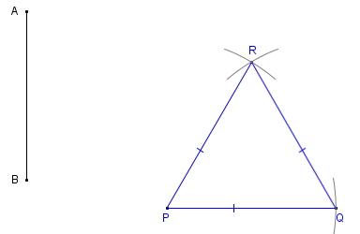

- Quadrilateral
Quadrilateral has four sides. Sum of angles of quadrilateral is 360⁰. Square has all four sides of same length. Rectangle has two opposite sides of same length. Square /rectangle is drawn as follows

C) Regular Pentagon
Following are the steps in drawing pentagon of five sides of equal length. For e.g lets draw a pentagon of 5 cm in length.
- Draw a line AB of 5 cm
- Draw a circle of 5cm radius by taking A as a center. Then draw another circle with B as a center. Both circle will cross each other at point X and Z. Join length XZ.
- Now take distance ZA in compass and draw circle with Z as a center. The circle will other circles at point S and R.
- Now draw line RC and line SE passing through point Y.
- Using compass ,mark arc of length 5 cm from point E and C. The arc will cross each other at point D.
- Now join all points A B C D E, to form a pentagon.

E) Hexagon.
Hexagon has six sides. To draw hexagon of equal side.
- Draw a circle of radius equal to side of hexagon.
- Put the compass anywhere at the edge of a circle , call that point as A.
- Draw arc of circle cutting circle at point B and F. Now put compass at point B and mark point C using compass. Similarly point D and E are marked.
- Join all points using scale to get a hexagon.

Area of geometric shapes.
Area of regular shape is calculated using standard mathematical formula.
- Traingle
Use following formula to calculate area of triangle.
Area = ½ * base * height

- Quadrilateral
Area of quadrilateral = Length * breadth

- Circle
Area of circle = ∏ * R ² ( R = Radius )

Area of irregular shape
1) Graphical Method
In regular practice, we need to measure irregular shapes of land, construction area, material etc. Graphical method is used to calculate area of such irregular shapes.
- Select appropriate scale and draw the drawing on graph.
- Then count number of complete square on the graph.
- Count number 75% ( three quarter )square on the graph.
- Count the number of 50% square on the graph.
- Count 25% square on the graph.

If you add all these squares then we get the area of the place. For e.g Fig. ___ is a graphical diagram of agricultural field. It has following squares.
Complete square ------ 71 * 1 = 71
75% square ---------- 10 * 0.75 = 7.5
50% square --------- 5 * 0.5 = 2.5
25% square -------- 8 * 0.25 = 2.0
Total square is = 83

This means total area of land on the graph is 83 Sq cm. If we multiply it with the scale we will get actual area of land.

2) We can also calculate the area of irregular shape by drawing many big size square and triangles into the drawing. We can add area of all these squares and triangles to get area of the irregular shape.

.

Intext question 1.2
i) Match the pair
A B
Area of triangle Length * breadth
Area of rectangle ∏ * R ²
Area of circle ½ * base * height

What you have learned
In this lesson, you have learned about standard symbols and lines used in engineering drawing. Now you will able to select appropriate scale for drawing. You also learned to draw different geometrical shapes. You also learned to calculate areas of regular and irregular geometrical shape.
1"
1"

Terminal question
- If an MS bar of 2 mm thickness has `L' shaped cross-section as shown in the figure. Calculate its cross-sectional area in cm².
30 mm

- Draw the following
  - Equilateral triangle of 10 cm length
  - Square of 15 cm in length
  - Rectangle of length = 12 cm , breadth = 10 cm
  - Circle with radius = 7 cm

- Draw symbols for the following
  - River
  - Road
  - Rail
  - Hidden line
  - Center line
  - Electric switch

Answer to intext question
Intext question 1.1
Scale = 1 cm : 3 m
Actual scale | Drawing dimension
A = 120 m | 40 cm
B = 80 m | 26.67 cm
C = 40 m | 13.33 cm
C = 60 m | 20 cm

Intext question 1.2
- ½ * base * height
- Length * breadth
- ∏ * R ²

Activity suggested
- On A3 size (11.693 X 16.535 inches) drawing sheet - Typical symbols used in all four forms of drawing – Engg. Drg., Geographical Maps, Contours & Graphs and Line types.
- Find area of a plant-leaf.
- Find top surface area of a percolation tank.

