
Module II: Rural Industries
Lesson 5 Engineering drawing

Topics: Orthographic and Isometric Projection

Introduction
Engineering drawing is a language of technicians. They can document and communicate all details of the job using engineering drawing. Drawing paper has two dimensions. To give information about 3 – D object, only one view is not sufficient. Orthographic projection is method to project 3 – D drawing in two dimensions.

Objective
After reading this lesson you will able to know about orthographic and isometric methods of projection. You will able to draw simple orthographic and isometric drawing.
You will also learn to select isometric scale.

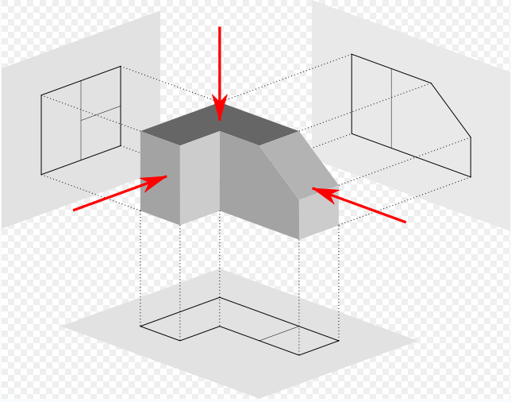
Orthographic Projections
A three dimensional sketch of an object to be manufactured doesn't always gives a clear idea about the exact construction. The artisan or craftsman needs constructional details which can be better explained in the Orthographic Projections.

Fig. 1

Orthogonal means 'Perpendicular' The object is observed with the viewer's eyesigh at 90 degrees to a face of the object. Refer fig. 1 .
In First Angle Projection we place our object in the First Quadrant and In Third Angle Projection the Object is placed in the Third Quadrant. (see fig 2 ). It is consider as if the object is placed in a glass box with three planes of the object being parallel to the glass box. The image (or shadow or reflections) received on the three planes, collectively are called as ‘orthographic projections’.

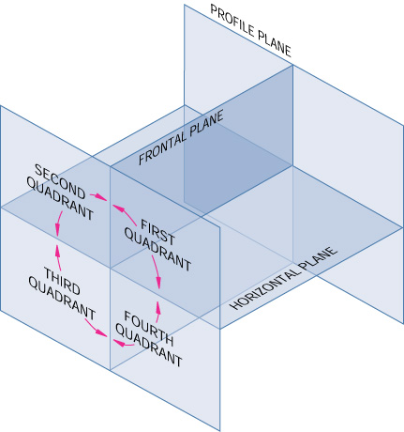

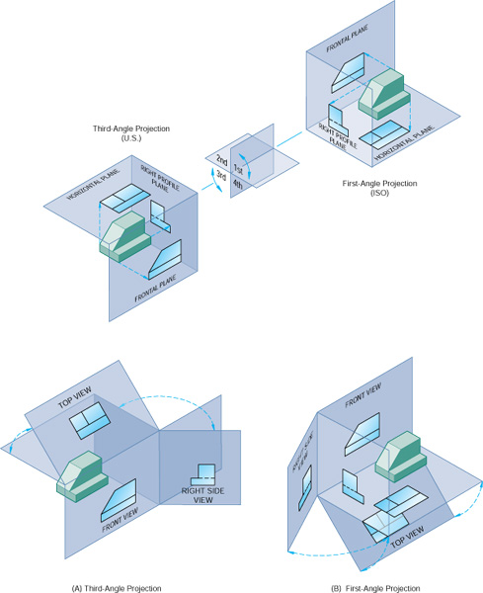
Fig 2.
When we draw an Orthographic view of the front of an object it is called a ELEVATION. When we draw an Orthographic view of the top of an object it is called a PLAN. When we draw an Orthographic view of one side of an object it is called an END ELEVATION.
If an object is very complicated then you can draw an End Elevation of the left and right hand side
Observe following object and their orthographic projections.

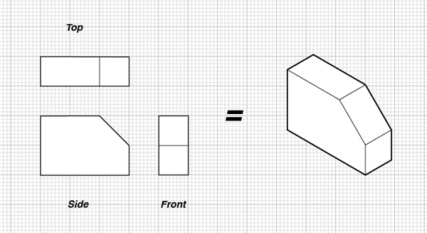

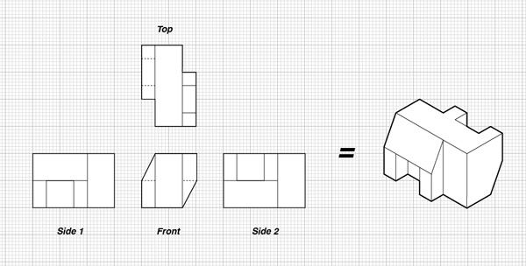
Fig. 3

- Steps to draw the Orthographic views -
Lets draw orthographic view of block shown in fig. 4 using third angle projection method.
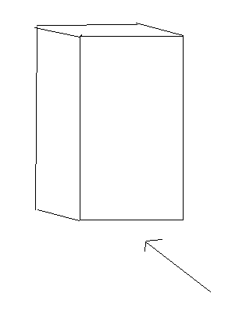
Draw a horizontal line XY in the middle of the paper.
  - Draw a rectangle measuring 'height CO length and AC width' below the line XY. This is the 'Front View' or the 'Elevation.' Leave some space, say 20 mm, between the line XY and top of the rectangle.
  - Draw two more rectangles on either side of the first rectangle. These are two 'Side Views.' These two rectangles must be admeasuring width of the object. Leave 20 mm space between each pair of rectangles.
  - Draw two vertical lines, AB and CD, from top of the Elevation and extend them above the XY line. These are 'Projections' from Elevation. These lines must be fainter than the rectangle orders.
Top View or
Plan
Left Side View
Front View
or
Elevation
Right
Side View
Width
Length
He
i
gh
t
X
Y
J
H
G
D
C
F
E
B
A
O
  - Draw vertical projections, EF & GH, from the top of either Side View, but these projections should just touch the XY line.
  - Draw two more projections at 45⁰, HB & FJ, so as to intersect the extended vertical projections AB and CD, from the Elevation. Intersections of all these projections will give the 'Top View' or 'Plan', exactly above the Elevation. This set of 4 views - viz. Elevation, Top View and Side Views - is called as the 'Orthographic Views' or 'Orthographic Projections'

Please study the examples of orthographic projection given in the following figures.

Isometric Drawing
An Isometric Sketch is drawn with free hand, its dimensioning is just proportional, whereas the Isometric View is to be drawn with the Isometric Scale. Isometric projection is a method of visually representing three-dimensional objects in two dimensions, in which the three coordinate axes appear equally foreshortened and the angles between any two of them are 120 degrees. Isometric is a 3-D sketch whereas Orthographic is a set of 3 Plane Projections. Look at the fig.___ to see example of isometric drawing.
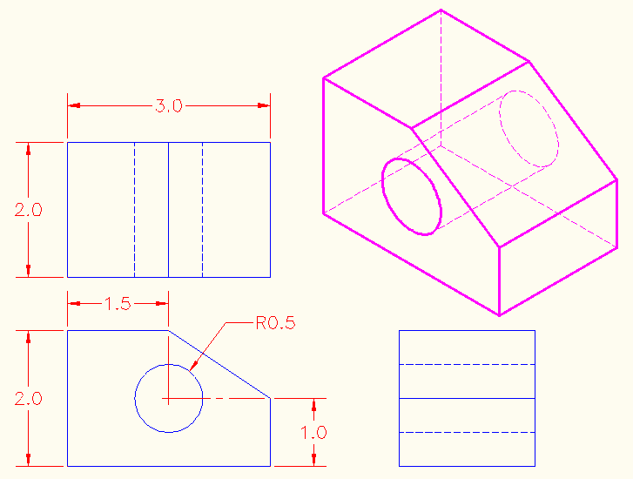
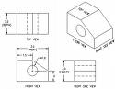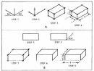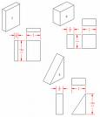
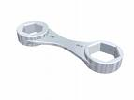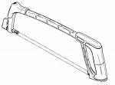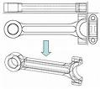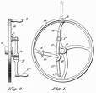
Spanner Brush Hack Saw Spanner Hand Wheel
Freehand Isometric sketches of common tools Orthographic Views of hand Tools

Natural scale and Isometric scale.
True Scale or Natural Scale is used to draw Orthographic Views. In these views, the viewer's direction is exactly perpendicular to the plane of view, hence true Dimensions are seen. But in Isometric view, object is seen from an angle to get view of all three plane. A corner of the 3D object is the nearest point to the viewer and all other dimensions of the object are moving away from the viewer. So the dimensions APPEAR to be smaller than the true ones. This difference can be computed by the figure shown above. Unit 1 on the natural scale appears to be Unit 1 on the Isometric scale.
Step in drawing isometric scale –
Ref. fig. Draw a line at 45⁰ and at 30⁰ . Mark points on true scale and draw line perpendicular to X – axis as shown in the fig. Distance of point O from point on isometric scale is the length of object on isometric scale.
TRUE SCALE
ISOMETRIC SCALE
0
10
20
30
40
50
60
30⁰
45⁰
Fig. ____

Steps to draw an Isometric
View -
- Orientation of the object and point of Origin, these two things are to be decided before drawing the Isometric View. For every Isometric View a separate Scale is required to be drawn.
- Draw the Isometric and Natural scale, mark each dimension on the Natural scale, drop a perpendicular on the horizontal line, and transfer the corresponding Isometric dimension on the paper with the help of divider. (As Isometric dimension cannot be and need not be measured in cm or inches). Suppose we need a dimension of say, 35 mm to be converted into Isometric Scale. Take 35 mm dimension on the Natural scale, drop a perpendicular on the horizontal line. The perpendicular meets the 30⁰
TRUE SCALE
ISOMETRIC SCALE
0
30⁰
45⁰
35
A
Fig. _____
line at point A. The dimension OA is the Isometric dimension of Natural 35 mm. Transfer the dimension OA to the Isometric View to be drawn.
- Take an Origin 'O' on the paper ref fig. ____, with sufficient space to draw the Isometric above the point 'O'. Draw a horizontal line XY through 'O' and another vertical line OZ.
- Referring the orthographic Views, transfer the height, length and width of the object on the Natural Scale and convert them into Isometric Scale.
- With the help of a Divider, transfer the height on the vertical line OZ, the length along OX and width along OY. Consider the Origin 'O'in the Elevation of the Orthographic Views (Lesson 2) to be the Origin in the Isometric View here.
- Complete the entire Isometric block with the help of Tee Square and 30-60 Set Square.

O
Z
X
Y
Isometric Height
Isometric Width
Isometric Length
Fig. ___

Examples of drawing isometric drawing
  - Draw isometric drawing of a cube.
Orthographic projection of cube of 40cm length, 40cm height and 40cm width is shown below.
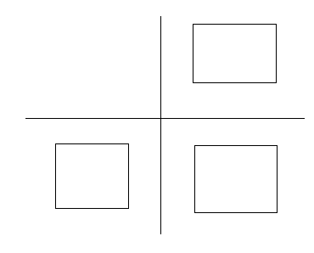
Fig. _____
To draw isometric of cube.
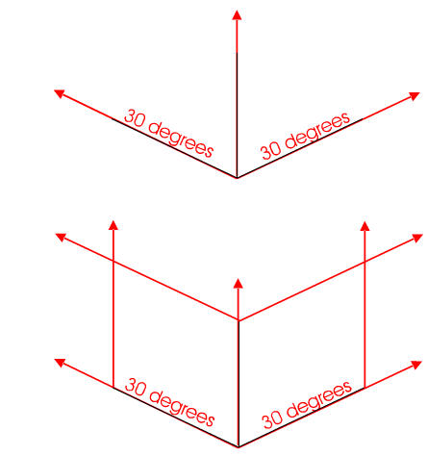
1) Draw two basic 30 degree guidelines, one to the left and one to the right, plus a vertical guideline in the centre of the drawing. In this example three edges of the cube have been drawn over the guidelines (they are slightly darker)
2) Remember to draw the line of length equal to isometric scale. Therefore each side of 40cm cube should be converted to isometric scale.

Fig. _____

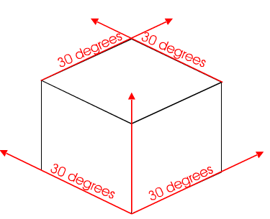
Complete the top of the cube by projecting lines with the 30 degree set square as shown. .

Fig. ___
  - Draw an square in isometric
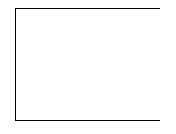
Fig. __
Square ABCD is of 50mm size.
- Draw a horizontal line.
- Mark one corner of square at the center of line ‘D’
- Draw two lines as shown in the fig at 30⁰ to the horizontal line.
- Select isometric scale as shown in the previous example. Measure distance on isometric scale.
- Draw point A and B equal to isometric length.
- Mark point ‘C’ using compass of length of isometric scale.

  - Draw an isometric circle
Draw a square ABCD, centred on the position of the hole. The square should be the same size as the diameter of the hole.
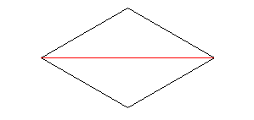
Fig. ___
Draw curves ( GF and HE ) using compass as shown in the fig.
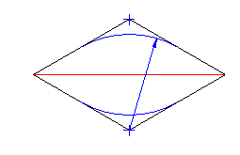
Fig. ___
Center of line CD and AB are marked as G and E. Join AG and CE as shown in the figure. Draw arc EF and GH using compass as shown in the figure. The isometric of circle is ellipse.
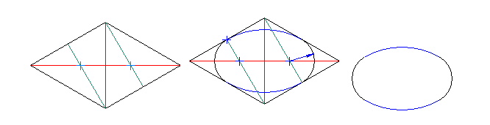
Fig. ____

Examples of isometric drawing

What you have learned
In this chapter, you learned about orthographic and isometric projection. You learnt to draw orthographic and isometric projection. You learnt the procedure to draw them. You learnt to draw basic isometric shapes. You also learnt to present textual information to drawing form and to read information on drawing and write in textual form.

Terminal Question :
  - Convert textual information into graphical form - A box measures 30 mm (length) X 20 mm (breadth) X 45 mm (height). Draw its isometric sketch with length on your right side.
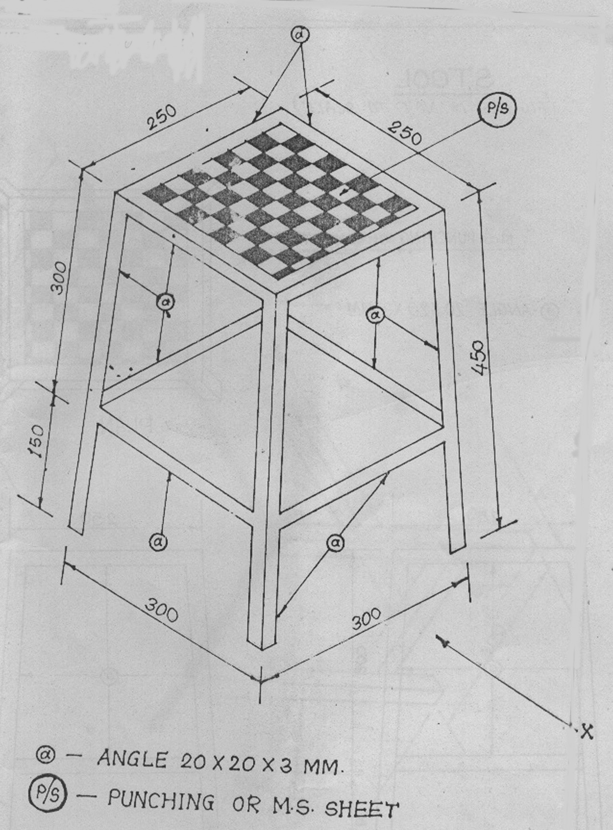
  - Convert textual information into graphical form - A cylinder measures 25 mm (base diameter) X 75 mm (height). Draw its three orthographic views.
  - Convert graphical information into textual form -
- What is the total length and breadth of the object?
- State the dimensions of the top of the object.
- What is the total length of each of the 4 legs?
- What is the maximum distance between two legs?
- What are the M.S. Angle dimensions?
- Which two materials are suggested for the top?
*********************************************

