Lesson 5
Manufacturing Process

Introduction :
Manufacturing is the use of machines, tools and labor to make things for use or sale. Manufacturing is of different form e.g electronics good manufacturing, chemical manufacturing, food products manufacturing etc. In this section, we are going to discuss manufacturing process in mechanical engineering field. These processes are basic processes for converting raw material into products. We will also discuss the basic safety precautions while working in the workshop. In practical section, you are going to do these operations yourselves.

Objectives
In this section, you will able to learn following manufacturing processes related to mechanical engineering.
- Fabrication and welding 2) Drilling, threading and tapping 3) Metal cutting using hacksaw, shearing machine and power hacksaw 5) Turning 6) Grinding

Safety precautions
Life is precious. Therefore while working with machines always follow following safety rules. Those who are not following safety rules are putting their own and others life at risk.
- Workshop place has to be clean. There has to be free space around the machine. All rotating parts of machines must be covered or not accessible.
- Please check electric connections and safety related to electric devices.
- Workshop floor has to be dry and free from oil, water and grease.
- Machine switch has to be near the machine table and free from any obstacle.
- Check wiring and earthing for all machines
- Never do welding without welding screen or goggles.
- Use safety goggles while grinding, drilling.
- While doing construction always use hand gloves and helmet.
- Keep all tools in its position.
- Keep the aisle free to run towards exit in case of emergency.
- Be careful while working with sharp objects.
- Whenever power goes off, please put all the switches in ‘OFF’ position.
- Please put the tools and safety gadgets in the designated place.
- Do not disturb person working in the workshop.
- Keep first aid box in the workshop.

Welding :
Welding is the most economical and efficient way to join metals permanently. Following are the types of welding.
- Forge welding : In this two pieces are heated upto plastic stage and then hammered together till they joined each other.
- Arc welding : It is commonly found method in fabrication workshop. An electrical current is used to form a arc. A welding rod is used as electrode. A arc is formed between the tip of the welding rod and the base material. Tip of the welding rod melts and works like a filler material between the pieces to be joined. A flux is applied to welded material to protect it from oxidation. The process is very versatile, requiring little operator training and inexpensive equipment. This process is generally limited to welding ferrous materials and filler metal. Welding machine required for this is generally inexpensive. This type of welding is best suited for welding mild steel in the range of 2-8mm in thickness.

Welding Joints
If joint to be welded has wide gap or is dirty, rusting or greasy then we will not get good result. Depending upon shape of the object to be welded , we need to prepare joints. Here are commonly used welding joints.
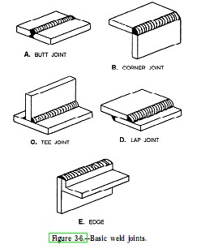
The 5 weld joints are named Butt joint, Corner joint, Edge joint, Lap joint and Tee joint as shown in fig.1.
The first one named Butt joint is a joint that is between two members lying approximately in the same plane.
The second one named Corner joint has two members located at right angles to each other in a from of an angle, mostly 90 degrees.
In Tee joint, it looks just like it is called because it forms a "T".
Fourth one is a Lap joint, that has two
Fig. 1 overlapping members to form the joint.
The Edge joint is a joint between the edges of two or more parallel members.
Depending upon the thickness of joint, butt joint is also made of following types.
1) A butt joint
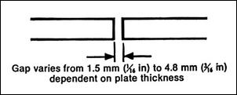 fig 2(a)
2) V butt joint :
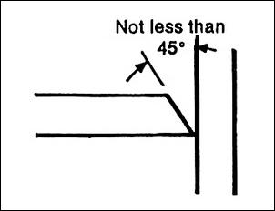 fig.2(b)
3) double V butt joints . When metal is thicker.
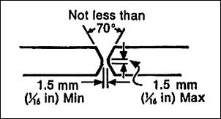 fig.2 ( c )
4) A Lap joint
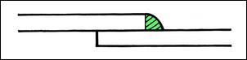 fig.2 ( d)

5) T joint

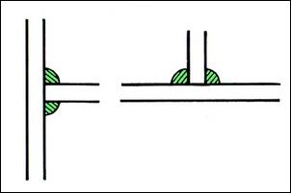 fig. 2 ( e )
Fig 2.
Gas welding : Gas Welding is widely used for repair work, especially in welding thing sheets, cutting ferrous material, welding non ferrous metals.

Commonly used welding are Oxy-Acetylene welding. Acetylene gas when burned alone can produce a flame temperature of about 4000 deg. F. With the addition of Oxygen a flame temperature in excess of 6000 deg. F. can be achieved. By using the proper tips, rods and fluxes, almost any metal can be welded, heated or cut using the Oxy-Acetylene flame.
Things to remember
Welding arcs are intensely bright lights. They contain a ultraviolet light which may cause eye damage. For this reason, the arc should never be viewed with the naked eye. Always use welding goggles while welding.

Intext question 5.1

Two metal pieces are heated and hammered together in _____ welding.

To carry out welding of material in same plane _____ type of joint is most suitable.

Commonly used gas in gas welding is ______.

Drilling
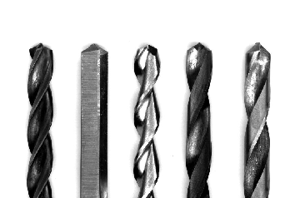
Drilling is the cutting process to cut or enlarge holes in solid materials, such as wood or metal using drill bit and drill machine. Different tools and methods are used for drilling depending on the type of material, the size of the hole, the number of holes, and the time to complete the operation. Ref fig.3(a)

Fig.3 (a)
Some hard material requires cooling while drilling. Speed and feed of drill also depends on the material to be drilled. Ensure direction of rotation of drill.

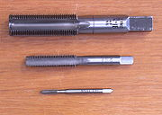
Taps and dies are cutting tools used to create screw threads in material. A tap is used to cut the female portion of the mating pair (e.g. a nut). The process of cutting the threads in a hole is called "tapping" the hole. A photo of tap is shown in the figure 3 ( b)

Fig 3 (b)
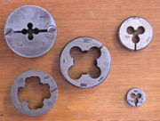

A die is used to cut the male portion of the mating pair (e.g. a bolt). The process of cutting with a die is called "threading". Different die are shown in fig. 3 ( c)

Fig.3 (c)

Metal cutting
Following tools we normally used for cutting materials in workshop.
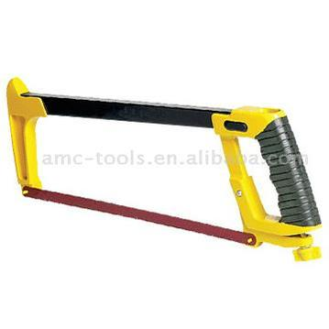
Hacksaw : It is most used tool in the workshop. Following care must be taken while using hacksaw.
i) Do not use worn out blades.
ii) Fix the blade tightly.
iii) If blades are too flexible then they will twist while cutting and generate friction.
iv) The cutting action takes place when you pull the saw towards you. Check the direction of teeth.
v) Keep the constant pace of the strokes.

Fig. 4 (a )

Power hacksaw 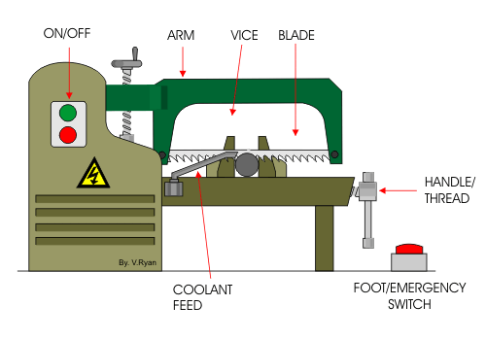
Fig. 4 (b)

Shearing machine
It is used to cut pipes, angles, bars, sheets etc.
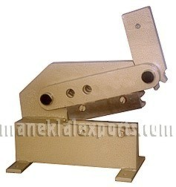
Fig. 5 ( a)

Lathe machine
Lathe is one of the oldest machines. Following operation are carried out with lathe machine.
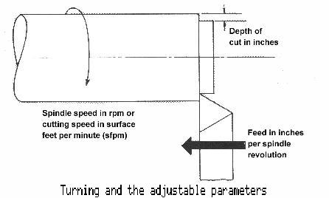
1) Turning: Turning is the machining operation that produces cylindrical parts.
Work piece is rotating on spindle and cutting tool is fed parallel to the axis of the work piece and at a distance that will remove the outer surface of the work

Fig. 6 ( a )

The quality of finish depends on the following parameters:
- Speed, always refers to the spindle and the workpiece. The speed (RPM) of lathe depends on the diameter of the workpiece and the material to be cut.
- Feed it is the rate at which the tool advances along its cutting path.
- Depth of Cut
There are different sizes and shapes and materials of tools are available for turning. Before starting the work, one must ensure right tool and proper speed, feed and depth of cut.
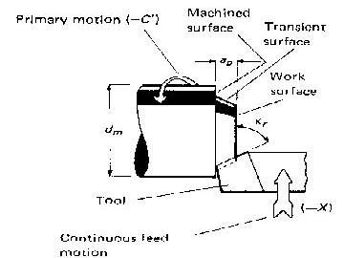
Other machining operations that can be performed on lathe machine are
- Facing :
Tool is fed across the axis of work piece and depth of cut is taken on the face of work piece.

Fig. 6( b)
3) Parting is used to create deep grooves which will remove a completed or part-complete component from its parent stock. Ref fig. 6 ( c )
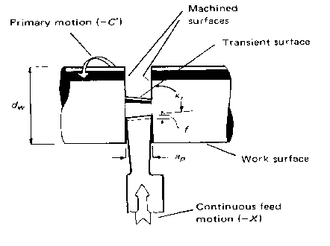
Fig. 6 ( c )

4) Grooving is like parting, except that grooves are cut to a specific depth by a form tool.
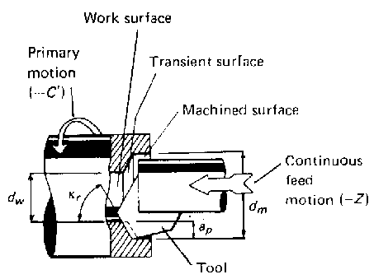
5) Boring – Tool is mounted on the tail stock and fed into the job along the axis of the workpiece to drill a hole in the workpiece. Fig. 6 ( d )

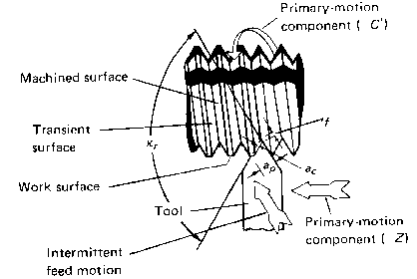
Fig. 6 ( d )
6) Threading – By selecting appropriate gears and threading tool, we can cut threads on the lathe machine. Ref fig, 6 (e) Threads on big shafts are made on lathe machine. The job is roated on the spindle. Gear selection chart is attached on lathe machine and its operational manual.

Fig. 6 ( e )
Grinding
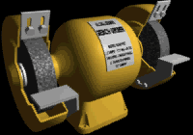
A grinding machine is a machine with abrasive wheel as the cutting tool. A job is hold against rotating wheel. It is mainly used for surface finish and to make tools sharp.
Bench grinder is commonly found in workshop. Other types of grinder are belt grinder, surface grinder, cylindrical grinder etc.

Fig. 7

Intext question 5.2
Match the pair
Application Tool
- To cut threads on bolt Lathe
- Cutting MS bar of 100mm dia drilling machine
- Sharpening of turning tool die
- To reduce diameter of a bar hacksaw
- To cut a drill on plate grinding machine

What you have learnt
In this lesson, you have learnt about different types of manufacturing processes and tools used for the same. You learned about welding, drilling, threading tapping, turning and grinding. You also learned about different uses of lathe. You also learned about safety precautions to be taken while working in the workshop.

Terminal question
- Write down different types of operations that can be performed on lathe machine.
- Write down safety rules for working in the workshop.

Answer to intext question

i) forged ii) butt iii) Oxy-acetylene
5.2 Match the pair
Application Tool
To cut threads on bolt die
Cutting MS bar of 100mm dia hacksaw
Sharpening of turning tool grinding machine
To reduce diameter of a bar lathe
To cut a drill on plate drilling machine

Activities suggested
1) Write down specification of all the machines used in your workshop.
2) List down types of cutting tools for different machines. Find out their specifications and nomenclature
i) Cutting tools for Lathe machine
ii) Different types of drill bits
iii) Tap sizes
iv) Die sizes
v) Wheel sizes and name
vi) Welding tools and cutting torches

