Lesson 8
Quality and Aesthetics

Introduction
In today’s world of competition, ‘Quality’ is the key word to remain in business. It is closely related to ‘Customer Satisfaction’. It is necessary to learn and be cautious about quality for doing well and doing it better everyday.
It is very important to present product in presentable form. A finished and good looking product gets more prices in the market.
Objective
After reading this lesson, you will know meaning of the world quality, how to ensure quality. We will also study painting and packing of the product.
Quality
Quality is always defined as meeting customer’s expectation. Quality is always seen from the eye’s of the customers. There is a quality in everything we do in our life. Commonly used terms with reference to Quality are Quality of manufacturing, Quality of performance, Quality of product, quality of compliance with dimensions, quality of design, Quality of service, Quality of life.
Quality is not only limited to product manufacturing it applied everywhere. For.e.g A good teacher will provide quality teaching to students, a government officer will provide quality service by becoming more sympathetic to the problem of citizen and try to solve their difficulties. A doctor will provide quality service by prescribing appropriate medicine and morale support to patient.
Mahatma Gandhi has famously said
"A customer is the most important visitor on our premises. He is not dependent on us. We are dependent on him. He is not an interruption in our work. He is the purpose of it. He is not an outsider in our business. He is part of it. We are not doing him a favor by serving him. He is doing us a favor by giving us an opportunity to do so."
All our action must be such to achieve customer satisfaction. Remember no business will grow or survive if proper service is not given to its customers.

Quality Assurance
The manufacturing is done broadly in 2 ways
To get the quality in our work follow the basic rules:
- Define the customer need
Discuss with customer and find out his exact requirement. Suggest him alternatives available. Do not hide disadvantages or possible problems.
Prepare a Job card and take customers signature on it. Following things must be incorporated into the job card.
- Product title
- Sketch with dimension
- All material specification, dimension
- Coloring, packaging and forwarding instructions
- Possible delivery time
- Payment terms/Advance received etc on the job card.
- Draw up an action plan: This will include what needs to be done, who will do it, how it will be done, and when. Check your specification from design point of view. If need revision, please do it at this stage. Inform customer about the changes and take his approval.
- Select proper material, check for warrantee for the bought out parts, and ensure quality for subcontracted material.
- Implement. Do the work. If you need to make any deviation, inform customer about possible changes.
- Housekeeping – keep the workplace clean and attractive to customer.
- Review. Always take review of the work in progress.
- Quality check – Please check the product for the final accuracy, performance etc.
- Finishing: Aesthetic is very important. Look of the product will create impression about product.
- Packaging: Make packaging as attractive as possible. Consider the transportation, handling issues, delicacy of instrument etc before shipping.

Intext question 8.1
True or False
- Quality is defined as meeting customer expectation.
- All our action must be to maximize profit and selling goods.
- Customer depends on us. He must accept our terms.
- If you make any deviation from the specification, keep it a secrete.
- Quality also includes quality in your appearance, language and behavior.

Painting :
Painting is the practice of applying color to a surface such as paper, canvas, wood, glass, concrete. Painting gives the product its appearance. It is also useful to increase durability of product, prevent rusting etc. Some of the paint has water proofing, heat resistant capabilities. Painting is cheapest way to give fresh look to the old things.

Types of paints
1) Distemper : Distemper paint has been used primarily in the painting of interiors. It has a wonderful matte finish and a soft feel to it.

2) Oil Paint : Oil paint is useful for glazing and impasto techniques.

3) Acrylic Paint : Acrylic emulsion is the binder in acrylic paints. Acrylics are water soluble, but dry to a water insoluble and impenetrable flexible film. They are very fast drying and used for different combination of texture.

Brush
Selection of proper brush is very important for efficient and quality painting. Following are the tips for selection of proper brush :
1) The more flags, or split ends, the better the brush and its paint-spreading capabilities.
2) A good brush may lose a few bristles while working, a bad brush will lose many bristles.
3) Find a brush with long, tapered bristles, particularly on narrow brushes.
4) Bristle length gives you flexibility to paint into corners and around trim.
5) Choose smooth, well-shaped handles of wood or plastic that fit in your hand comfortably.

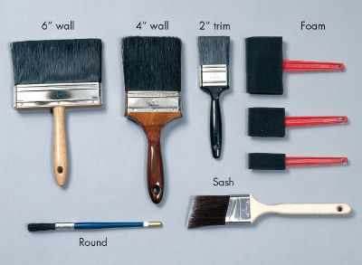
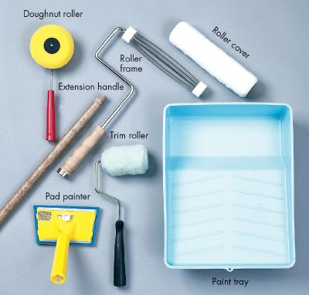
Fig. 1

Following are types of brushes ref. fig (1):

- Wall. This type spreads the most paint over the most surface.
- Trim. A 2-inch-wide trim brush is ideal for woodwork and for "cutting in" around windows, doors, and corners.
- Sash. A sash brush has an angled bristle end. It is useful for painting around windows.
- For flat surfaces, roller is used.

Painting practice

1) Clean up the surface. Fill up the gaps on the wall / article.

2) To save other items from falling of paint drops on them covered the area with old newspaper.

3) Never dip a brush more than about one-third the length of the bristles into the paint. Otherwise it will become impossible to clean.

4) One of the most important aspects of a successful paint job is keeping things clean as you're working. It's also important to clean equipment as soon as you're finished and to wipe up any drips as soon as they occur.

5) When the work is over, clean the brush. Shake out the excess solvent or water, and comb out the bristles.

Packaging :
Packaging is enclosing of a physical object, typically a product that will be offered for sale. Packaging is the outer wrapping of a product. The purpose of the packaging is to make a product readily sellable as well as to protect it against damage and prevent it from deterioration while storing. Furthermore the packaging is used to create brand image and helps in marketing, advertising and communication.
Importance of packaging
- Protection during transport – The product getting shipped to other places need to be packed well enough to protect against damage during handling, transport and storage. Eg: fiberboard, wooden crate etc. A cushion material is used to save material from shock and vibration.
2. To protect the product from weather.
3. To protect against dirt, insect etc.
4. Communication: A package must communicate what it sells. It must inform consumer about the product, how to use it and other utility information. It provides information including: quantity; price; lot number; manufacturing place, manufacturing date, colour; and merchandising and premium data.
5) Consumer Packing: It is mainly for marketing and attracting consumers.
Intext question 8.2
- _________ is the cheapest way to give fresh look to old things.
- _________ Paint is used to paint interior.
- Roller is used to paint on _______ surface.
- ________ is to protect goods during transportation.
What you have learnt
Quality of product is judged from all the process involved in the manufacturing of product to selling them to customer. A successful business has to remain concerned about customer satisfaction and therefore quality. Quality in design, manufacturing, painting and packaging are important to make customer happy. Most important thing is the quality of service you give to your customer. You also learnt about paints and packaging in this chapter.

Terminal Question
- Write down things that must be incorporated on the job card.
- Write down steps in carrying out painting job.
- Why packaging is important ?

Answer to intext question
  - i) True ii) False iii) False iv) False v) True
  - i) Painting ii) Distemper iii) flat iv) Packaging

Suggested activities

Observe packaging of following goods available in the market
  - Food products
  - Furniture
  - Glassware
  - Clothes
  - Grocery items
  - A food served in good restaurant

