Productive task :
- Learning the safety measures for equipments and tools used in the workshop
- Demonstrate the safe use of equipments and tools used in the workshop

Tools : Drilling machine, Welding machine , Grinding machine, Shearing machine, hammer, hacksaw, spanners, chisels, vice and pliers

Class-Age Group : 14+

- Safe use of equipments and tools used in the Engineering workshop
- Mandar Damle
Open Education Resource
Productive task-
- Learning the safety measures for equipments and tools used in the workshop
- Demonstrate the safe use of equipments and tools used in the workshop by following all the safety guidelines while constructing a tools box or any such object.
- Explain which all safety guidelines have you followed while constructing a box or an object

Productive task objective -
- After going through this unit students will be able to :
- Explain how to carefully handle equipments and tools used in the workshop?
- Demonstrate the safe use of workshop equipments and tools

Introduction-

The word safety refers to, your freedom from danger, injury and damage, and to your personal security
You might be wondering why to learn about safety why there is so much emphasis on it?

You all know cricket right !!!. Can you imagine a below cricketer playing a “world-cup “match without using guards?
Obviously..... NO. So, safety is must in everywhere, irrespective of the task we perform.

This OER is designed to introduce you with how to safely use engineering equipments and tools.
It is extremely important for you all to know and follow these guidelines before you start using these tools and equipments.

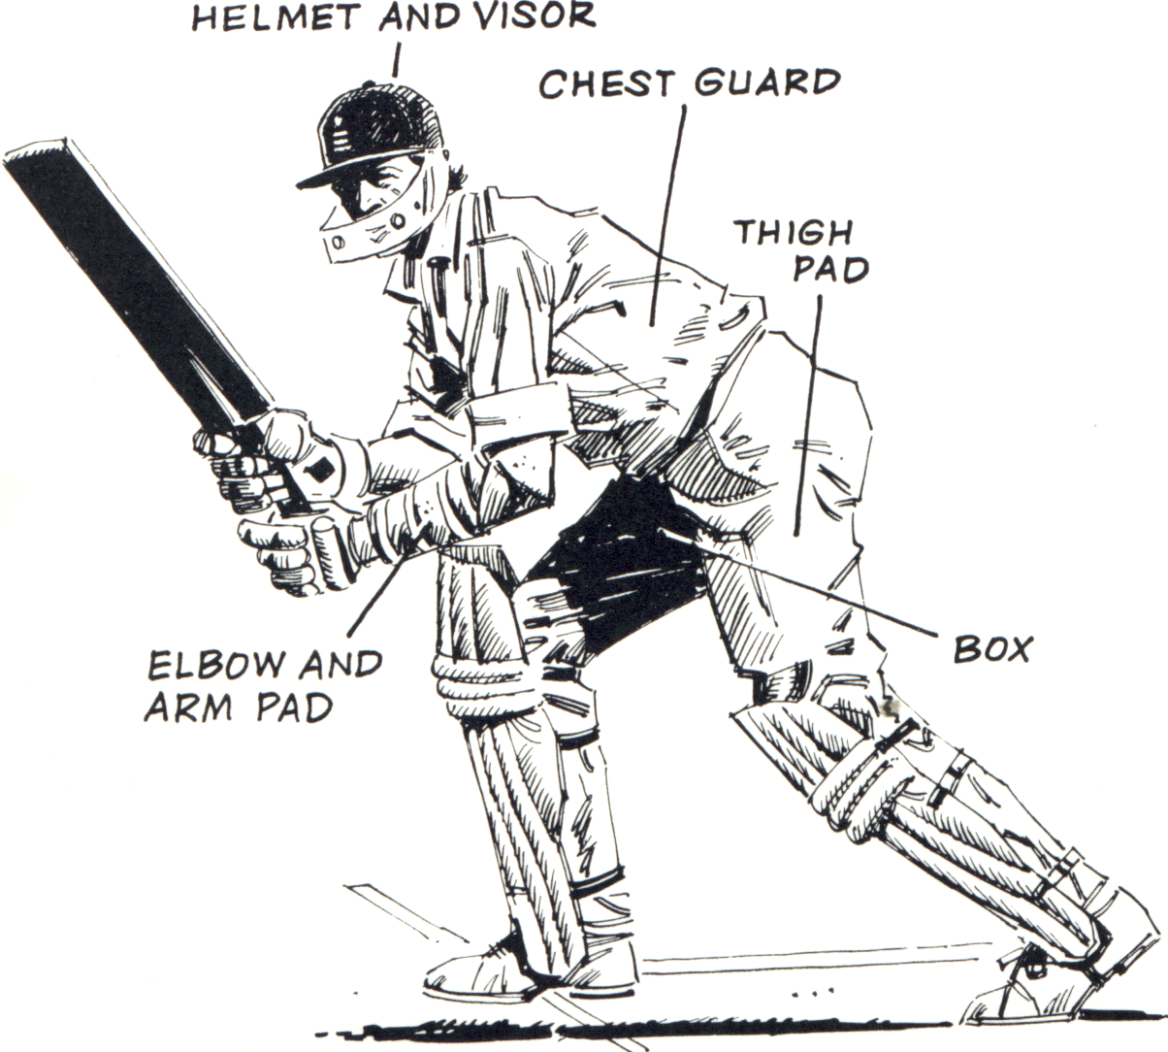in

Just the facts :-

The Occupational Safety and Health Administration states that most injuries on construction sites involve excavation cave-ins, power tool accidents, falls, electrical hazards, and exposure to potentially dangerous materials

Working with power tools, you can get an electric shock, lose a finger, lose an eye, or go deaf. It's especially dangerous to use a tool that's defective, that's been modified, or that's not designed for the job. Of course, you can also get injured if you use any tool carelessly.

By now we all are convinced that, safety is a must… let us learn about the safety guidelines for the tools we use in our engineering workshop

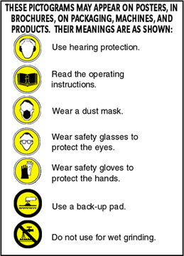
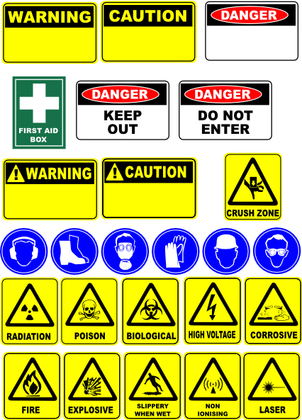

Safety guidelines for equipments or machines used in engineering workshop :
.

Drilling Machine

A drilling machine is a device used to cut holes into or through metal, wood, or other hard surface. This device is normally made of a tapered shank rotated by a motor or by hand (manually). Most drilling machines are made of hard elements like diamond or steel

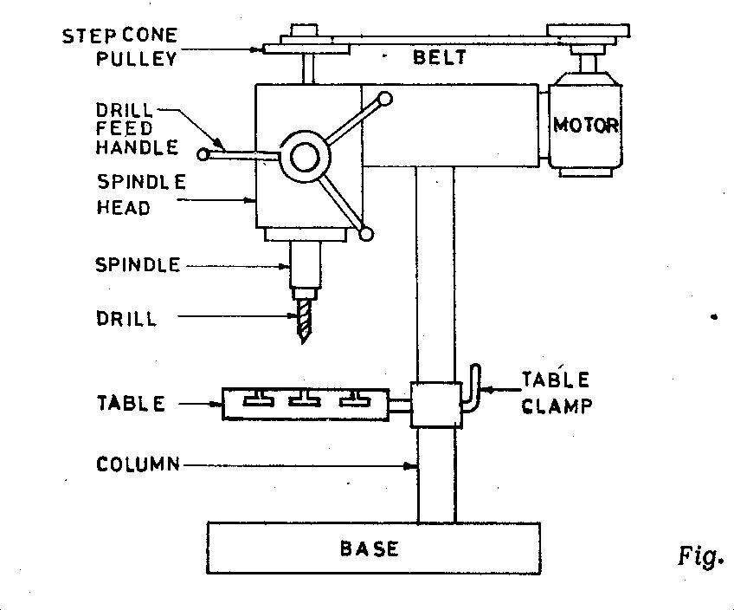
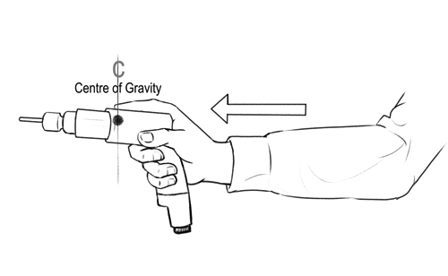

General Precautions for Drilling machine
- Lubrication is important to remove heat and friction.
- Machines should be cleaned after use
- Chips should be removed using brush.
- T-slots, grooves, spindles sleeves, belts, pulley should be cleaned.
- Machines should be lightly oiled to prevent from rusting

Safety Precautions
- Do not support the work piece by hand – use work holding device.
- Use brush to clean the chip
- No adjustments while the machine is operating
- Ensure for the cutting tools running straight before starting the operation.
- Ease the feed if drill breaks inside the work piece.
- Do not wear loose or baggy clothing, ties, jewelry, or sandals. If you have long hair, tie it back or wear a cap — especially when drilling
- Wear eye protection when sawing and drilling. Safety glasses or goggles are inexpensive and available at any hardware store.
- Do not hold your finger on the switch button while carrying a plugged-in tool — it may start accidentally.
- Grip all tools firmly.
- Be sure to work at a safe distance from others.
- Do not use electric power tools in wet or damp locations.
- Never carry a power tool by its cord.
- Never leave a running power tool unattended.

Grinding machine

The grinding machine consists of a bed with a fixture to guide and hold the work piece, and a power-driven grinding wheel spinning at the required speed. The speed is determined by the wheel’s diameter and manufacturer’s rating. The user can control the grinding head to travel across a fixed work piece, or the work piece can be moved while the grind head stays in a fixed position.
Grinder showing guards 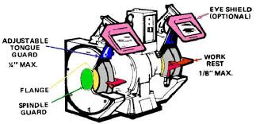
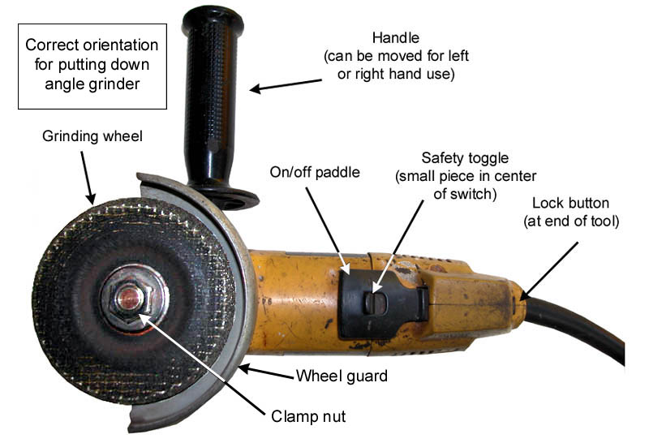

Safety precautions:

Grinding machines are used daily in a machine shop. To avoid injuries follow the safety precautions listed below.
- Wear goggles for all grinding machine operations.
- Check grinding wheels for cracks before mounting.
- Never operate grinding wheels at speeds in excess of the
recommended speed.
- Never adjust the workpiece or work mounting devices when the machine is operating.
- Do not exceed recommended depth of cut for the grinding wheel or machine.
- Remove workpiece from grinding wheel before turning machine off.
- Use proper wheel guards on all grinding machines.
- On bench grinders, adjust tool rest 1/16 to 1/8 inch from
the wheel.

Welding Machine :

Welding is joining metal parts (usually) together by heating the surfaces to the point of melting with a blowpipe, electric arc, or other means, and uniting them by pressing, hammering, etc.

Two popular welding types:

Arc Welding Gas Welding

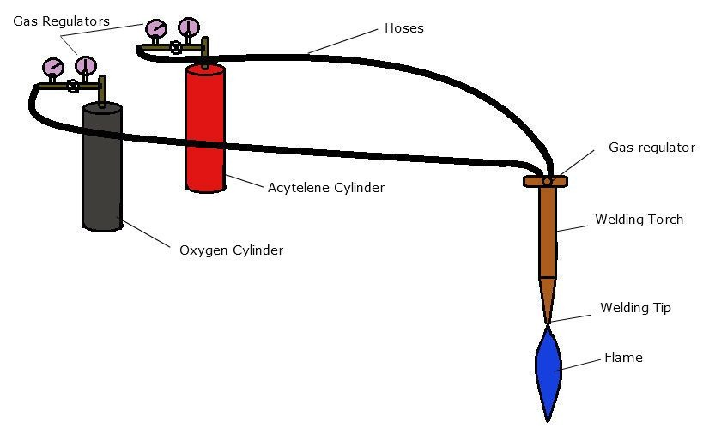

General welding Precautions
- Construction personnel that is welding should be properly trained and qualified
- Inspect work area for fire hazards before welding
- Make provisions for ventilation before welding
- Compressed gas cylinders should always be secured in an upright position when not in use and handled with extreme care
- Gas cylinders should be stored at least 20 feet away from flammable materials and heat sources
- Oxygen cylinders should be stored at least 20 feet away from gas cylinders and combustible materials.
  - When not possible, use a 5 ft tall noncombustible barrier with a 30 min. fire-resistance rating or better

Safety precautions for welding :

- Welding booths should be painted with dull finishes so they don’t reflect UV light
- Eye protection should be used in all welding operations
- Wear face shields or helmets and goggles or safety glasses
- Use appropriate filters on eye protection
- Protective Clothing
  - Fire resistant gauntlet gloves
  - Head cap
  - High top hard toed shoes
  - Leather apron
  - Face shield
  - Flame retardant clothing
  - Safety Glasses
  - Safety helmet
  - Hearing plugs and/or muffs

- Electrical Hazards
  - Even though welding generally uses low voltage, there is still a danger of electric shock
  - Wet work areas, cramped work spaces
  - Falls, fractures and other accidents can result from electrical exposure
  - Even small shock can cause brain damage
  - Death can occur from large shocks

- Fire and Explosion Precautions
  - Never weld or cut on containers that have held a flammable or combustible material unless the container is thoroughly cleaned or filled with an inert gas
  - A fire inspection should be performed prior to leaving a work area and for at least 30 minutes after the operation is completed
  - Fire extinguishers should be nearby, of proper size, type and number for the hazards involved
Gas welding Precautions
- When transporting and handling, valve cap should be securely in place
- Cylinders should never be lifted by valve cap
- Cylinder valve should be closed when cylinder is empty, being moved or not in use
- Cylinders should be secured to a pallet, cradle, or sling board for hoisting
- Cylinders should not be dropped, bumped, struck or receive any other huge impact
- Cylinders should be thawed with warm water when frozen in place
- Fuel, gas and oxygen hoses must be easily and clearly distinguishable.
- Oxygen and gas hoses must not be interchangeable
- When oxygen and fuel hoses are taped, no more than 4 inches per foot of hose may be taped
- Gas and oxygen hoses must be inspected before every shift and removed if defects are found.
- Torches should be inspected before each shift to detect leaks
- Tip openings should be kept clean and unclogged
- Torches should be lighted by friction lighters
Arc welding Precautions
- Only use manual electrode holders designed specifically for arc welding
- All current-carrying parts should be properly insulated for maximum voltage encountered
- Cables must be properly insulated, flexible and able to handle maximum current required
- All equipment and cables should be inspected before each shift and should be removed if any defects are found
- Operations should be shielded appropriately as to protect other workers in the area

Shearing machine :

A shearing machine is an industrial machine that cuts metal. An industrial shearing machine generally presses blades down into metal sheets to punch out shapes. These shapes may be the desired end product or they may be the waste product. While shearing metal sheets is most common, other metallic objects may be processed in one of these machines.

Bench shearing machine (hand operated)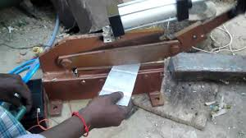
Power shearing machine
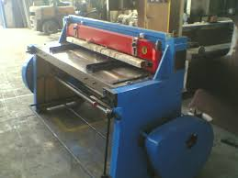

Safety Precautions

- Bench shears must be securely fastened to a bench or purpose designed stand.
- Guards or safety devices must never be removed or adjusted, except by an authorized person for maintenance purposes.
- Shearing edges should be maintained in good condition, should be distortion free and correctly adjusted.
- Working parts should be well lubricated and the blades free of rust and dirt.
- Ensure no slip/trip hazards are present in workspaces and walkways.
- Sufficient space must exist around the machine to prevent accidental contact with passers by.
- Familiarise yourself with and check all machine operations and controls.
- Never use bench shears for cutting metal that is beyond the machine’s capacity with respect to thickness, shape, or type.
- Material should be properly supported during cutting and industrial type gloves should be worn to protect the hands.
- Use supports for long material - signpost if a tripping hazard.
- Manual handling tasks should be assessed and appropriate procedures put in place.
- Hold material securely to prevent it tilting during the cut.
- Ensure fingers and limbs are clear before operating the bench shears.
- When not in use this machine must be locked by, for example, a stout pin through the hole in the blades and kept in place by a padlock.
- Leave the work area in a safe, clean and tidy state.
- Closing movements between shearing surfaces and other parts can result in trapping
- Sharp edges on cutters, work pieces can cause cuts
- Squash/crush and pinch points

Safety guidelines for tools used in engineering workshop :

Hand tools are non-powered. They include hammers, hacksaw, spanners, chisels, vice, pliers...etc . The greatest hazards posed by hand tools result from misuse and improper maintenance.

General precautions
- Using a screwdriver as a chisel may cause the tip of the screwdriver to break and fly, hitting the user
- Using a tool with a wooden handle (e.g., hammer) if the handle is loose, splintered, or cracked, the head of the tool may fly off and strike the user or another worker;
- Using a spanner (wrench) if its jaws are sprung, because it might slip
- Using impact tools (e.g., chisels, wedges) if they have mushroomed heads, the heads might shatter on impact, sending sharp fragments flying.
- Hecksaw blades, knives or other tools be directed away from passage-way areas and others working in close proximity. Knives and scissors shall be sharp. Dull tools can be more hazardous than sharp ones;
- Floors shall be kept as clean and dry as possible to prevent accidental slips with or around dangerous hand tools; and
- Around flammable substances, sparks produced by iron and steel hand tools can be a dangerous ignition source. Where this hazard exists, spark-resistant tools made from brass, plastic, aluminium or wood shall be used.
- Disconnect tools when not in use, before servicing and when changing accessories such as blades, bits and cutters

For further information refer VIDEO LINKs

1. Hand and Power Tool Safety Training
http://www.youtube.com/watch?v=THqYYYDg-qM

Productive task
- Describe general precautions for power tools and hand tools
- Describe why safty is imporant for workshop
- Construct a metal tool box as shown below or any appropriate object by following safety measures for all the tools and equipments you will use to construct.
- Explain which all safety guidelines have you followed while constructing a box or an object
