**Bathroom plumbing.**

C:\Users\Hannah\AppData\Local\Microsoft\Windows\Temporary Internet Files\Content.IE5\31FW49J2\MC900251703[1].wmf

Here is a plan of my bathroom at home.

In this section I am going to show you how to install the correct fittings in a bathroom. Let’s begin by thinking about the different types of fittings we have in a bathroom. Draw a plan of your bathroom at home and label the different fittings.

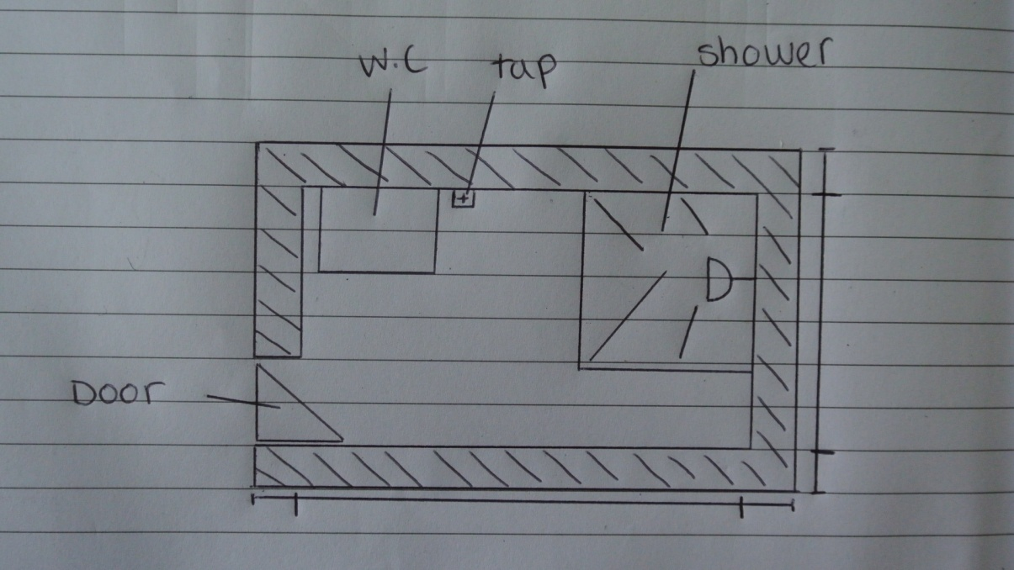

How many different bathroom fittings can you think of? Make a list with a friend.

C:\Users\Hannah\AppData\Local\Microsoft\Windows\Temporary Internet Files\Content.IE5\31FW49J2\MC900251703[1].wmf

The most popular ones here in India are **wash basins** and **showers**. Let’s think about wash basins first, there are many different types to pick from. When selecting which wash basin to install you must first look at your blueprint and decide whether your wash basin is going to be fixed to one wall or in the junction of two walls (in a corner).

**Here are 3 types of wash basin, match the names to the pictures:**

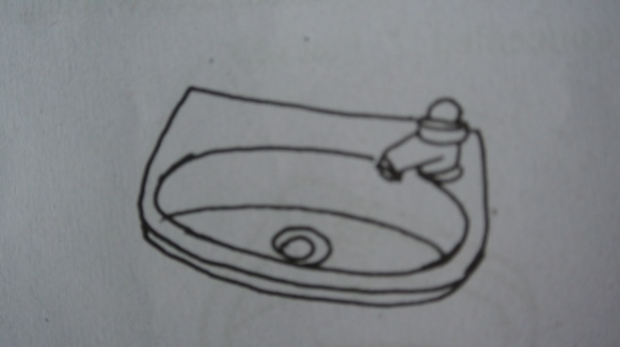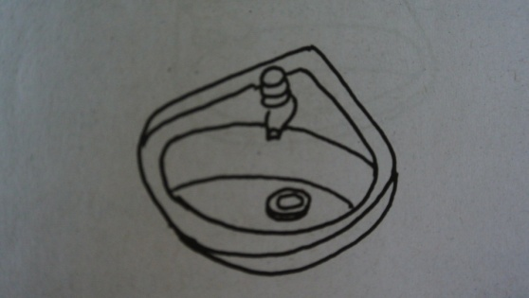

1. Flat backed wash basin

B) Flat backed wash basin with pedestal

E

D

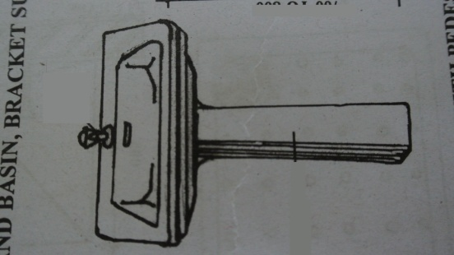

C) Angle backed wash basin (to be fitted at a junction of two walls, i.e. in a corner)

F

[answers: AE, BF, CD]

C:\Users\Hannah\AppData\Local\Microsoft\Windows\Temporary Internet Files\Content.IE5\31FW49J2\MC900251703[1].wmfThese wash basins are provided with single or double tap holes. These tap holes are fitted with C.P Bib Taps for cold or hot water supply. For hot water supple the tap is connected to a pipe coming from the geyser and for cold water the tap is connected to a pipe coming from the over head tank.

Let’s begin our wash basin practical! I will show you step by step how to install your wash basin. Read through my steps first, I will ask you some questions at the end and if you feel confident answering these then that means you are ready to install your own wash basin.

**How to install a wash basin:**

**Step 1:**

Measure and draw out where the wash basin will be. To do this you will need to use a piece of string and some chalk, you will also need to follow the blueprint we made earlier.

Draw a line where you would like the top of the wash basin to be. Now draw circles where you need to make holes in the wall for the tubes to go through. The circles should be drawn with the same diameter as the tubes. You can now use a chisel and hammer to make these holes.

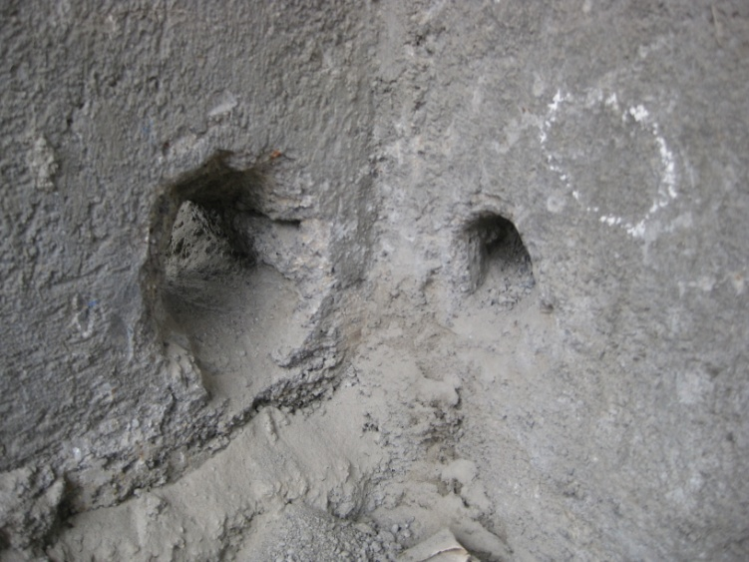

**Step 2:**

Some wash basins come with a readymade bracket, if not then we have to make one. To make the sink bracket you will need to bend a metal rod so that it fits under the rim of the wash basin. You must then attach brackets to either end, so that it can be screwed to the wall and support the weight of the wash basin. To do this you will need to use a soldering iron.

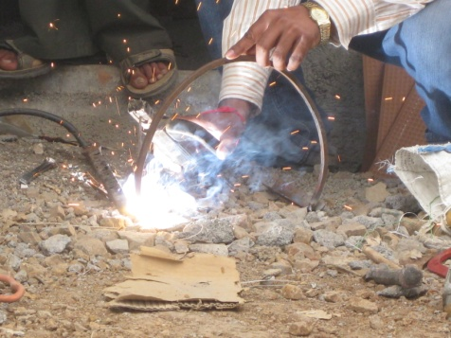 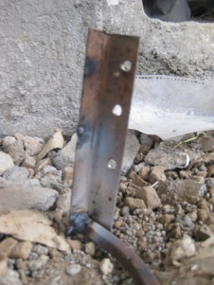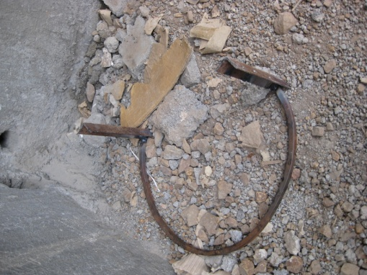

**Step 3:**

Drill the wash basin to the wall

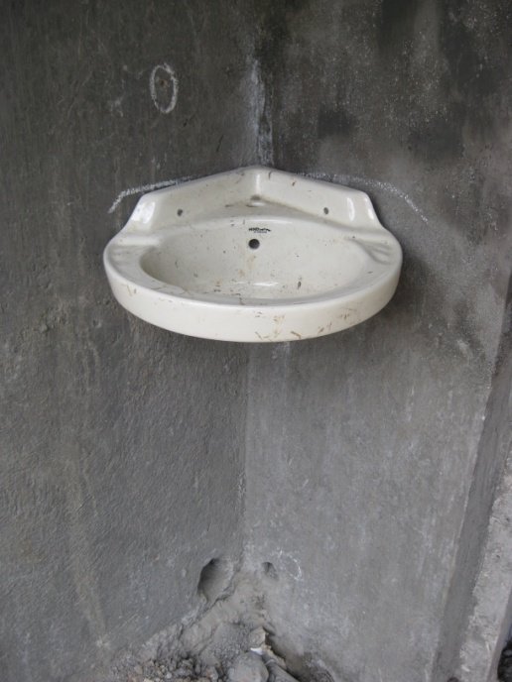

**Step 4:**

Place the bracket under the wash basin so that it is taking the weight and then drill it in place.

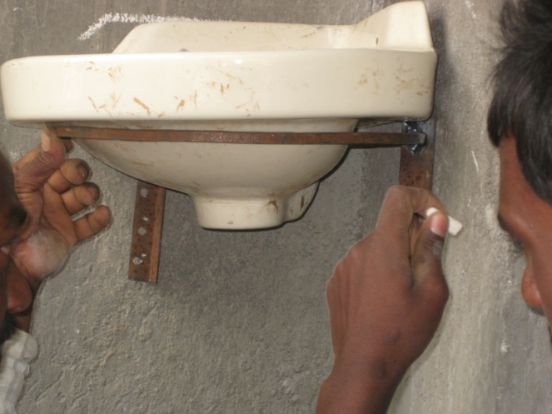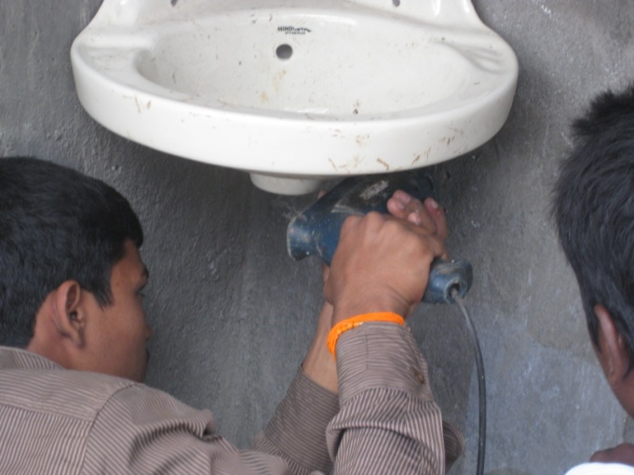

**Step 5:**

Unscrew the C.P Waste coupling, removing the locking nut and rubber washer. Then place the C.P waste fitting in the circular waste hole at the bottom of the basin. This is fitted in place by screwing the rubber washer followed by the locking nut underneath the basin.

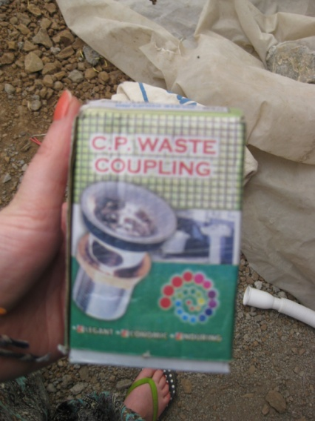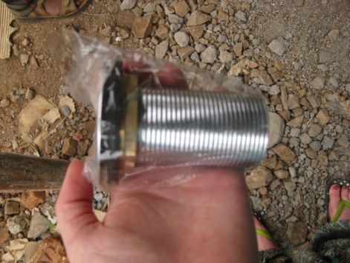

**Step 6:**

Now attach the flexible PVC waste pipe to the C.P Waste fitting.

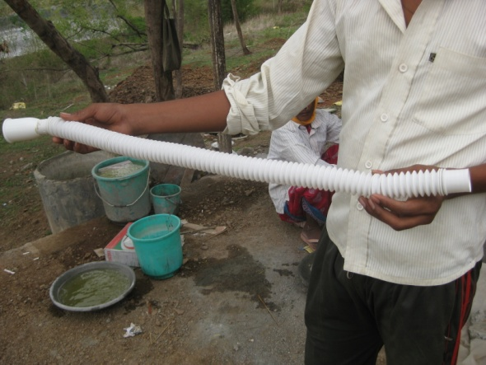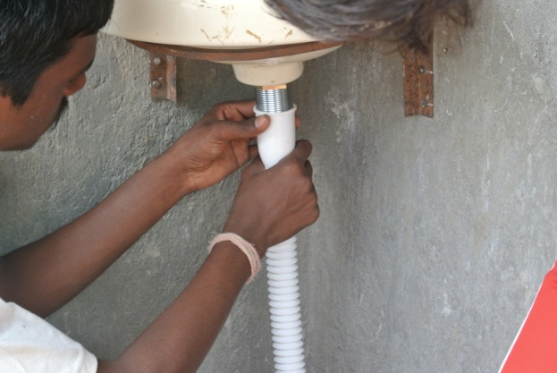 (Double click for a video of screwing the pipe in place)

**Step 7:**

Attach the flexible piping to the PVC internal piping.This will require you to measure the amount of tubing needed and then cutting it to the appropriate length. When threading the pipes you should use adhesive to prevent leakages and ensure water tight joints.

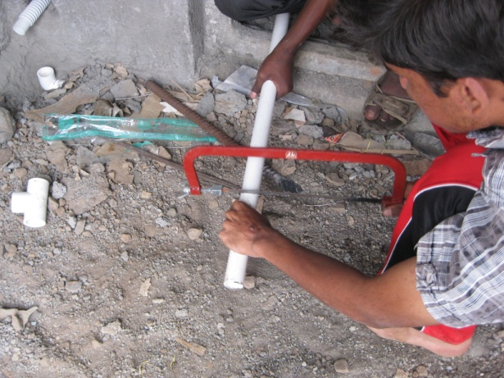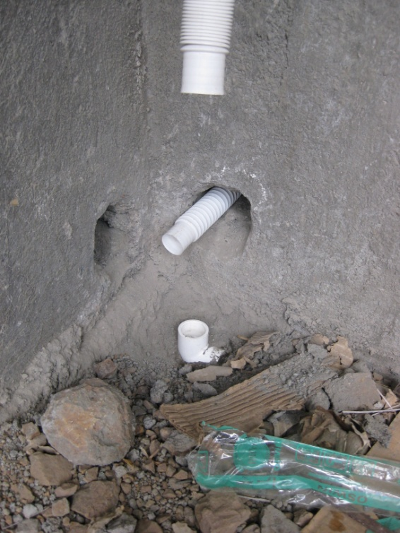

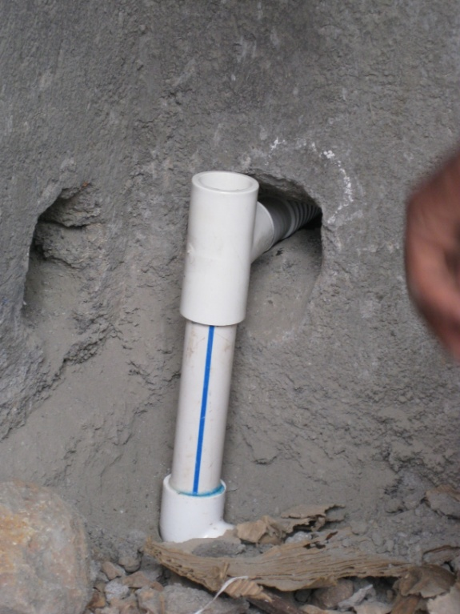

 (Double click for a video showing how to apply adhesive)

**Step 8:**

Finally attach the tap. *Using......*

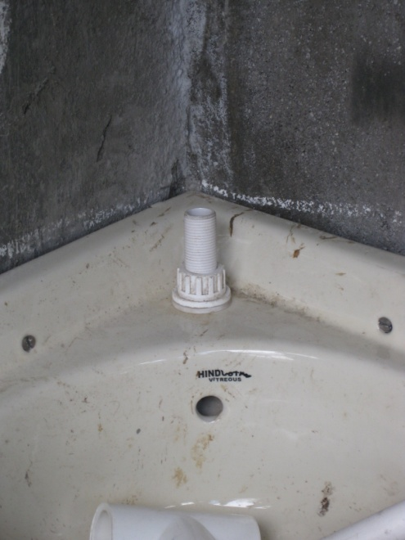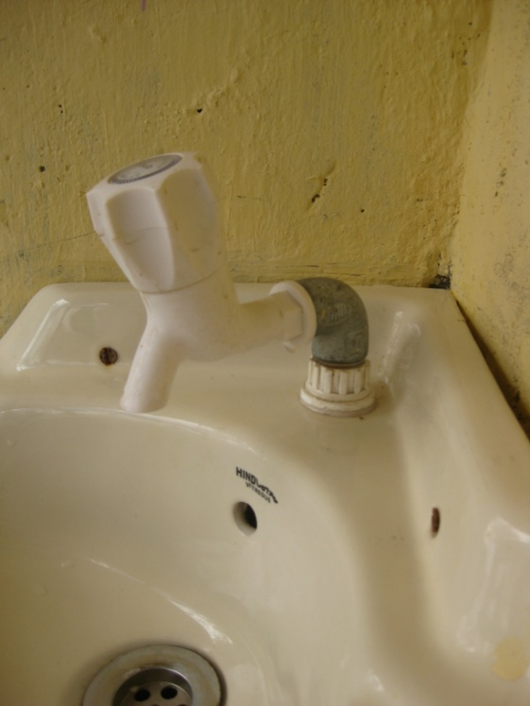

**Wash Basin quiz:**

1. Why is it important to fit a bracket under your wash basin?
2. When joining two pipes together what must we do to ensure they don’t leak?
3. What must we do before we chisel a hole in the wall?
4. What is the purpose of a rubber washer?
5. C:\Users\Hannah\AppData\Local\Microsoft\Windows\Temporary Internet Files\Content.IE5\31FW49J2\MC900251703[1].wmfWhat safety precautions must be taken when using a soldering iron?

You are now ready to fit your own wash basin, good luck!

Now let’s discuss the other common type of bathroom fitting: **Showers**

Showers can either have a floor sink or a built in floor trap:

