Tiling
I really want to learn how to tile! But where do I start?
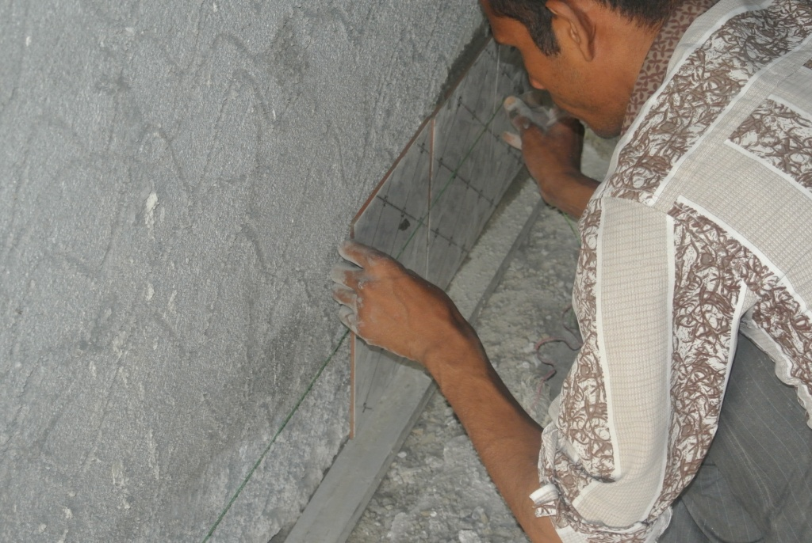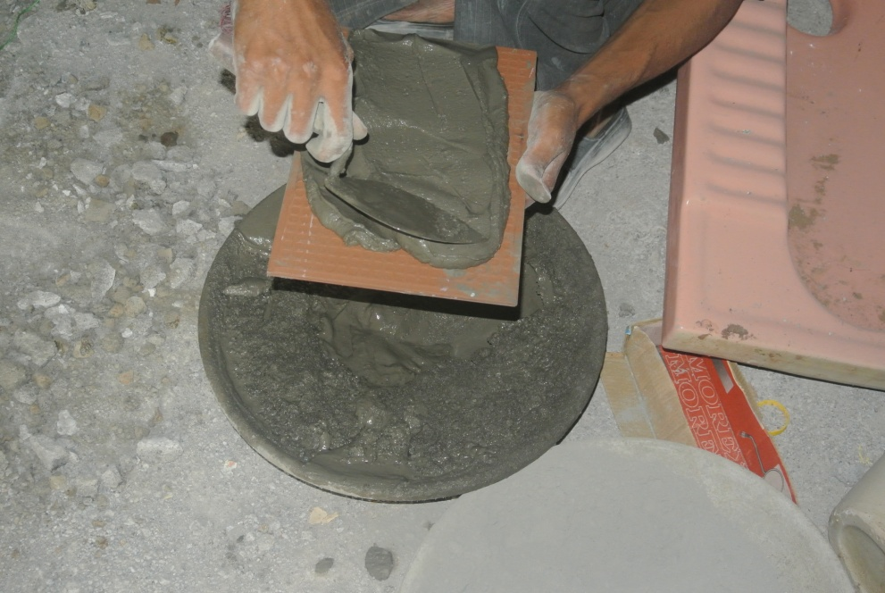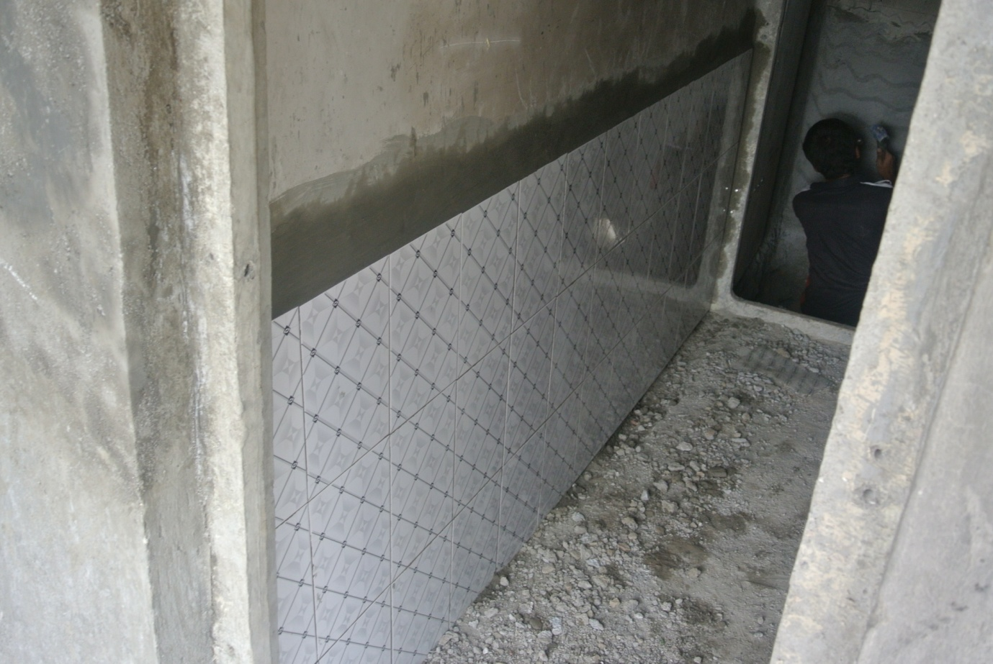
Step 1: Planning
How many tiles do we need for our wall?
Well, it depends on the size of wall you wish to tile and the area of the individual tiles.
OK. But how do we know how many to use?
Look at the wall you want to measure. Measure how high and how wide it is. Multiply the height of the wall by its width. It is important to have surveyed which size tile you are likely to use. Have 2 or 3 different size tiles in mind. Simply divide the area of the wall by the individual area of the tile and you will have the number of tiles needed.
Do you understand? Use the online tile calculator to check your work:
http://www.online-calculators.co.uk/diy/tiling-paving.php
Don’t forget to order some extra perhaps 10% (Take total number of tiles and times by 1.1) more in case you need to cut some or break any.
Okay, I’ve got the number of tiles I need. But how do I arrange on a wall correctly?
Use a straight edged measuring stick to plan how the tiles will fit. If you have a space needing only half a tile – do not worry we will come back to that.
Step 2: Preparation
Prepare the wall. Clean wall and ensure it is smooth and levelled throughout. Remove existing tiles.
Step 3: Get it straight
Ok I’ve got my tiles and my wall is prepared, what next?

To make sure that the tiles are applied straight, you need a sprit level and a piece of thin wood that is perfectly straight. If tiling from the ground use the sprit level to assess how level the ground is all the way along the tiling area. If level then good, just place the thin wood and you are ready to begin! If not, it is not a problem. Just measure from the bottom of the wall one tile length plus grouting (usually 3mm) and draw a straight line along your wall. Check with spirit level that this line is exactly straight.
Video footage taken from Vigyan Ashram of another way to keep tile straight:
< double click on the icon to watch the video

Step 4: Fixing
Ok, now how do I stick the tile to the wall?

Use adhesive or cement and sand mix. Apply either to wall (if clean) or tile. See picture above for amount
Video footage taken from Vigyan Ashram : <double click the icon to watch
MIXING: 1 PART CEMENT (1/2 BAG ) 12.5 KG,
3 BAGS X 25 KG WASHED SAND.
1 PART FLEX ADHESIVE (1/2 BAG 10.00 KG.)
(IF POSSIBLE)
Ok so how do I work out the space needed between tiles?
Either use a plastic separator (width 3mm) and put one at top and one at bottom of tile or measure roughly the same gap throughout. Remember 3mm is very small.
Step 5: Cutting
What if I need to cut the tile?
Mark the line along the tile which needs to be cut. Use a sharp blade to cut the tile – be firm. Cut on the glazed side of the tile.
I have a power socket in the way! HELP!
Measure the exact dimensions needed and cut the tiles accordingly, ‘jigsaw’ them into place.
Great I’m ready to start tiling!!

Activity:
Tiling a wall: You have a 1m x 1m wall needing tiling. How many tiles would you need (you can select the tile size)? Your aim is to tile the wall correctly so that every tile is level and has a gap of 3mm between all tiles.

1m

1m

Floor Tiling:http://www.youtube.com/watch?v=SSARCtFYU04

