Food
- Mrs. Pallavi R Shanbhag
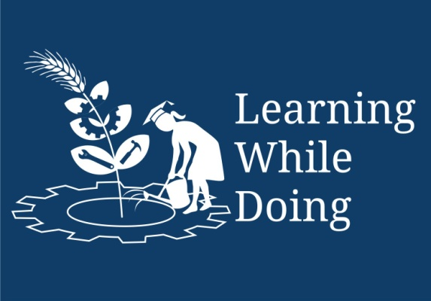

Open Education Resource

Food
“Food is any substance consumed to provide nutritional support for the body.”
It is usually of plant or animal origin, and contains essential nutrients, such as carbohydrates, fats, proteins, vitamins, or minerals.
Food is important for life. To be healthy and active, we should certainly have enough food. But the foods we eat should also be safe and rich in all the nutrients for our body needs. We should choose from a wide variety of foods and we should eat them regularly, throughout the day, every day of the year. Do not forget that we should also enjoy the food that we eat; it should look, smell and taste good. Without good nutrition, children and young people cannot develop their potential to the full, and adults will have difficulty in doing their best.
Food provides our bodies with what they need to:
- stay alive, be active, move and work;
- build new cells and tissues for growth;
- stay healthy and heal themselves;
- prevent and fight infections
Functions of Food:
- Growth and development
- Develop strong muscles, bones and teeth;
- Keep our bodies warm and give us energy;
- Keep our bodies healthy by helping our immune systems to prevent or fight disease;
- Repair or healing of injuries.
- Helps our brains to grow and function properly.
- Development and proper working of our organs: heart, kidneys, lungs, liver, etc.

Let’s see - what is diet?
Diet:
Diet is sum of food and drink we consumes.
- The kinds of food that a person, animal, or community habitually eats
- The sum of the food consumed by an organism or group
A healthy diet is one that helps to maintain or improve general health.
Balanced Diet:
You cannot eat only fruits you need something more. You cannot eat only vegetables. You need something more. Hence to maintain normal functioning of the body, we need varieties of food which gives us proteins, carbohydrate, fat, vitamins and minerals.
A diet containing all the essential food constituents in correct proportions is called as ‘balanced diet’.
A balanced diet should have the following qualities:
- It must be rich in various essential nutrients and include foods from all food groups.
- It should provide necessary energy required by the body.
- It should be economical.
Different food gives us different nutrients. So, we must try and eat a little of all types of food every day.
"Food & Nutrition Guidelines"
- Eat a variety of Foods
- Eat vegetables and fruit every day
- Eat more fish
- Use whole grain products
- Use only iodised salt, but use less salt
- Eat at least three meals a day
- Avoid drinking alcohol
You will ask me now- What are the nutritional components of food? For that click on the link below:
Nutritional Components of Food.pptx

Basic Facts about Nutrients
Nutrient | Functions | Good Sources
Protein | Helps us to grow, develop and repair muscles and tissues. Some protein foods such as milk and eggs give us strong bones and teeth. | Peas, beans, poultry, cereals, lentils, milk, cheese, eggs, meat, wet and dry fishes, pulses, and nuts.
Carbohydrates | Provide energy for the body. There are three kinds of carbohydrates: sugar, starch, and fibre. | Starch (storage forms carbohydrate of chlorophyll containing plants), sugars, cereals, potatoes, legumes, millets, roots and other vegetables. Sugars are found in fruits, juice, cane, honey, palm, milk, etc.
Fats | Provide energy for the body and carry certain vitamins through the body. | Marula nut, ground nut, butter, margarine, cooking oil, seeds.
Vitamin A | Needed for healthy eyesight and to prevent night blindness, (exophthalmia). | Liver, heart, kidney, milk, cod liver oils, fish liver-oils, butter, eggs, carrots, cabbage, vegetables, green leaves, mangoes, potatoes tomatoes, spinach, papaya etc.
Vitamin D (Cholecalciferol) | - Control calcium and phosphorus absorption from the small intestine, concerned with calcium metabolism, helps in the bone and teeth formation.  - Minimize the losses of calcium and increases phoshate excretion by the kidneys, affects insulin secretion in pancreases. | Fish liver oils e.g., cod liver oil, halibut - liver oil etc. Butter, milk, eggs, liver. In sub coetaneous tissue,  7 dihydrocholesterol is conveted to vitamin D by UV light.
Iodine  (mineral) | Iodine is for the thyroid gland (in the neck area), which regulates growth and many body functions. A lack of iodine can lead to an enlargement of the thyroid gland called goiter. | Iodised salt, seafood and foods which are grown in soil that contains iodine.
Vitamin C (Ascorbic acid) | Acts as antioxidant.  Helps in bone formation.  Helps in wound healing. | Guava, amla, green chilli, amaranth leaves, citrus fruits, green vegetables, potatoes, tomatoes, cheese, milk etc.
Vitamin B1 (Thiamine) | - Acts as a co-enzyme in carbohydrate metabolism  - Require for the synthesis of glycine  - It has a specific action on nerve tissue  - Maintains normal appetite. | Rice polishing, dried yeast and wheat germ are rich sources of vit. B1.
VitaminB2 (Riboflavin) | - Precursor of coenzymes (FMN and FAD) in oxidation-reduction reactions of electron transport chain, fatty acid synthesis etc.  - Essential for growth, essential for tissue oxidation related to carbohydrate, fat and protein metabolism.  - Maintain mucosal, epithelial and ocular tissues.  - Essential for normal vision. | Milk, liver, kidney, muscle, butter, chicken, fish, yeast, cheese, raw egg, white grains, green vegetable such as spinach, peanuts, fruits such as apple, orange etc.
Iron  (mineral) | Iron helps the body to make red blood cells, which carry oxygen from the lungs to cells throughout the body. A lack of iron can lead to the disease called anemia. | Beef, goat, pork, dark green leafy vegetables such as spinach, brown bread, beans.
Niacin  (vitamin) | Helps the body to get energy from other nutrients and helps keep the skin and nervous system healthy. A lack of niacin leads to pellagra. | Whole grain cereals, meats and seeds: Brown bread, groundnuts, pumpkin and inara seeds, sorghum, pearl millet, meat, and chicken.
Water | Water carries nutrients in the body and waste products from the cells and helps control body temperature. When the body does not have enough water, this can cause dehydration (drying out) | Water, milk, fruit juice, soups, tea and vegetables with high water content such as lettuce, apples and potatoes.
Now you will come to know why a variety of (different foods from the Food Groups) foods are needed by the body.
Responses to expect are:
- Food Groups contain many different things call nutrients, and each nutrient has a different job within the body.
- Some nutrients need to be combined with other ones before they can work properly.
- Some foods contain a few different nutrients and not all foods contain the same ones. This is why it is important for us to eat a variety of different foods from all Food Groups, to make sure that our bodies get the right kinds of nourishment to help them to work properly.
And how food choices get influenced – get to know please follow the link-Influences on Food Choices.pptx

