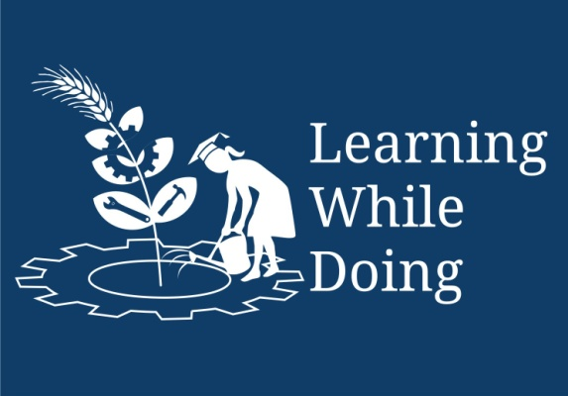

Productive task:
- Preparation of Pickle.
- Preparation of Fruit Candy.
- Preparation of nut brittle.
Concept:
Learner will able to understand about preparation of pickle from different fruits and vegetables, fruit candy, nut brittle- their costing and preservation techniques.

Tools: mentioned in each task...

Class-Age Group: 14 and above.

Module IV – Food Processing
Lesson 3: Fruits &Vegetables- Preparation of Pickle & Fruit Candy
- Author Name : Mrs. Pallavi R Shanbhag

Open Education Resource
Concept Map (Image):
Eating a variety of things, which are available in the market, grew human interests. Hence his needs grew. Every man in this country to enjoy the meal began to increase the use of this pickle. With the help of available seasonal fruit vegetables, fruits; one could prepare pickle. Also these fruits can be used after processed as candy.
For example: mango, lemon, tamarind, tomato, chillies, pepper, aonla etc.
First we will know about Pickling.
Do you know what pickling is?
Pickling is the process of preserving food by anaerobic fermentation in brine or vinegar. The resulting food is called a pickle. This procedure gives the food a salty or sour taste.
Prerequisites:
- Purchase good quality fruits/ fruit vegetables from the market, out of which we have to prepare pickle.
- Get the ceramic/glass jar to store the pickle.
- Keep ready all required utensils and ingredients together.
Expected skills:
1. To know the pickle recipe.
2. To take all ingredients in appropriate proportion.
3. Selection of sound and firm fruits.
Important information:
Pickle once get prepared, can be consumed for long term of period.
How to preserve pickle?
Homemade Mango pickle as well as lemon pickle which are prepared 2-3 years back will not remain good. It means, within 2-3 months it get covered with mould. Even though, it is rich in oil.
The container is cleaned carefully; also care is taken while removing the pickle from the pickle container. Container's lid is fitted well.
Though why does it happen?
Do you know how to preserve the pickle for long time?
Here some tips are given below to preserve the pickle:
- Use salt in given proportion.
- All ingredients should be dry and cleaned well.
- All utensils and jars also dried in sunlight before using for preparation.
- Use fresh pickles and add salt in proportion only.
Before going through the actual task we will first see, the role of preservatives added through the documents given in resource documents. Role of Preservatives in Pickle Preparation.pptx
FOOD PRESERVATION BY SALT, ACID, SUGAR AND CHEMICAL PRESERVATION.pptx
Productive Task1: Mango Pickle Preparation.
In this task we will learn common mango pickle preparation.
For the recipe please go through the document from resource link below:
Pickle preparation.pptx

If you about aonla pickle preparation please go through the document from resource documents.

aonla pickle.docx

Questions:
- What is role of oil?
- Explain the role of salt.
- Why we should used threaded jars for Storage?
- How sugar plays important role in preservation?
Is there any question in your mind – how much will it cost?
For get to know this go through the document from resource documents
costing of pickle.docx
Questions:
- Which are the different fruits and vegetables which can preserve as pickle?
- Calculate costing of aonla pickle.
- Aonla is rich in which vitamin?

Now we will see what candy is-
Productive Task 2: Fruit Candy Preparation.
Candy is of different types.
To know some more key points about candy please go through the document from resource documents:
candy.docx
Now we will prepare candy fruit candy...

For Fruit Candy Preparation go through the document from resource documents:
Fruit Candy.docx

Questions:
- Is there any fruit out of which a fruit candy can be made? Prepare the flow chart for the new recipe of fruit candy.
- Which preservation method is used in making fruit candy?
- What is the role of sugar syrup in fruit candy?
- Is there drying is necessary during the fruit candy preparation?
- Calculate the costing of aonla candy both sweet and spiced differently.

Productive Task 3: Candy – nut brittles i.e. chikki Preparation.
Introduction:
Nut brittle i.e. chikki is traditional ready-to-eat Indian sweet generally made from groundnuts and jiggery.
There are several different varieties of chikki in addition to the most common groundnut chikki. Each chikki is named depending upon the ingredients used. Usually, ingredients such as puffed or roasted Bengal gram, Sesame, puffed rice; beaten rice and desiccated coconut are used.
Some chikkies are made using a combination of these ingredients.
Special chikkies are made out of cashews, almonds, and pistachios.

Purpose:
To prepare chikki from the ingredients such as coconut, groundnut, sesame seeds which can be readily available in local market and calculate costing.

Prerequisites:
- Get available all the material in proper proportion.
- Selection of tray is very important to get ideal thickness of nut brittle.
- To cut into pieces, a good cutter- knife, having sharpness is essential.
Expected Skills:
- Jaggery melting is very important and judging checking point.
- Calculate costing of final product by using material cost.
- Cutting into uniform pieces.
Precautions:
- Take care that peelings of the groundnut should not be in the chikki preparation.
- Uniform thickness should be there while spreading in the chikki tray.
- Each piece should be uniform while cutting.
- Do not pack the chikki when it is too hot.
- Cut the pieces of chikki when the final mixer of groundnut and Jaggery is hot.
How to prepare nut brittle i.e. chikki?
For the procedure please click the link below:
Nut brittles - chikki.docx
Questions:
- Calculate the costing of chikki which you made.
- Enlist the different types of chikkies which are available in local market with cost and ingredients added.
- Visit chikki manufacturing unit in nearby area and note the observations which you have made.
- Give the flowchart for the nutritious nut brittle with addition of dry fruits. Also specify its nutritional value.

