BASICS OF WELDING

Introduction :
Manufacturing is the use of machines, tools and labor to make things for use or sale. Manufacturing is of different form e.g electronics good manufacturing, chemical manufacturing, food products manufacturing etc. In this section, we are going to discuss manufacturing process in mechanical engineering field. These processes are basic processes for converting raw material into products. We will also discuss the basic safety precautions while working in the workshop. In practical section, you are going to do these operations yourselves.

Safety precautions
Life is precious. Therefore while working with machines always follow following safety rules. Those who are not following safety rules are putting their own and others life at risk.
- Workshop place has to be clean. There has to be free space around the machine. All rotating parts of machines must be covered or not accessible.
- Please check electric connections and safety related to electric devices.
- Workshop floor has to be dry and free from oil, water and grease.
- Machine switch has to be near the machine table and free from any obstacle.
- Check wiring and earthing for all machines
- Never do welding without welding screen or goggles.
- Use safety goggles while grinding, drilling.
- While doing construction always use hand gloves and helmet.
- Keep all tools in its position.
- Keep the aisle free to run towards exit in case of emergency.
- Be careful while working with sharp objects.
- Whenever power goes off, please put all the switches in ‘OFF’ position.
- Please put the tools and safety gadgets in the designated place.
- Do not disturb person working in the workshop.
- Keep first aid box in the workshop.

Welding :
Welding is the most economical and efficient way to join metals permanently. Following are the types of welding.
- Forge welding : In this two pieces are heated upto plastic stage and then hammered together till they joined each other.
- Arc welding : It is commonly found method in fabrication workshop. An electrical current is used to form a arc. A welding rod is used as electrode. A arc is formed between the tip of the welding rod and the base material. Tip of the welding rod melts and works like a filler material between the pieces to be joined. A flux is applied to welded material to protect it from oxidation. The process is very versatile, requiring little operator training and inexpensive equipment. This process is generally limited to welding ferrous materials and filler metal. Welding machine required for this is generally inexpensive. This type of welding is best suited for welding mild steel in the range of 2-8mm in thickness.

Welding Joints
If joint to be welded has wide gap or is dirty, rusting or greasy then we will not get good result. Depending upon shape of the object to be welded , we need to prepare joints. Here are commonly used welding joints.
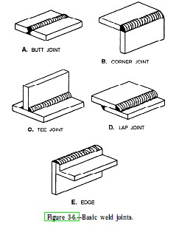
The 5 weld joints are named Butt joint, Corner joint, Edge joint, Lap joint and Tee joint as shown in fig.1.
The first one named Butt joint is a joint that is between two members lying approximately in the same plane.
The second one named Corner joint has two members located at right angles to each other in a from of an angle, mostly 90 degrees.
In Tee joint, it looks just like it is called because it forms a "T".
Fourth one is a Lap joint, that has two
Fig. 1 overlapping members to form the joint.
The Edge joint is a joint between the edges of two or more parallel members.
Depending upon the thickness of joint, butt joint is also made of following types.
1) A butt joint
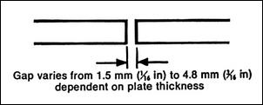 fig 2(a)
2) V butt joint :
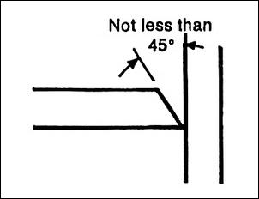 fig.2(b)
3) double V butt joints . When metal is thicker.
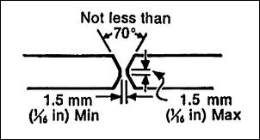 fig.2 ( c )
4) A Lap joint
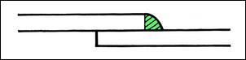 fig.2 ( d)

5) T joint

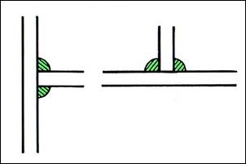 fig. 2 ( e )
Fig 2.
Gas welding : Gas Welding is widely used for repair work, especially in welding thing sheets, cutting ferrous material, welding non ferrous metals.

Commonly used welding are Oxy-Acetylene welding. Acetylene gas when burned alone can produce a flame temperature of about 4000 deg. F. With the addition of Oxygen a flame temperature in excess of 6000 deg. F. can be achieved. By using the proper tips, rods and fluxes, almost any metal can be welded, heated or cut using the Oxy-Acetylene flame.
Things to remember
Welding arcs are intensely bright lights. They contain a ultraviolet light which may cause eye damage. For this reason, the arc should never be viewed with the naked eye. Always use welding goggles while welding.

Intext question 5.1

Two metal pieces are heated and hammered together in _____ welding.

To carry out welding of material in same plane _____ type of joint is most suitable.

Commonly used gas in gas welding is ______.

