- Productive task :
Cultivation of any one exotic vegetable variety in kitchen garden and / or pots in balcony.
Concept :
- After going through this OER, Students will be able to identify different exotic vegetables in Indian market and perform cultivation practice of selected crop in their kitchen garden.

Tools :

Class-Age Group : 8th Pass and above.

Cultivation of exotic vegetables
- Mr. Ranjeet Shanbag
Open Education Resource
Introduction:

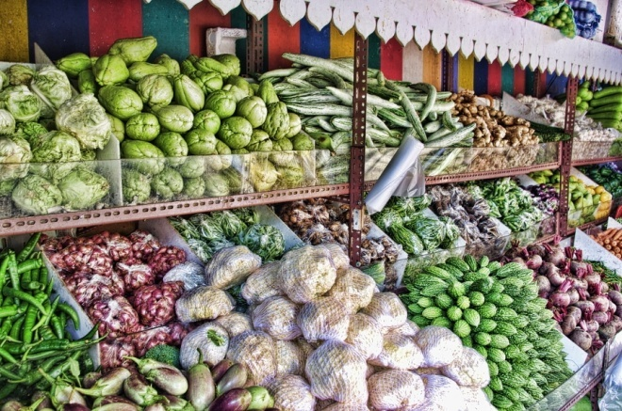
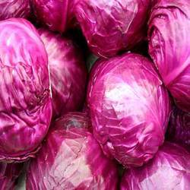
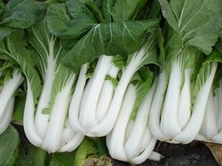

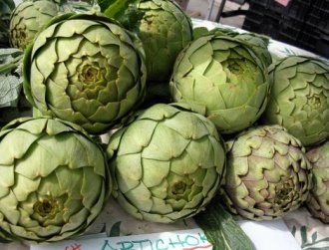
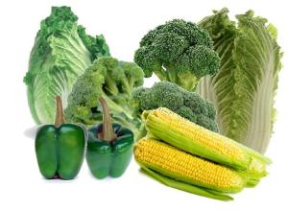

Can you identify vegetables shown in above photos? (NO? then this OER will help to know more about these photos)
If you visit any shopping mall in cities like Pune, Mumbai, Delhi, Kolkata, you can see these vegetables or fruits which are not very common to us. They are mainly exotic vegetables (not native of India) and now a day’s grown and sold at high price, that our Indian vegetable in metros/ city market. These fruits / vegetables are used for preparation of exotic dishes in big hotels / homes. For more information on this you can visit to –
http://agricultureavenues.blogspot.in/2012/08/globalization-has-brought-many.html
http://timesofindia.indiatimes.com/india/Cultivation-of-exotic-vegetables-picking-up-in-HP/articleshow/7531260.cms
Growing of exotic vegetable & fruits is more profitable business than cultivation of traditional Indian vegetables. Let’s for example see below market rates for common exotic vegetables Vs common traditional vegetables –
Regular capsicum Colored capsicum Cauliflower Broccoli

Vs Vs Vs

Rate Rs.20 / KG Rate Rs.16 / KG
Rate Rs. 80 / KG Rate Rs. 60 / KG

Rate Rs. 80 / KG Rate Rs. 60 / KG
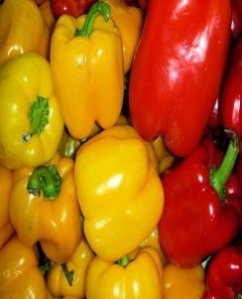
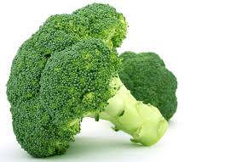
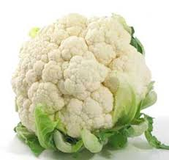

Many innovative farmers are now growing these vegetables on commercial scale and earning handsome income from it. Now let’s see some of the successful farmers and their experiences.
- Mrs. Vanita Gunjal is innovative lady farmer from Junnar area of Pune district, Maharashtra. From last 25 year she is cultivating many exotic vegetables in her …. Acrea area and supplying to various traders of Mumbai/ Pune city with contract farming system. She is earning 75000 Rs/ month from 1 hector area as net profit. For more information about her farming you can visit - http://www.icar.org.in/node/2330
- Trikya agriculture (http://www.trikaya.net/) is India’s one of the largest cultivators and suppliers of exotic vegetables. They cultivate variety of vegetables on more than 200 acre of land in Maharashtra state with cold storage facility.

Friend do you know, exotic vegetables are mainly grown for city market and now days they are in high demand in –
Now a day’s online shopping site are also trading exotic vegetables. Like that of –
http://www.buysubzi.com

- Shopping moll located in big cities.
- 5 Star hotels / International hotels.
- Multinational fast food chains like Mcdownlds / Dominoes etc.
- International tourist places.
- High profile societies.

So, friends as per above links this is very clear that cultivation of these exotic vegetables is one of the fastest growing industry with high profit margin than traditional vegetables. So let’s see which are the important exotic vegetables commonly grown in India with their respective common cultivation requirements.
To know more about common exotic vegetables in India with their basic cultivation requirements follow following PPT:-
Download:- Introduction to important - Exotic Vegetables.ppt
You can also refer following link for more information –
http://www.scribd.com/doc/66520958/20524737-Exotic-Vegetables-and-Fruits

Self Assessment:

- Write down common Exotic vegetable (any 5) available in your area.
- Discus important advantages and constrains of exotic vegetable cultivation in India.
- Visit to nearest exotic vegetable growing farmer and/ or retail out let’s to know more about its cultivation economics and demand-supply chain.

HPNPDL:
- Do you know in which climatic condition broccoli grows?
- Find out in which food dishes coloured capsicum is used?
Productive task 1:

Let’s try some cultivation practices –
- Bring any exotic vegetable seed from your nearest Agro clinic store (seed for exotic vegetables are mostly available in cities / metros).
- Depending on the vegetable you select (seed purchased) find the cultivation practices and climatic requirement for this crop.
- Cultivate these seeds in small pots / trays / raised beds in kitchen / terrace garden.
- Record the growth of the plants like – germination % , growth , number of leaves etc.
- Harvest your crop and try to sell to your friend with profit for your success.
You can also try humid chamber / hydroponic cultivation of these vegetables in your school / home garden/ terrace garden.

For commercial cultivation of exotic vegetables it’s very important to consider following points as –
- Climatic and soil requirement of selected crop – Most of the exotic vegetables prefer cool climate and requires well drain fertile soil, so for commercial cultivation of these crops requires climatic control system like polyhouse / greenhouse cultivation.
- Planting material / seeds required for exotic vegetable cultivation are mainly imported from countries where they grow commonly, so need to purchase from authentic source.
- Markets for exotic vegetables are mainly city / metro situated and they can’t be sold in regular market with desire price. So before large scale cultivation it requires to have firm knowledge of market / sales outlet. It’s better to have contract farming with forward marketing linkages.
- Cultivation of exotic vegetables requires high investment.

For more details on individual vegetable cultivation you can visit on -
http://www.mnn.com/your-home/organic-farming-gardening/stories/how-to-grow-broccoli

Summary:

From this above OER we have learnt –
- Scope of cultivation of important exotic vegetables in India with advantages and constrains in exotic vegetable cultivation.
- Important exotic vegetables grown in India with few case studies of Indian farmers.
- Soil and climatic requirement for the important exotic vegetables in India with.

