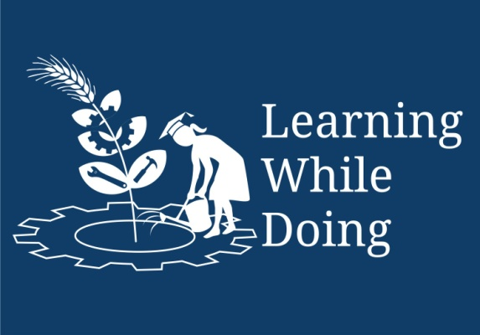

**Productive task** : Make use of solar cooker and solar dryer, make a bamboo solar dryer, make a solar cooker using available material/aluminium foil

**Concept** : Types of solar cooker – Parabolic & box type, Dryers

**Tools** : Solar cooker / Dryer

**Class-Age Group** : VIII - X

* ***Solar cooker and solar dryer***
* **Jenny Ralston, Sarah Lumsden**

*Open Education Resource*

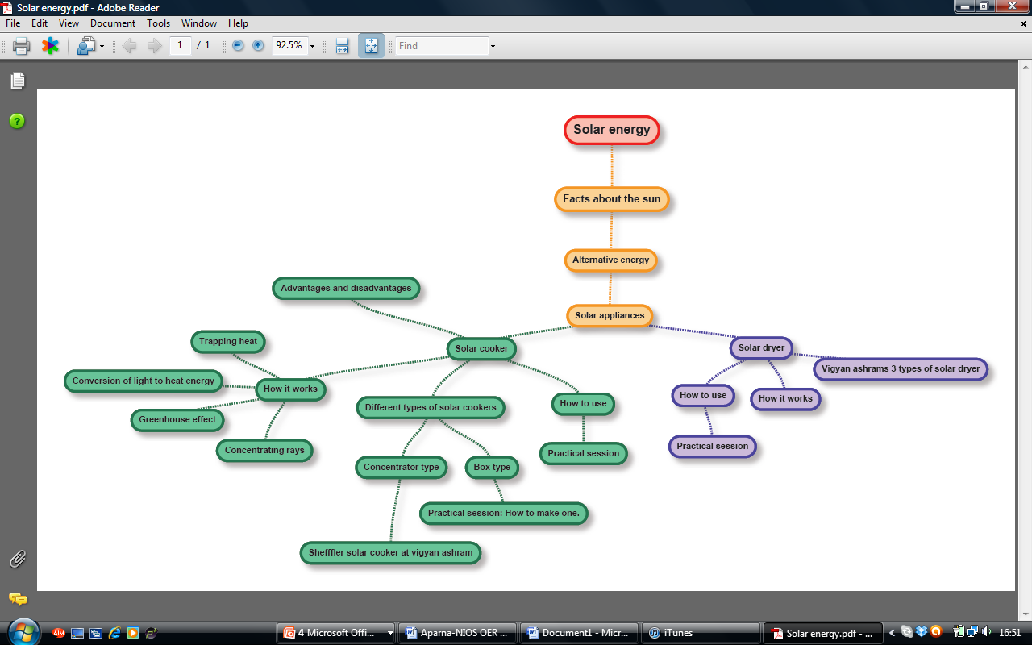**Concept Map (Image) :**

Solar Cookers and Solar Dryers

Hi! My name is Sunny. People use my solar energy in solar cookers and solar dryers to prepare food to sell at the market and to feed their families. I’m going to tell you all about how they do this, so that by the end of this lesson you will be able to;

* Explain how solar cookers and dryers work and why they are useful.
* Be able to construct your own solar cooker.
* Be able to demonstrate the use of a solar cooker and dryer.

Let’s begin by watching this PowerPoint:

Let’s begin by watching this PowerPoint:

MC900438205[1]

Please see the powerpoint :’Solar cookers & Dryers Part1.ppt’

**Productive task1: Using solar cooker**

**Activity 1:** Take a trip to see a local solar cooker and draw what you see. Annotate your drawing to explain how you think the cooker uses the 30-40°C heat from the sun and converts it into 100 °C to boil water and to cook. Note down rough dimensions so take measuring tape with you. If you don’t have a local solar cooker, you can look at these pictures instead:

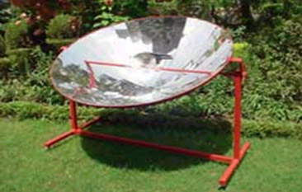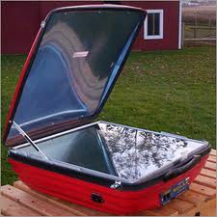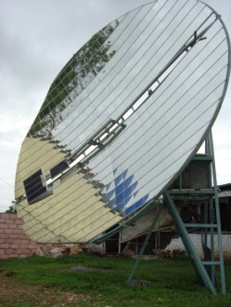

1. Use solar cooker to make hot water. Find out time required, temperature of water
2. Cook rice using any solar cooker.
3. List out advantages and difficulties of using solar cooker.
4. Discuss number of sunny days in village. What is the temperature outside ? Cloudy days ?

MC900438205[1]

Let’s see if you have correctly guessed how a solar cooker works!

Please use Powerpoint lesson ‘*Solar cookers and dryers part 2* PPT’

Make sure you read the ‘notes’ section under the slides on the PPT (if there are any)

**Productive task1: Making own solar cooker / Dryer**

**Activity 2:** You are a designer and after learning about the different ways a solar cooker works, you have decided to design your own. Use your previous drawings, from Activity 1, and your new knowledge to design a solar cooker to use in your village.As the designer you must then try to sell your design to someone in the village. You must explain to them exactly how it works and how this solar cooker will benefit them.

Here are some examples of the things that you must consider:

* Will the cooker to be portable or stationary?
* What quantities of food will be cooked on it
* What are the weather conditions in your village and what precautions need to be made for these conditions?
* Where will the cooker be placed?

MC900438205[1]

Now let’s take a look at the different types of solar cooker already available in the market.

You may use Presentation ‘*solar cookers and dryers part 3* PPT’

* **Students may be asked to undertake this activity as project.**
* **To make solar cooker using scrap material, aluminium foil etc.**
* **Different D-I-Y solar cookers design available on internet.**

You may use Presentation ‘Solar cookers and dryers part 4 PPT’

* **Students can make Bamboo dryer designed by ARTI.**

**Activity 3:** You are now going to construct your own box type solar cooker/ Bamboo dryer with help from Sunny.

MC900438205[1]

Now we have built our own solar cooker lets learn how to use it!

Next we are going to learn about another appliance that uses solar energy: Solar Dryers.

**Productive task1: Making own solar cooker / Dryer**

**Activity 5:** Imagine you go to your local market and meet Mandip. This is what she says to you:

I am tired of my dried fruit always getting eaten by insects. It takes me days to dry it outside in baskets and then when I try and sell it at the market nobody will give me a good price for it because it is covered in insects. I don’t know what I should do and I am running out of money.

C:\Users\Hannah\AppData\Local\Microsoft\Windows\Temporary Internet Files\Content.IE5\D4V0HS8B\MC900435534[1].wmf



You must try and persuade her to use a solar dryer to dry her fruit**.** Write in a speech bubble what you would say to her. Some things you must consider are:

* She doesn’t have much money
* She dries lots of different types of fruit
* She wants to dry fruit even in the monsoon season
* She doesn’t understand science so it must be easy to use and understand.

**HPNPDL Session :**

After every activity or work exercise, all class will assemble together and brainstorm various questions. They will generate list of questions - What , Why , How, When , Where ? Attempt should be made that every student will ask min 2 questions.

The questions will be recorded. Teacher’s may able to answer some of them. It is not necessary to answer every questions but such questions must be recorded as ‘HPNPDL’ { Hame pata nahi par dhudh lenge }