

**Productive task** : Drawing map of school, measuring land, drawing contours on hill slop, measuring elevation of slope using dumpy level

**Concept** : Maps, Scale, contours

**Tools** : Levelling instruments – spirit level, plan table instruments

**Class-Age Group** : IX , Xth

**Maps, Survey of land, draw contours using Survey instruments**

* **Jenny Ralston, Sarah Lumsden**

*Open Education Resource*

**Productive task 1: Draw map of classroom**

**C:\Users\Hannah\AppData\Local\Microsoft\Windows\Temporary Internet Files\Content.IE5\N02VTYY2\MC900232110[1].wmf**

Hi I’m Anita and I’m going to help explain everything to you. This topic is my favourite, it is lots of fun! Let’s start by looking at this PowerPoint.

Learn about maps from ‘Introduction to maps.pptx’

**Activity 1:**

Draw a scale map of the room you are sat in. To do this you will need to use a measuring tape and go around the room measuring everything. This will be a birds-eye-view of the room so we don’t need to measure the heights of the objects in the room. You will however need to measure the distance between different things in the room.

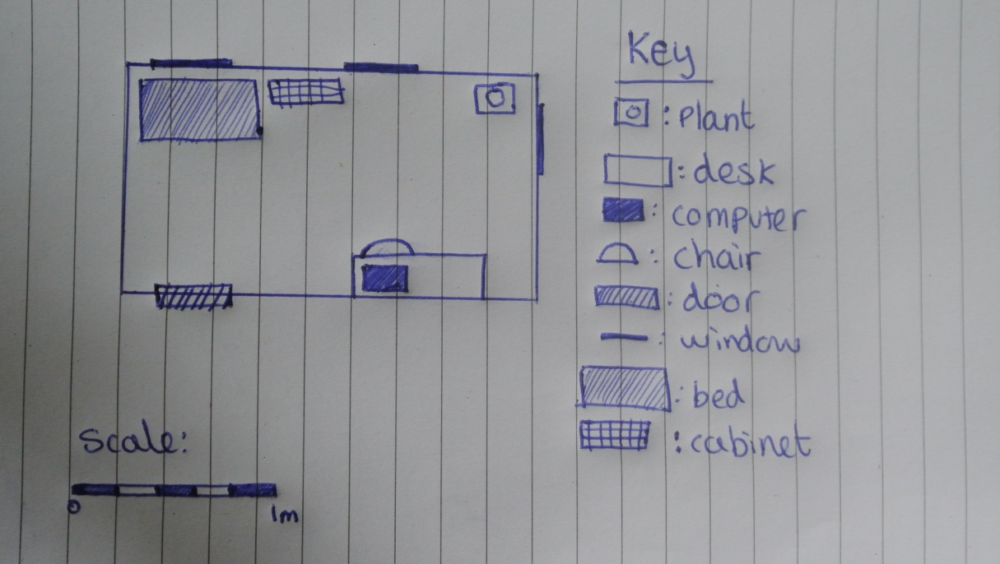

How do you draw a map of a hill ? How will you show different elevation on map ? Do you know, why trenches are dig on some hills ?

C:\Users\Hannah\AppData\Local\Microsoft\Windows\Temporary Internet Files\Content.IE5\N02VTYY2\MC900232110[1].wmf

Let’s now watch the second PowerPoint:

Learn about maps from ‘Introduction to contours.pptx’

**HPNPDL Session :**

After every activity or work exercise, all class will assemble together and brainstorm various questions. They will generate list of questions - What , Why , How, When , Where ? Attempt should be made that every student will ask min 2 questions.

The questions will be recorded. Teacher’s may able to answer some of them. It is not necessary to answer every questions but such questions must be recorded as ‘HPNPDL’ { Hame pata nahi par dhudh lenge }

**Productive task 2: Draw contour using ‘A Frame**

As a part of community service work, draw contour and dig trenches on nearby hill. You may make simple ‘A’ frame made of bamboo to mark points of same elevation on the hill slop.

Learn about drawing contour from ‘A’ frame from :

**Productive task 3: Carrying out plane table Survey to measure plot of a land**

Now let us measure agriculture plot or school ground using plane table survey method !

*C:\Users\Hannah\AppData\Local\Microsoft\Windows\Temporary Internet Files\Content.IE5\N02VTYY2\MC900232110[1].wmf*

Learn about survey from ‘Plane table survey.pptx’

Use the method described in the PPT to conduct your own survey of a farm or field.

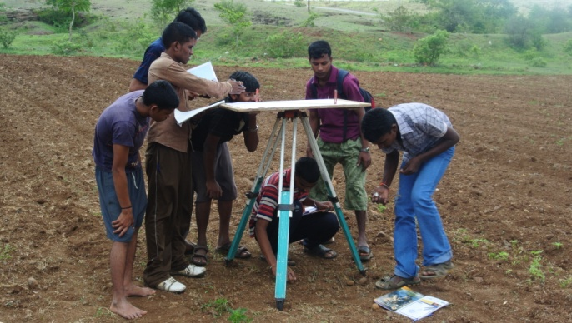 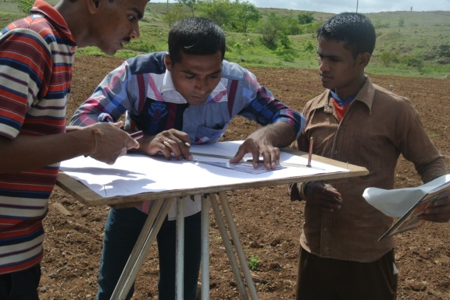

**Productive task 3: To measure height of a hill / slope, Levelling of a tripod**

Okay so we have completed the plane table survey. Now let us have a look at Dumpy Levels!

C:\Users\Hannah\AppData\Local\Microsoft\Windows\Temporary Internet Files\Content.IE5\N02VTYY2\MC900232110[1].wmf

We need to know elevation of slope, height of building etc for many things. For e.g laying of pipeline, construction of road etc.

Learn about dumpy level from ‘Introduction to dumpy level.pptx’

It is necessary to level the instrument. Levelling is needed for installation of machinery, for correct position of all legs of dumpy level.

Learn about levelling from ‘Levelling technique.pptx’

Learn about using dumpy level instrument using ‘How to use dumpy level.Example of use.pptx’

**HPNPDL Session :**

After every activity or work exercise, all class will assemble together and brainstorm various questions. They will generate list of questions - What , Why , How, When , Where ? Attempt should be made that every student will ask min 2 questions.

The questions will be recorded. Teacher’s may able to answer some of them. It is not necessary to answer every questions but such questions must be recorded as ‘HPNPDL’ { Hame pata nahi par dhudh lenge }