

*Open Education Resource*

**Low Cost Housing- Ventilation**

**Productive task**:

1. Visit sites/places like house/temple/school/public toilet/community hall...etc and draw at least three sketches of ventilation systems you have observed
2. Studying wind directions and its effect on ventilation
3. Designing the ventilation system

**Concept**:

* Introduction to ventilation.
* Types and examples of ventilation systems
* Exercise: Evaluation of example ventilation system
* Designing a ventilation system

**Tools**: Plumbing tools, construction tools

**Class-Age Group**: 13 years age +

**Concept Map (Image) :**

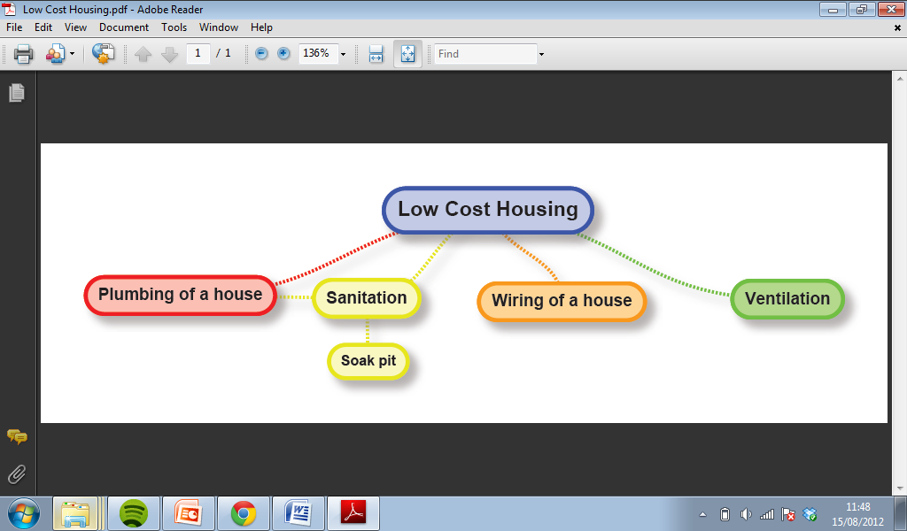

# Introduction to Ventilation

Good ventilation can help improve **health** and **wellbeing** and reduce **energy usage**.

C:\Users\Hannah\AppData\Local\Microsoft\Windows\Temporary Internet Files\Content.IE5\IS0AG6O6\MC900441902[1].wmf

Okay, but what is ventilation?

C:\Users\Hannah\AppData\Local\Microsoft\Windows\Temporary Internet Files\Content.IE5\IS0AG6O6\MC900423171[1].wmf

Refer the below learning resource to know more

C:\Users\Mandar\AppData\Local\Microsoft\Windows\Temporary Internet Files\Content.IE5\Z9BW6DE0\MC900371050[1].wmf **Learning Resource :**

|  |
| --- |
| Power Point Presentation |
| Vent PPT 1.pptx |

**Productive task1: Draw sketches of ventilation systems you have observed**

In this production task it is expected that you visit at least three different sites/places (house/temple/school/public toilet/community hall...etc) in your village or near by location and draw a simple sketch indicating how ventilation is implemented for the place you have visited.

-------------------------------------------------------------------------------------------------

**Productive task2: Studying wind directions and its effect on ventilation**

In the PowerPoint we saw an example of ventilation being described. Every year in England, the Wimbledon Tennis competition is played. In order to keep the players dry when it is raining, a roof was placed on the centre court in 2009. When the roof is closed you can fit 290million tennis balls in Centre Court! The Centre Court stadium can fit 15,000 viewers and there is always at least 2 players on the court at any time. Because there are so many people in this space there is a real need for ventilation. When the roof is open, air from outside can circulate the stadium and keep players and viewers cool. During the design of the roof, engineers had to consider the ventilation very carefully in order to ensure that the players and viewers do not become too hot. In order to do this, 8 litres per second of fresh air per person is pumped into the stadium though natural ventilation and air conditioning. As you can see in the picture, vents were used to allow air from outside to continue to enter the stadium, even when the roof is closed. Chiller units stored underground are required to cool the air.

C:\Users\Hannah\AppData\Local\Microsoft\Windows\Temporary Internet Files\Content.IE5\IS0AG6O6\MC900423171[1].wmf

C:\Users\Hannah\AppData\Local\Microsoft\Windows\Temporary Internet Files\Content.IE5\IS0AG6O6\MC900441902[1].wmf[1]

That is interesting but I do not need to cool a stadium – just my house! How do I cool my house?

C:\Users\Hannah\AppData\Local\Microsoft\Windows\Temporary Internet Files\Content.IE5\IS0AG6O6\MC900423171[1].wmf

The same principle can be used to design the ventilation system for your house and with the Wimbledon design. Firstly we are going to do a simple exercise on windows and identify which windows we should have open and closed for optimum ventilation.

Refer the below learning resource

C:\Users\Mandar\AppData\Local\Microsoft\Windows\Temporary Internet Files\Content.IE5\Z9BW6DE0\MC900371050[1].wmf **Learning Resource :**

|  |
| --- |
| Power Point Presentation |
| Vent PPT 2.pptx |

C:\Users\Hannah\AppData\Local\Microsoft\Windows\Temporary Internet Files\Content.IE5\IS0AG6O6\MC900423171[1].wmf

How did you find the exercise? Do some research in your area as to which wind direction is the most prominent i.e. which direction most wind comes from? Look again at the map in the PPT – what direction do you think would be prominent if you lived in Southern Africa or Madagascar?

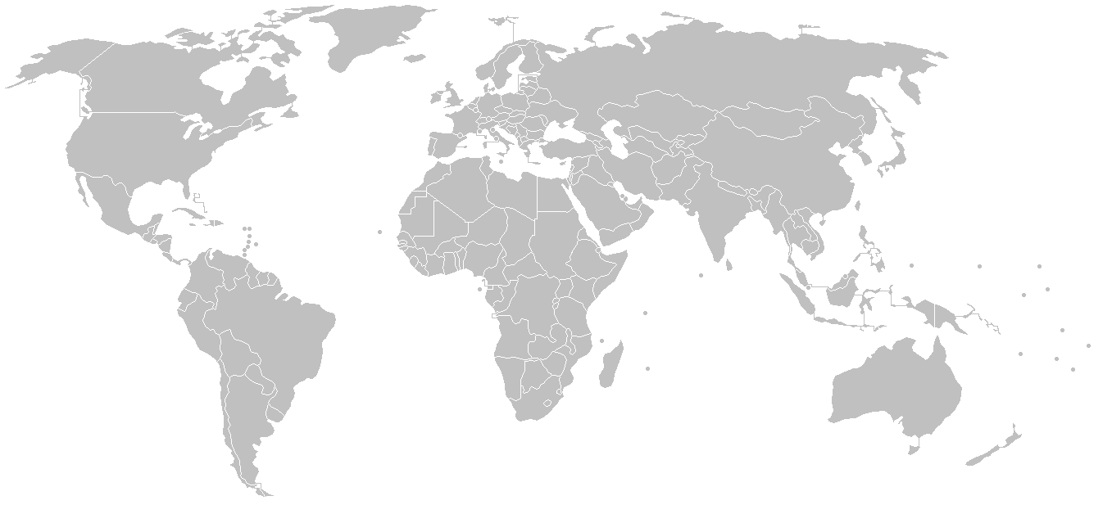

C:\Users\Hannah\AppData\Local\Microsoft\Windows\Temporary Internet Files\Content.IE5\IS0AG6O6\MC900423171[1].wmf

Do you remember the question at the end of the PPT?

Option A: Option B:

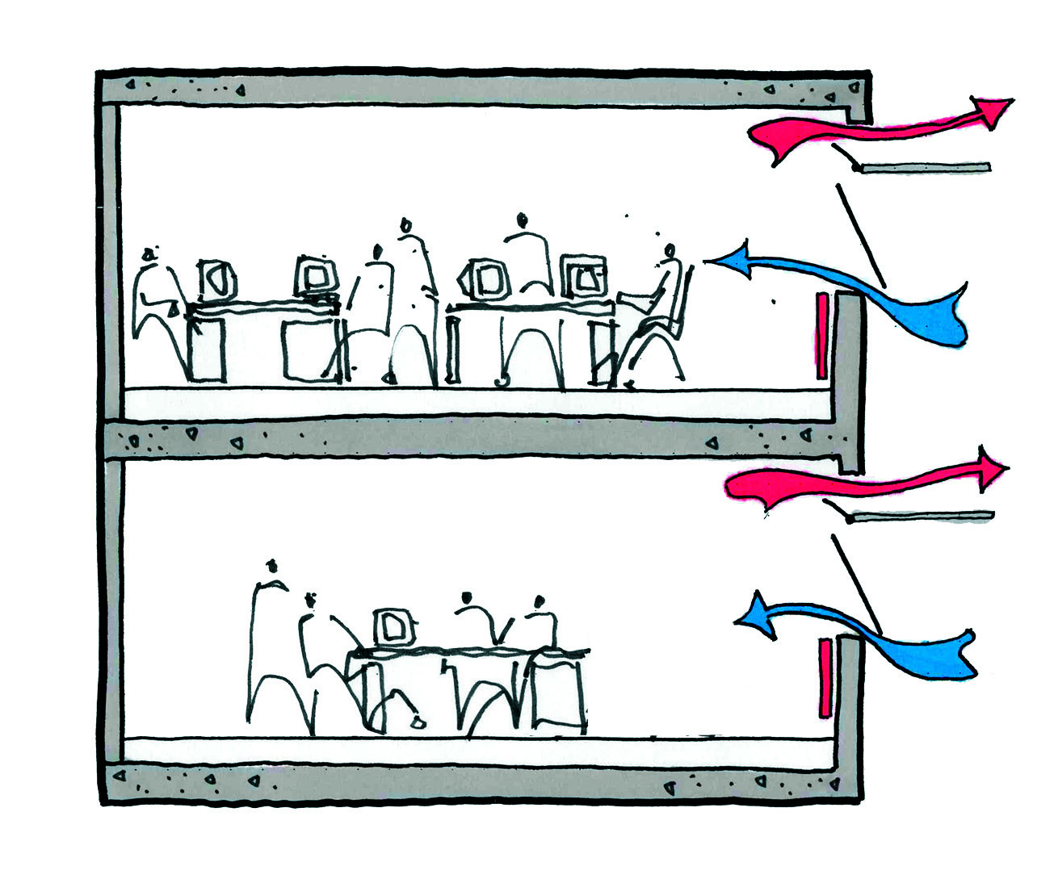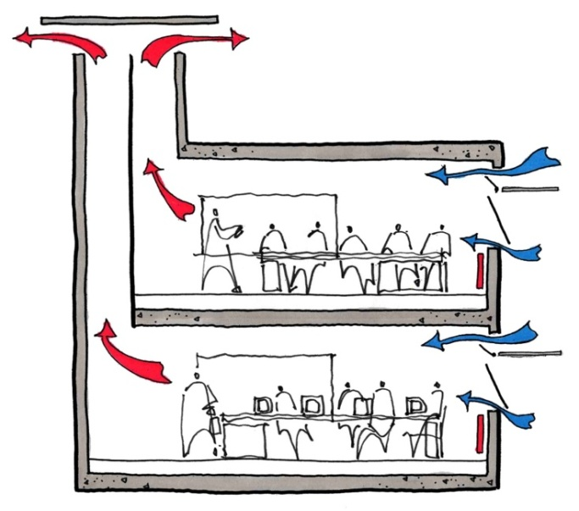

Have a discussion with a friend about this. Why did you choose one design over the other one? Which had better ventilation?

We touch on some important principles by asking this question so consider:

* Why does the red line (hot air) always points upwards?
* How far does the air travel from the moment it enters the building to when it leaves?
* What is the purpose of this building? (hint: Look closely at the sketches)
* See if you can guess what type of material is used? Do you think materials affect ventilation?

Also consider what parts of the picture contribute to the ventilation.

Answer: Option A has the same air entry and exit point. So the air may come in to the room but not necessarily travel across it. The path for air to travel across is small. However in option B the air travels across the room due to the change in air pressure provided by the chimney design. Hot air rises so does not remain in the room – therefore keeping it cool. In the picture it looks like the building is used for work. In an office, ventilation is very important as sometimes people are sat at their desk all day so they need a good air supply or the room can become hard to work in. Try shutting all the windows where you are sitting on a hot day and see if it affects your concentration!

# Types of Ventilation Systems

There are two types of natural ventilation:

1. Wind driven ventilation
2. Stack driven ventilation

*Wind driven ventilation* relies upon the force of the prevailing wind to push air through a building.

*Stack driven ventilation* comes from the building having a range of different temperatures or pressures.

A fan increases the rate of ventilation and/or can cool the outdoor supply of air.

The two main reasons for ventilation are thermal comfort and improving indoor air quality.

Ok so ventilation is essential to allow for a constant air supply it also helps get remove bad smells, air borne chemical, moisture and mould.

C:\Users\Hannah\AppData\Local\Microsoft\Windows\Temporary Internet Files\Content.IE5\IS0AG6O6\MC900441902[1].wmf

But how do I build a house with good ventilation?

C:\Users\Hannah\AppData\Local\Microsoft\Windows\Temporary Internet Files\Content.IE5\IS0AG6O6\MC900423171[1].wmf

Lets have a look at the next PowerPoint for information on appropriate windows, fan, air pipes, thermal mass and materials.

Link to PPT 3 Double Click on this box:

C:\Users\Mandar\AppData\Local\Microsoft\Windows\Temporary Internet Files\Content.IE5\Z9BW6DE0\MC900371050[1].wmf **Learning Resource :**

|  |
| --- |
| Power Point Presentation |
| Vent PPT 3.pptx |

**Window Openings:**

Buildings in hot climates will have a high heat gain. A rough estimate for the numbers of windows a building needs is an area totalling **25% of the floor area**.

**Exercise:**

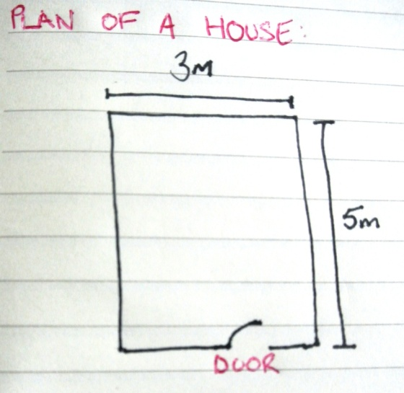

Priya is designing a new home to live in with her husband. The building will have a floor area of 5m by 3m, what is the area of the floor?

She is wondering about the number of windows she will need. She read that the area required for windows is 25% of the floor area.

What is the total area of wall she will require for window openings?

C:\Users\Hannah\AppData\Local\Microsoft\Windows\Temporary Internet Files\Content.IE5\IS0AG6O6\MC900423171[1].wmf

Once you have calculated the answers you can check if they are correct by looking at answer below:

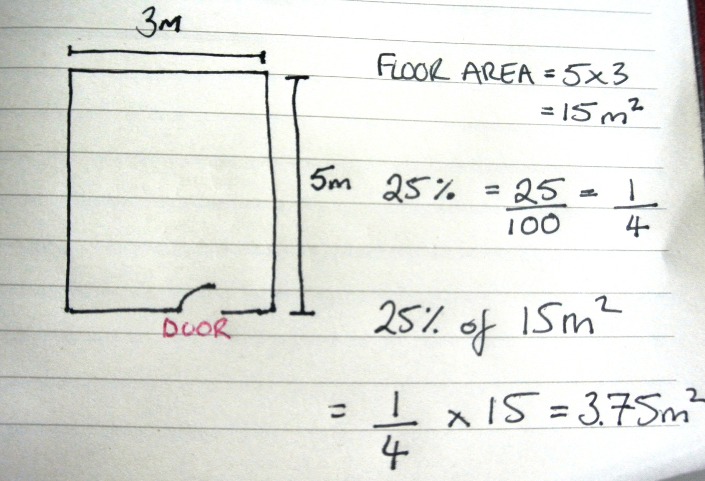

Okay so in total she needs 3.75m2 of window area on the walls.

What size windows would you recommend she needs?

How many windows would you recommend she designs?

In order to give her advice you ask a house builder. His name is Ranjeet.

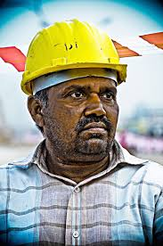

Ranjeet recommends three sizes of window:

1. 0.5m wide and 0.5m high.
2. 1m wide and 0.5m high
3. 0.75m wide and 0.5m high.

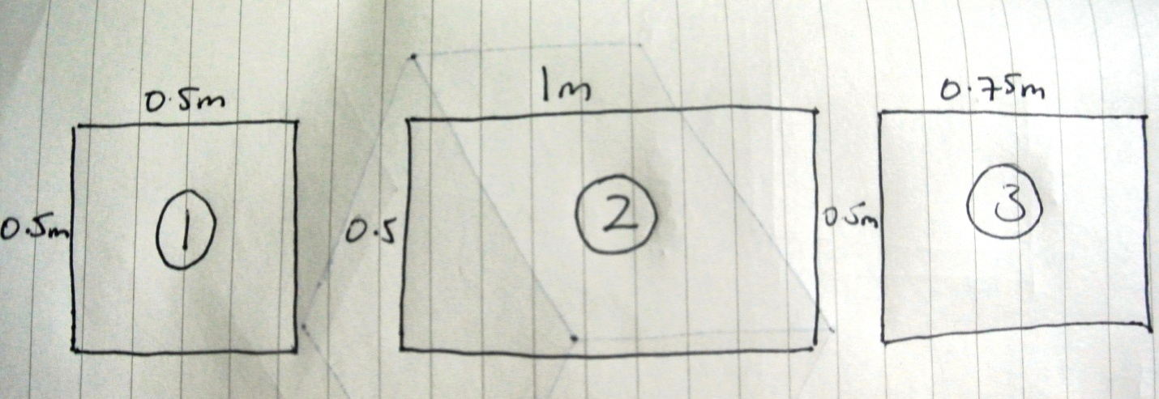

How many openings does she need for each size of window?

For example if we chose option 1:

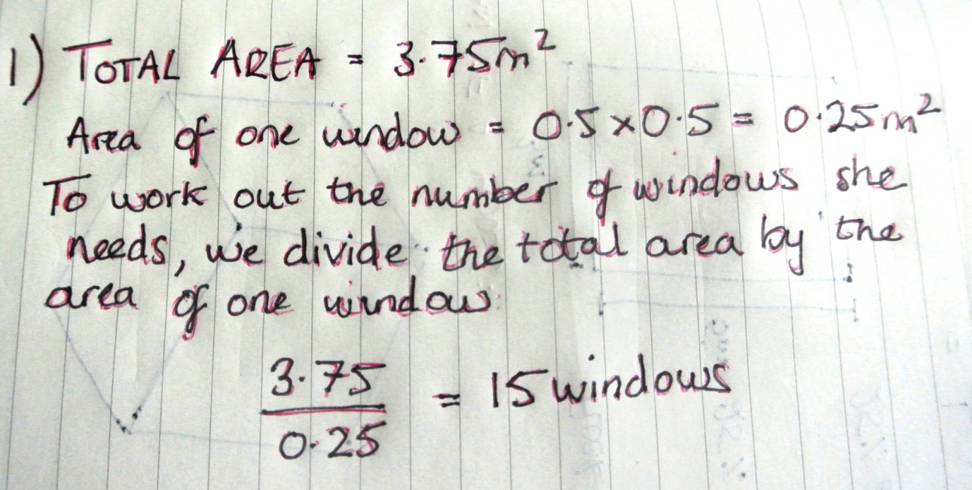

Now work out the number of windows needed for the other two possible opening sizes.

*C:\Users\Hannah\AppData\Local\Microsoft\Windows\Temporary Internet Files\Content.IE5\IS0AG6O6\MC900423171[1].wmf*

Once you have calculated the answers you can check they are correct by looking at my answer below:

*Answer: Option 2 = 7.5 windows, Option 3 = 10 windows.*

What size window would you recommend?

There is no correct answer here and you could recommend that Priya selects more than one window size and repeats the calculation to determine how many windows she would need.

Discuss with a friend where you would place these windows in terms of the prominent wind direction.

Additional Information: Horizontally shaped windows (width greater than height) work better than vertical windows.

C:\Users\Hannah\AppData\Local\Microsoft\Windows\Temporary Internet Files\Content.IE5\IS0AG6O6\MC900441902[1].wmf

Okay, I understand! But what if I want to include glass in the windows i.e. glazing?

For more information on glazing watch the PowerPoint below:

C:\Users\Hannah\AppData\Local\Microsoft\Windows\Temporary Internet Files\Content.IE5\IS0AG6O6\MC900423171[1].wmf

C:\Users\Mandar\AppData\Local\Microsoft\Windows\Temporary Internet Files\Content.IE5\Z9BW6DE0\MC900371050[1].wmf **Learning Resource :**

|  |
| --- |
| Power Point Presentation |
| Vent PPT 3b.pptx |

C:\Users\Hannah\AppData\Local\Microsoft\Windows\Temporary Internet Files\Content.IE5\IS0AG6O6\MC900423171[1].wmf

Okay let’s have a look at **other possible ventilation options**: this PowerPoint includes vents, earth pipes, green solutions and heat and insulation. See the PowerPoint below.

C:\Users\Mandar\AppData\Local\Microsoft\Windows\Temporary Internet Files\Content.IE5\Z9BW6DE0\MC900371050[1].wmf **Learning Resource :**

|  |
| --- |
| Power Point Presentation |
| Vent PPT 4.pptx |

**Productive task 3:- Designing the ventilation system**

In this productive task you will perform following tasks

1. Get the three sketches you have drawn in the productive task 1.
2. Write down the flaws or problems in the way the ventilation system is designed for the sketches
3. Now draw three sketches (one for each place), applying your own idea to overcome the problems you have noted in the 2nd step of this productive task

Okay so here is where our lesson on Ventilation ends. Ventilation is an important consideration when building a house, farm house, office or any type of shelter. It is much easier to consider it during design than have to install fans or air conditioning once the building is constructed – it is cheaper too! See If you can spot any other types of ventilation when you are in buildings.

References and Extra information:

<http://www.islington.gov.uk/publicrecords/library/Environmental-protection/Information/Guidance/2011-2012/(2012-03-03)-Low-energy-cooling-good-practice-guide.pdf>

<http://www.yourhome.gov.au/technical/fs46.html>

For an extensive understanding of how to implement ventilation systems (from UK), with a focus on ventilation system in schools see: <http://www.education.gov.uk/schools/adminandfinance/schoolscapital/buildingsanddesign/a0058229/ventilation-and-indoor-air-quality-in-schools-building-bulletin-101> and download building bulletin 1.

For more information see: <http://www.architecture.com/SustainabilityHub/Designstrategies/Air/1-2-1-3-naturalventilation-crossventilation.aspx>

Solar Induced Ventilation: Wall and roof or chimney

<http://www.cibse.org/content/Groups/Building_Simulation_Group/NMMV10/01%20Hazim%20Awbi%20(University%20of%20Reading)%20-%20Basic%20Concepts%20for%20Natural%20Ventilation%20of%20Buildings.pdf>

Ingle – sided ventilation, cross ventilation, s

1. <http://aeltc2011.wimbledon.com/footer/press-and-media/facts-figures.html> (Assessed 26.08.2012)