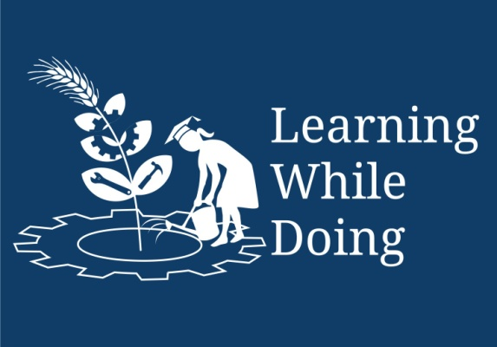

**Productive task** : Carry out plumbing, fitting tiles

**Concept** : Joints in plumbing, Septic tank, W.C fitting

**Tools** : Plumbing tools, construction tools

**Class-Age Group** : IXth and above (13 years age +)

**Learn Plumbing**

**Jenny Ralston, Emma Crichton**

*Open Education Resource*

**Concept Map (Image) :**

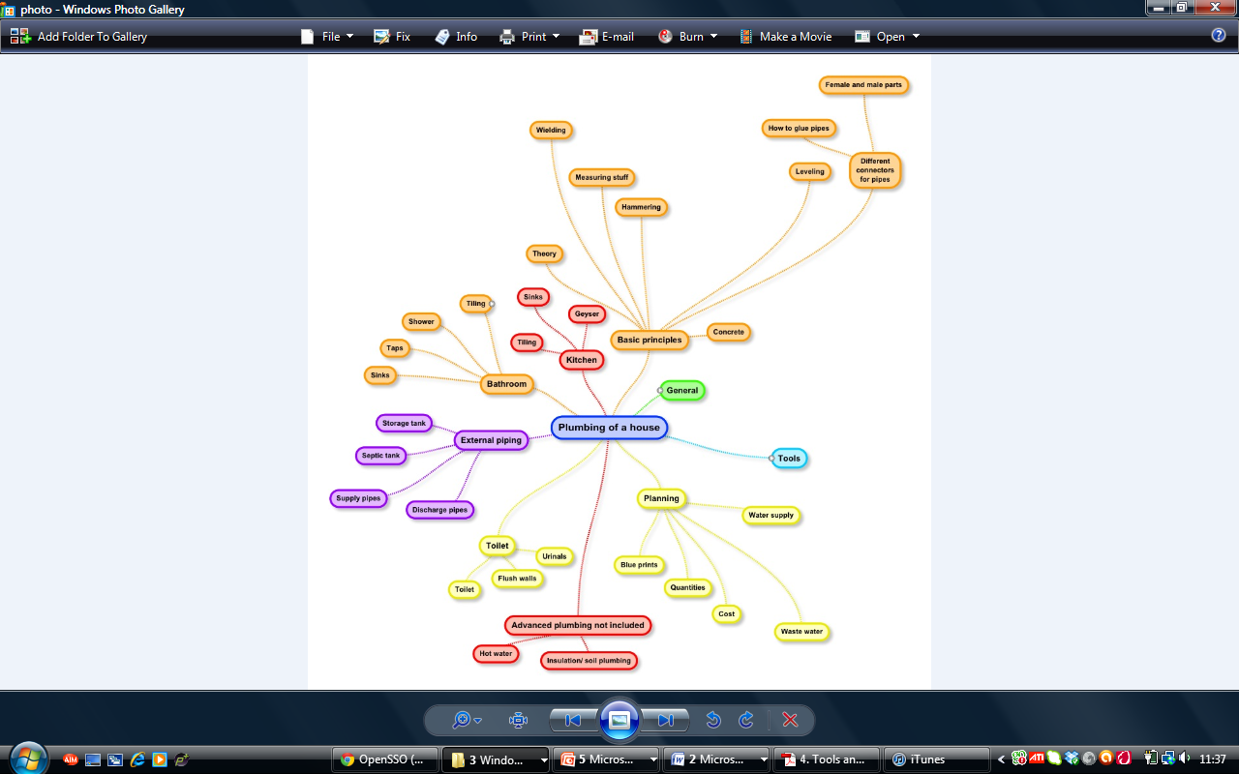

**How to plumb a house**

Hi I’m Raj, I’ve been working as a plumber in my town for 20 years. I’m going to help throughout this plumbing lesson, so that by the end of it you will be able to:

* Explain the basic theory of plumbing
* Demonstrate the correct use of tools and materials
* Draw blueprints and estimate the costs of project. You will also be able to estimate the quantities of materials needed select a feasible water supply and waste water route.
* Demonstrate basic principles such as welding, mixing concrete, hammering and even tiling.
* Correctly and safely install plumbing in the toilet, bathroom and kitchen.
* Repair leakages and carry out general maintenance of plumbing.

Let’s start with a short introduction to plumbing:

C:\Users\Hannah\AppData\Local\Microsoft\Windows\Temporary Internet Files\Content.IE5\D4V0HS8B\MC900320088[1].wmf

Learn from this PowerPoint: ‘2.Introduction to Plumbing PPT.’

**Activity 1:** Can you help Raj explain to this woman what plumbing is and why it is important.

C:\Users\Hannah\AppData\Local\Microsoft\Windows\Temporary Internet Files\Content.IE5\D4V0HS8B\MC900320088[1].wmf

Hi can I come and plumb your house?

MC900304311[1]

I don’t want plumbing in my house, I don’t even know what it is!

Teacher: Ask your students what they think plumbing is.

Individual: Write down what you think plumbing is.

Hi can I come and plumb your house?

Thanks for your help! Now let us start learning about the important planning process we must go through before we start plumbing.

C:\Users\Hannah\AppData\Local\Microsoft\Windows\Temporary Internet Files\Content.IE5\D4V0HS8B\MC900320088[1].wmf

Learn from this PowerPoint: ‘3.Introduction to Plumbing 2’

**Productive task1: Make a layout**

**C:\Users\Hannah\AppData\Local\Microsoft\Windows\Temporary Internet Files\Content.IE5\D4V0HS8B\MC900320088[1].wmfActivity 2:** In pairs calculate how much pipe is needed for your house. Then draw a scale drawing of the plan and one elevation. This plan is called the Blueprint and we will refer to it later on in this lesson.

Once you have completed this we can move onto the next stage of plumbing. Before we do this we must check the plumbing checklist:

Please use the checklist from : Powerpoint : - ‘3.Planning checklist.pptx

Now let’s learn about the different tools we will be using and how to use them correctly.

C:\Users\Hannah\AppData\Local\Microsoft\Windows\Temporary Internet Files\Content.IE5\D4V0HS8B\MC900320088[1].wmf

Learn from this document to. 4. Tools and their uses.doc

In this next PowerPoint we will learn how to do the basic principles of plumbing

Learn from the document ‘5. Introduction to plumbing 3’

**Productive task : Doing Toilet plumbing**

We are now ready to begin plumbing! Let’s start with toilet plumbing. But first I will introduce you to my friend who will help you, his name is Bharat.

C:\Users\Hannah\AppData\Local\Microsoft\Windows\Temporary Internet Files\Content.IE5\D4V0HS8B\MC900320088[1].wmf

C:\Users\Hannah\AppData\Local\Microsoft\Windows\Temporary Internet Files\Content.IE5\D4V0HS8B\MC900440420[1].wmf

Hi I‘m Bharat I work as a plumber so I am an expert at installing toilet fittings. I will therefore help you along the way. Let’s get started!

C:\Users\Hannah\AppData\Local\Microsoft\Windows\Temporary Internet Files\Content.IE5\D4V0HS8B\MC900320088[1].wmf Learn from the document ‘7. Guide to toilet plumbing.docx’

Learn from the document ‘7. How do W.C works.ppt’

**Productive task 2: Tile the toilet**

I hope your toilet plumbing was a success! Now let’s learn how to tile the toilet.

Learn from the document ‘8.Guide to tiling.docx’

C:\Users\Hannah\AppData\Local\Microsoft\Windows\Temporary Internet Files\Content.IE5\D4V0HS8B\MC900320088[1].wmf

Now another one of my friends will teach you all about bathroom plumbing.

**HPNPDL Session :**

After every activity or work exercise, all class will assemble together and brainstorm various questions. They will generate list of questions - What , Why , How, When , Where ? Attempt should be made that every student will ask min 2 questions.

The questions will be recorded. Teacher’s may able to answer some of them. It is not necessary to answer every questions but such questions must be recorded as ‘HPNPDL’ { Hame pata nahi par dhudh lenge }

**Productive task 3 : Bathroom plumbing**

Learn from the document ‘9.Guide to Bathroom plumbing.docx’

C:\Users\Hannah\AppData\Local\Microsoft\Windows\Temporary Internet Files\Content.IE5\D4V0HS8B\MC900320088[1].wmf

Another important thing we must be able to do is recognize why we have a leak or blockage. Here is a helpful diagram to help with this:

**Productive task : Soak pit & Septic tank**

Learn from the document ‘12. Extra Plumbing Information

C:\Users\Hannah\AppData\Local\Microsoft\Windows\Temporary Internet Files\Content.IE5\D4V0HS8B\MC900320088[1].wmf

I hope you have enjoyed this plumbing lesson and that your practical work has been a success! Here is a short feedback form where you can tell me about any issues or problems that you faced, so that I can cover these areas in more detail in the future.