Extraction of Orange-peel Oil with the help of Hydraulic Press:

- Author Name - Ms. Anita S. Pansare
- Edited by – Mrs. Shanbhag Pallavi R
Open Education Resource
Productive Task:
Extraction of orange peel oil with the help of hydraulic press mechanism

Objective:
- To Extract orange peel oil for food fortification, pharmaceutical purpose and perfume making.
Tools and material needed:
Hydraulic press machine (manually operated), gas stove, spatula, holder, 6-8 mature oranges, stainless steel utensils, strainers- big and small, sharp Knife, bowl, plastic bottle, weighing machine.
Procedure:

Step 1. | Take 6-8 mature oranges. | 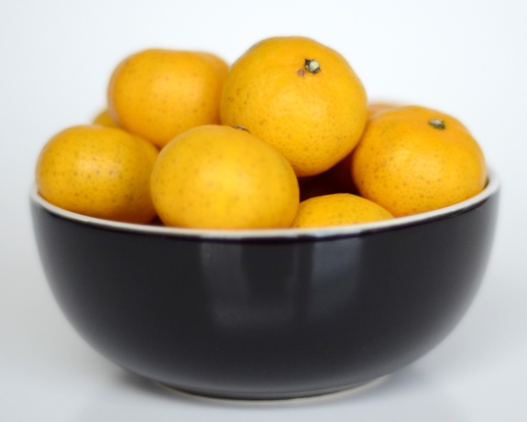
Step 2. | Peel oranges. | 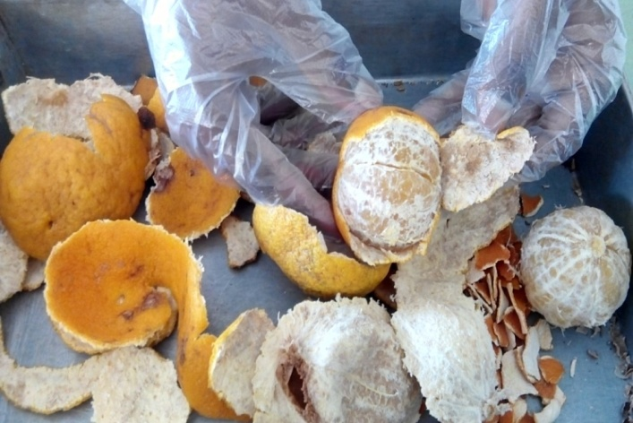
Step 3. | Weigh the peeled portion of oranges. | 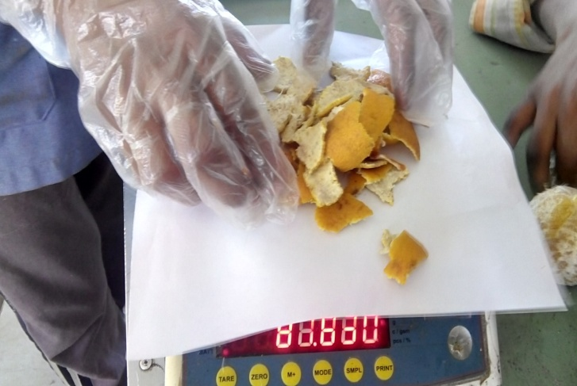
Step 4. | With the help of gas Stove on light flame warm up the water. Add peeled skin to it. | 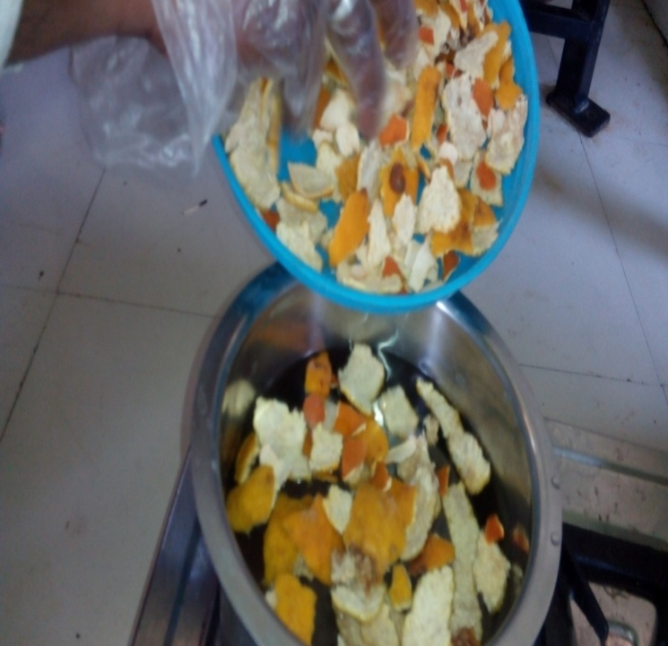
Step 5. | Allow to boil till the peel get soften (approximate for 10 minutes). | 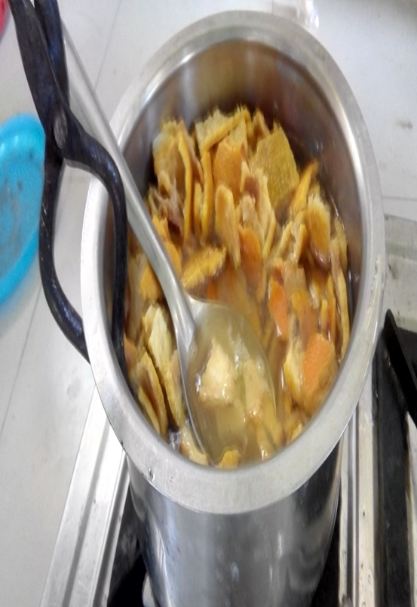
Step 6. | Strain out the extract with the help of strainer to get softened peels.  Note: Only soft partially cooked peels are being used for extraction of oil. | 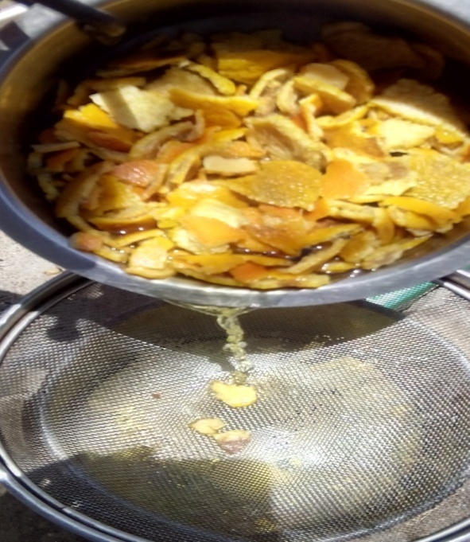
Step 7. | Fill the hydraulic press cylinder with soft soak orange peel with the help of plates in alternate way. | 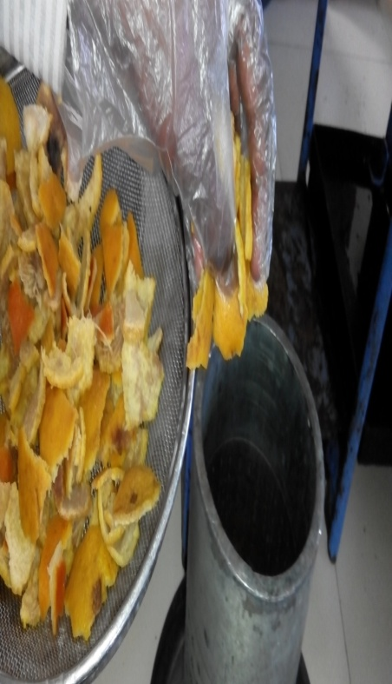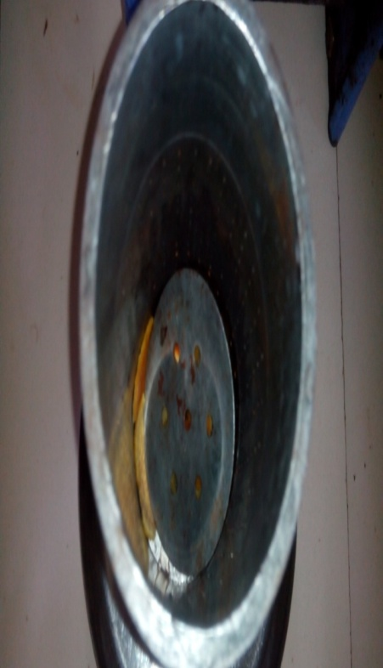
Step 8. | Adjust the piston of hydraulic press. | 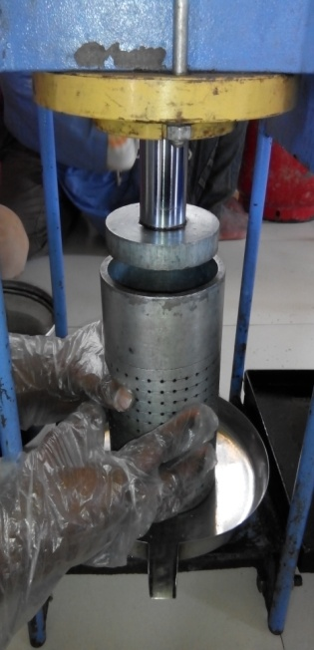
Step 9. | Extract the peel oil with the help of hydraulic press handle. | 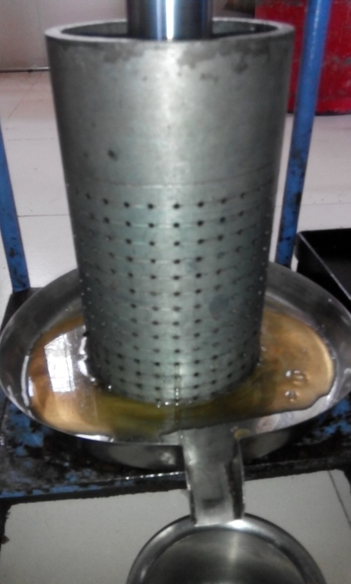
Step 10. | Strain the oil with strainer to get filtered extracted oil. | 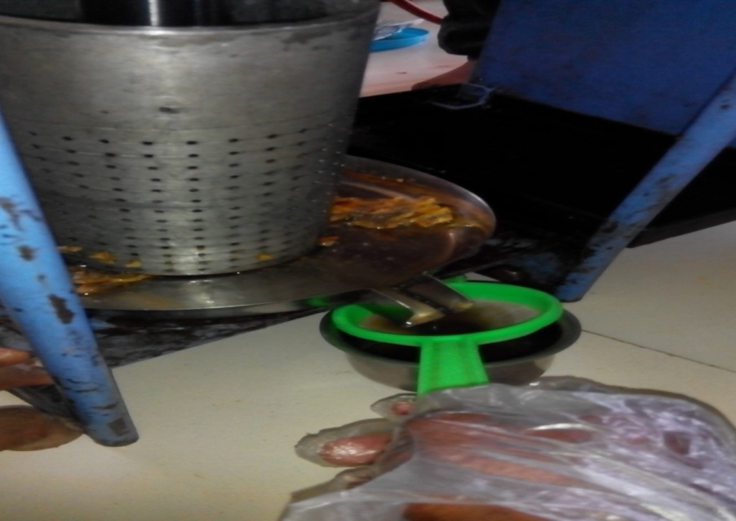
Step 11. | Extracted filtered oil is ready for further use. | 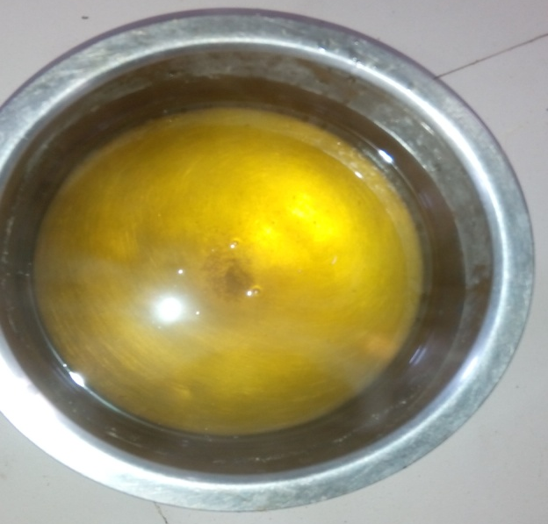

Conclusion:
We got filtered extracted orange peel oil for purposes as mentioned in objective.

