Productive task :
- Prepare a budget estimation for 1 week vegetable purchase in your family with approximate cash flow your mother need to maintain with her for weekly purchase.
- Collect at least 2 quotations for any of your schools / homes purchase and decide best option out of them.
- Preparation of cash flow with simple example.
- Preparation actual costing statement as per given drawing.
Tools:
Note book, Pencil , survey tour in village market.
Resource person :
Maths teacher
Class-Age Group : 16 +

Basics of accounting and budget estimation
- Mr.Anand Gosavi & Mahesh Lade
Open Education Resource

Productive task1:
- Prepare a budget estimation for 1 week vegetable purchase in your family with approximate cash flow your mother need to maintain with her for weekly purchase.
- Collect at least 2 quotations for any of your schools / homes purchase and decide best option out of them.
- Preparation of cash flow with simple example.
- Preparation actual costing statement as per given drawing.

Productive task objective:
After going through this unit you will be able to, perform simple accounting practices with budget estimation, cash flow management. Now which are thinks you will need to consider for estimation budget –

Introduction:

Many time s we have seen this type of scene in market, even it’s happened with your mother also

Customer- What is a cost of this basket?

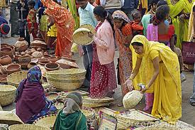
Seller – 50 rupees
Customer- Give me it in 30 Rupees

Seller –No no the production cost of the basket is more than 40 rupees

Customer- Then keeps it I don’t have that much budget

Exchanges of goods and services with money are happening in every business. An entrepreneur must be aware, whether he is making profit or loss in his business. Maintaining accounts of all transaction is very much important in daily business. It is also required for audit and Govt. taxation purpose. Banks needs audited information while evaluating loan proposals. Therefore it is very much important to learn about accounts to become successful.
Before starting any work, budgeting of expenses is done. Read few uses of budget –
- If activity-wise funds required are known, provision for funds can be made.
- If there is two or more option, then best option can be selected.
- Areas of cost reduction can be found out and worked out.
Budget helps to understand, deficit or surplus in income. Every year finance minister presents budget for the country. If there is deficit then taxes are raised to meet the deficit. Similarly every organization makes budget. It is advisable that every household should have its budget.
Suppose you want to celebrate your birthday by arranging a party for your friends. Your mother is ready to cook poha and tea for your friends but she has asked you to make approximate estimate of quantity poha and tea you will required. Now in this case you need to find out –
- Number of friend?
- Quantity of Poha and Tea cups?
- Material and its quantity required for total friends.
- Total price of material
- Time required to purchase / cook food (value of time).

In the same form you need to estimate your budget, manage cash flow and record all your expenses and earnings in business. So let’s see what are the different steps in simple accounting of any financial activity? –
Steps in accounting:
- Budget Estimation-
Estimate is approximate calculation of raw material, labor and money required for a particular service or task or product manufacturing (Estimation of Input and output). Estimation is done normally, when customer has not yet made up his mind for purchase and studying option. The details are likely to change as per the material used, process performed or market situations. Estimate is to help customer to select appropriate option.
Please follow PPT link for basics budget estimation –
Budgeting.pptx
Productive task 1 :
- Prepare a budget estimation for 1 week vegetable purchase in your family with approximate cash flow your mother need to maintain with her for weekly purchase. ( make a list of vegetables and their quantity (average quantity ) you consume in your home (by purchasing from market) with their costing details and then prepare budget estimation)

- Quotation-
Quotation is a time-bound, written surety about the price of certain service or Product, given to the customer based on the estimation of that particular Service or Production process. Sometimes, quotations assure a guaranteed sale for the seller and assure a guaranteed supply to the customer. Quotation helps customer to select best option for him.

Example –
Suppose you want to purchase a computer and for this you have received 2 quotations from market. Then as per quotation value and its specification you can make decision out of 2 options as –
Please follow link to see sample quotations - Quotations.docx
Productive task 2 :

- Collect at least 2 quotations for any of your schools / homes purchase and decide best option out of them.

- Cash flow management -
While executing a job, customer generally pays at the time of delivery. To meet payment of supplier or for labour payment, entrepreneur has to spend money. A statement showing timetable of requirement of funds and receipt of funds is called as cash flow.
It is a schedule showing cash received and paid over a certain time period. We will first see a PPT link and then study cash-flow statement using an example.
PPT Link for cash flow management –
Cash flow.pptx
Cash flow example –
E.g. a Poultry Farm owner needs to prepare a Cash Flow Statement, based on the following information -
- Farmer need to may advance for purchasing poultry chicks first.
- The sale amount is received within 15 days from the day of sale.
- The order for the Poultry food is to be given 15 days in advance.
- Medicines and cages are available immediately.
Hence, the owner prepared a Cash Flow Statement as follows table 1 -
Month | November | December | January | February
Expenses | Order for Birds - 540.00 | Cage purchase - 2000.00  Food - 1280.00 | Medicine - 200.00  Bird of batch 2 - 540.00  Received batch 1 | Food - 1280
Revenue | Initial investment - 5000.00 |  |  | Sold batch 1
Balance | 5000.00 - 540.00 = 4460.00 | 4460.00 - 3280.00 = 1180.00 | 1180.00 - 740.00 = 440.00 | 440.00 - 1280.00 =  -840.00

Month | March | April | May | June | July
Expenses | Order for batch 3 - 540.00 | Food - 1280.00 | Received batch 3 | Food - 1280.00
Revenue | Batch 1 - 2128.00 | Sold batch 2 | Batch 2 - 2128.00 | Sold batch 3 | Batch 3 - 2128.00
Balance | -840.00  -540.00  + 2128.00  __________  740.00 | 740.00  -1280.00  ------------  -532.00 | -532.00  +2128.00  -------------  1596.00  -540.00  ------------------  1056.00 | 1056.00  -1280.00  -----------------  -224.00 | -224.00  +2128.00  ------------  +1904

The conclusions based over this Cash Flow Statement are -
- Even though the transactions begin in January, he has to invest 2 months in advance, i.e. in November.
- Even though at the end of a session the business seems to be in profit, there are times of deficiency (at the end of months February, April, June). So if some financial provision is not made for meeting these deficiencies, the progress is bound to halt.
- If this deficiency is recovered from the initial investment, in small installments, then slowly this deficiency will be ceased.
- If the advance payments of food and birds is done in small installments, say, 25 % or so, and the remainder is paid at the time of receiving the food or birds, then this periodic deficiency can be avoided.
- Or if all transactions are done through Bank account, due to assurance of repayment, this deficiency can be demanded from the bank on interest basis.

Thus, the Cash Flow Statement helps to support the business and explore various means to smoothen the ups-n-downs of the business.

Productive task 3 :

- Ready cash flow example given in above PPT link and prepare cash flow with following example –
Now suppose you have already prepared a 1 Kg of pickle and on 7th May , you recived order for another 10 Kg . This extra order you need to fulfil by 31st May. Now calculate cash flow for month of May for your pickle activity.

- Cost accounting –

Cost accounting OR Costing is calculation of actual production expenses and revenues of a certain task. A Cost-Benefit Ratio is calculated to study whether the benefit is sufficient with respect to the Cost of the product or service. The overall costing includes -
- Pre-production expenses (Marketing Survey, advertisement etc.),
- The production expenses (from raw material purchase to packing of finished product, depreciation of assets, running expenses etc.),
- Expenditure for Sale of the product (include. VAT or other taxes, advertisement, commissions, transportation etc.),
- Profit (Manufacturer - 10%, Distributor - 1% -5%, Wholesaler - 10% -15%, Retailer - 10% -20%)

Lest see how simple costing is code in case of fabrication business –
Costing1 (2).ppt
Productive task 4 :

- Now as shown in PPT , lets try to prepare costing for following activity –

You need to prepare a actual costing for coconut peeler , you have just fabricated as per following drawing and inputs as –
Material used
Sr.No. | Description | Rate
1 | Flat 50 X 5 | 60.00 / mt.
2 | Flat 25 X 5 | 35.00 / mt.
3 | Flat 30 X 5 | 40.00 / mt
4 | 2" Square Pipe | 50.00 / mt
5 | Round Bar | 20.00 / mt
6 | Redoxide ( 200 Ml) | 90.00 / lit.
7 | Color ( 200 Ml) | 180.00/ lit

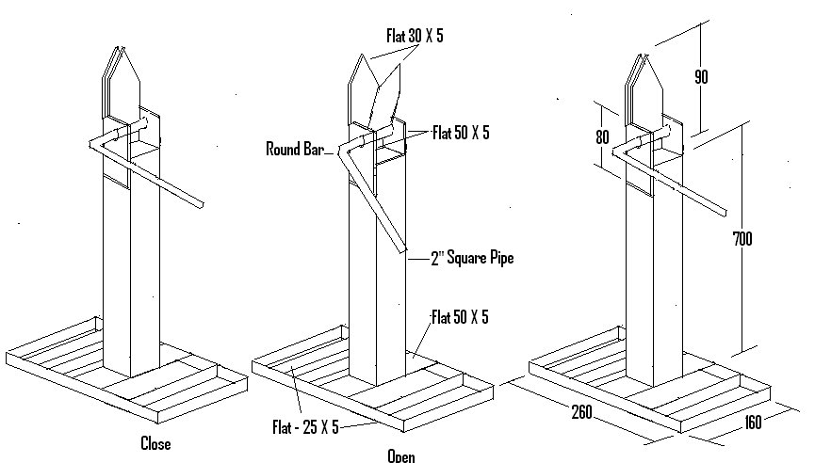
Product actual drawing

- Profit and loss accounting:
Simple accounting normally ends at preparation of profit and loss account statement. Profit & loss account statement is simple recording profit or loss of your business. Balance sheet shows health of the organization. Income statement also called as profit and loss statement (P&L), gives company's financial statement for particular period. This shows if the organization has made profit or loss during particular period.

For detailing let’s see following PPT –
Profit & loss.pptx
Note - Amount spend on fixed assets is not shown in the P&L statement. But interest on the capital invested is shown in the P&L statement.

HPNPDL session:

Main Activity – visit to our grampanchayat office and talk about the budget of your village with the sarpanch and help them for making the village budget.

Other useful references:

http://www.youtube.com/watch?v=rK6WLHNYjwM
https://www.mint.com
http://www.thousandaire.com/downloads/

